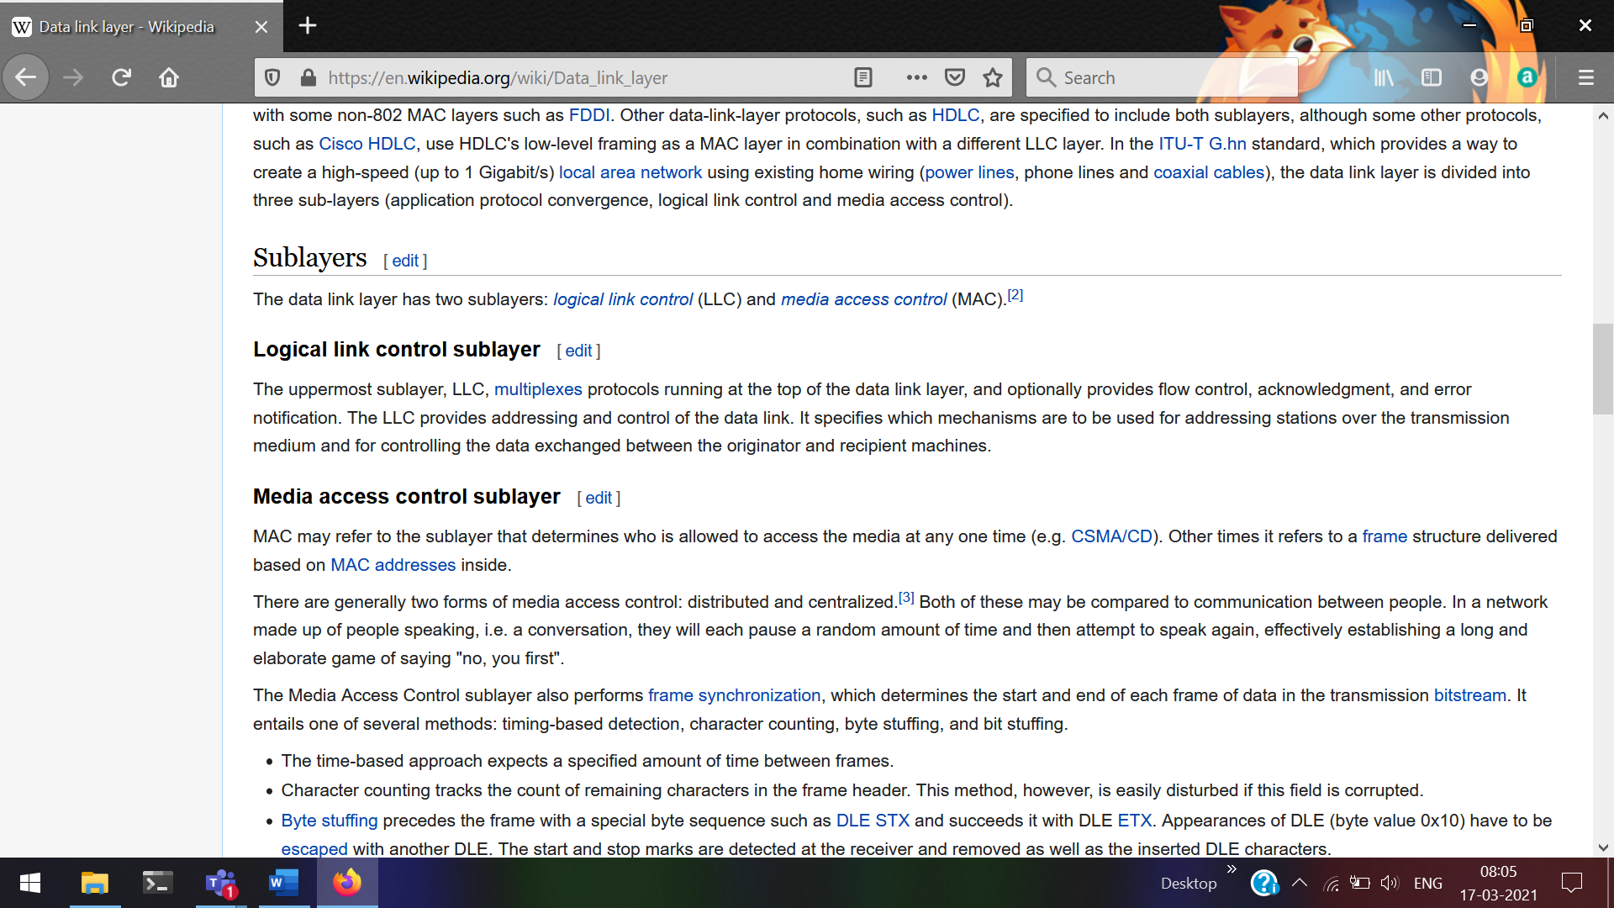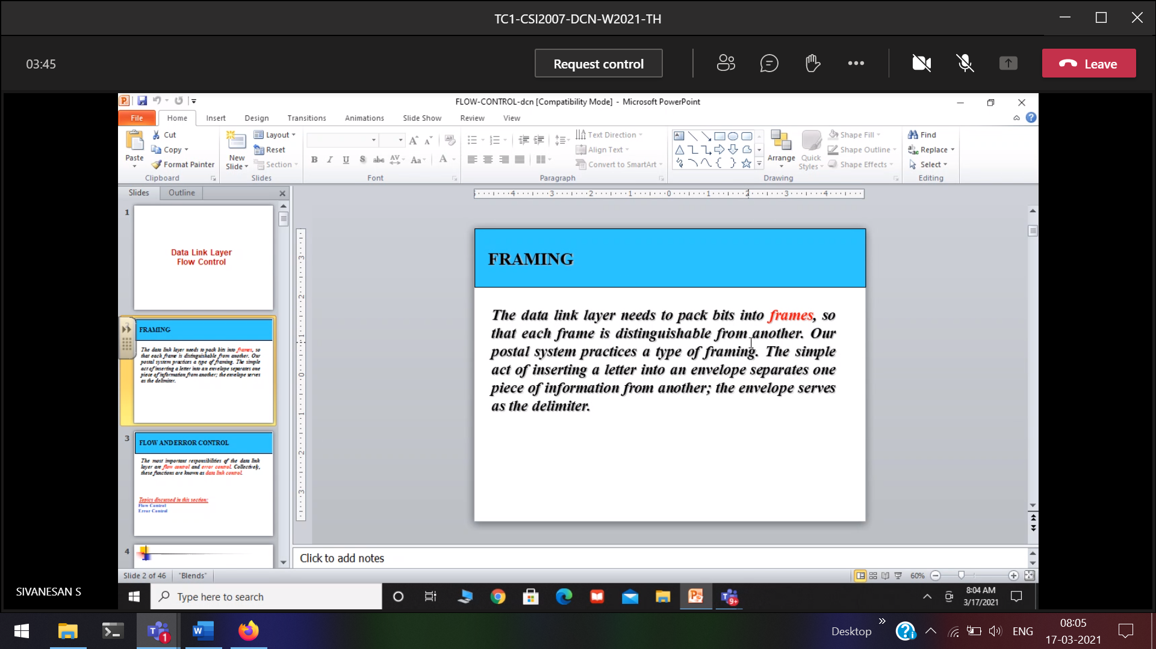

Making bits into frames

delimiter 🡪 header trailer  
Used to differentiate 1 frame with other frame

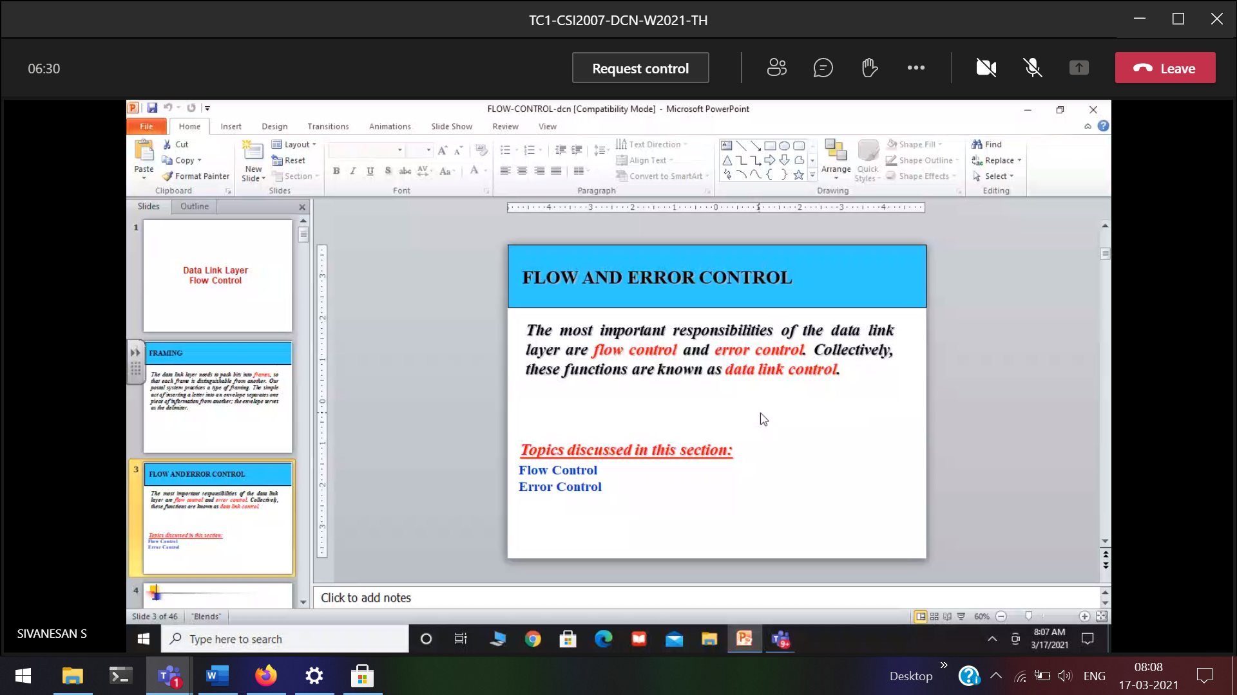

We have to control   
Sender 🡪 more NIC speed  
Receiver 🡪 Less NIC speed

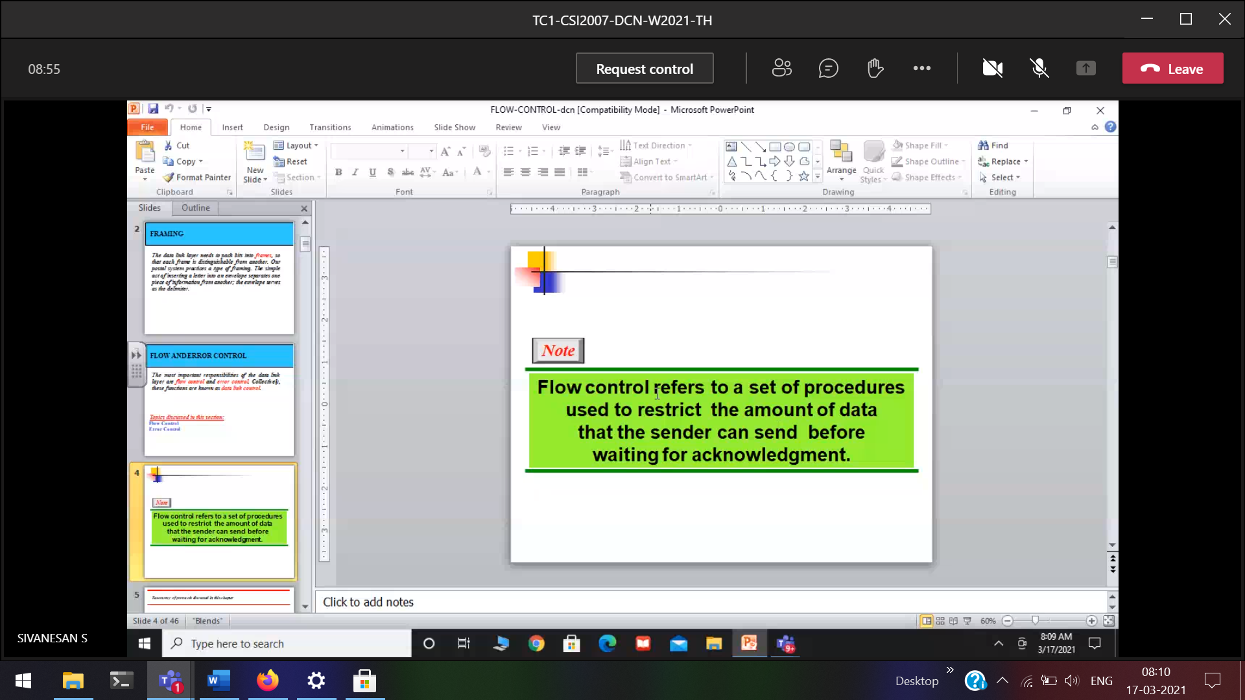

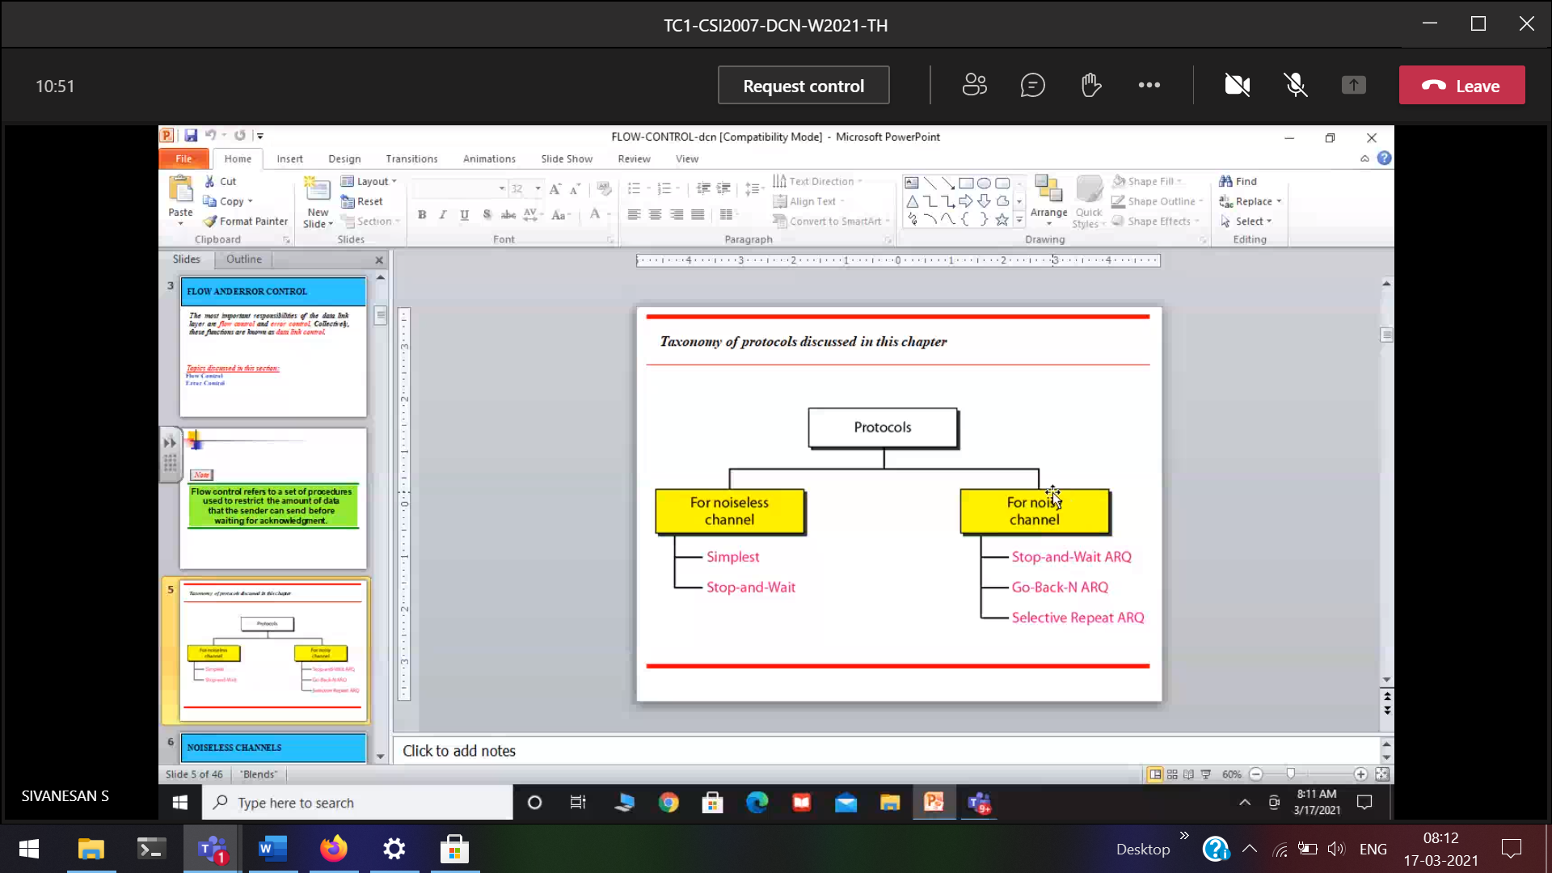

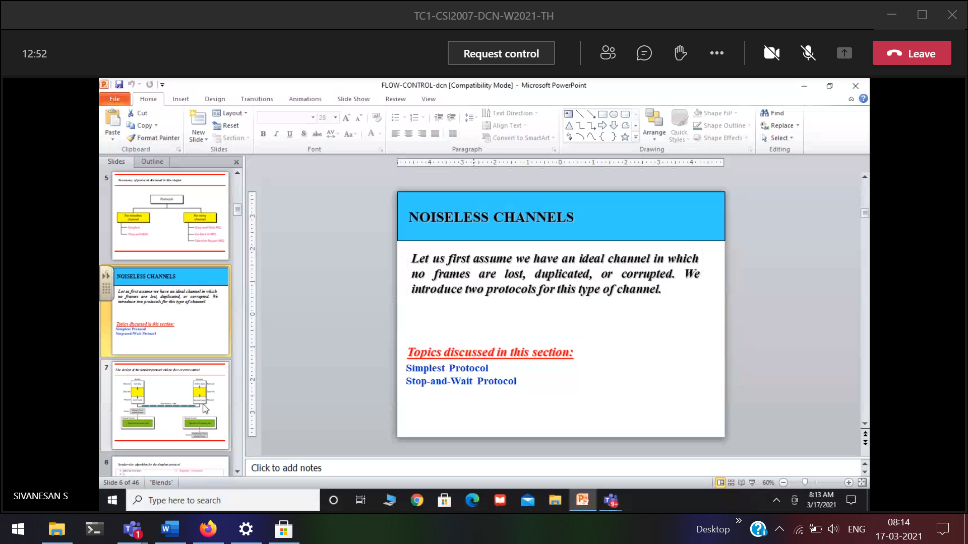

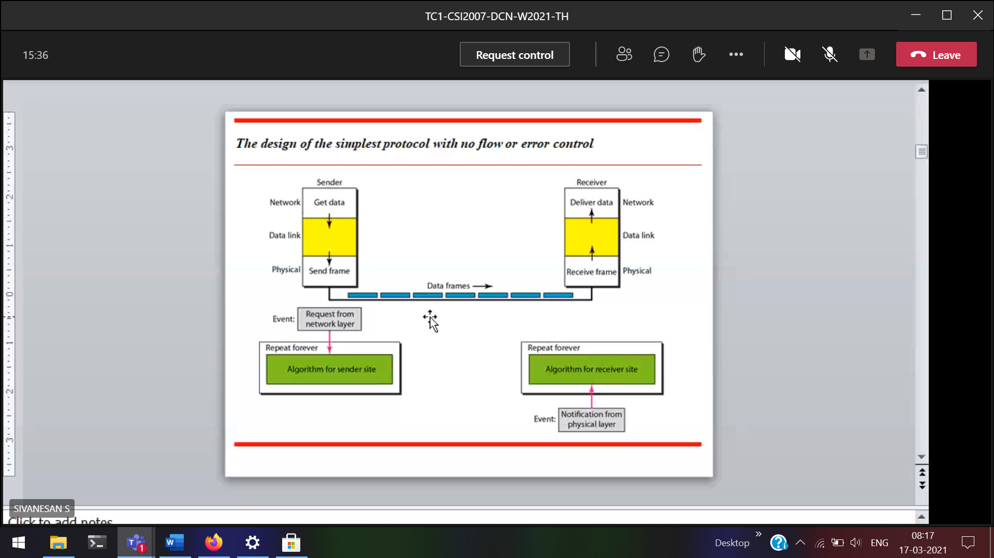



There is no exclusive flow control.

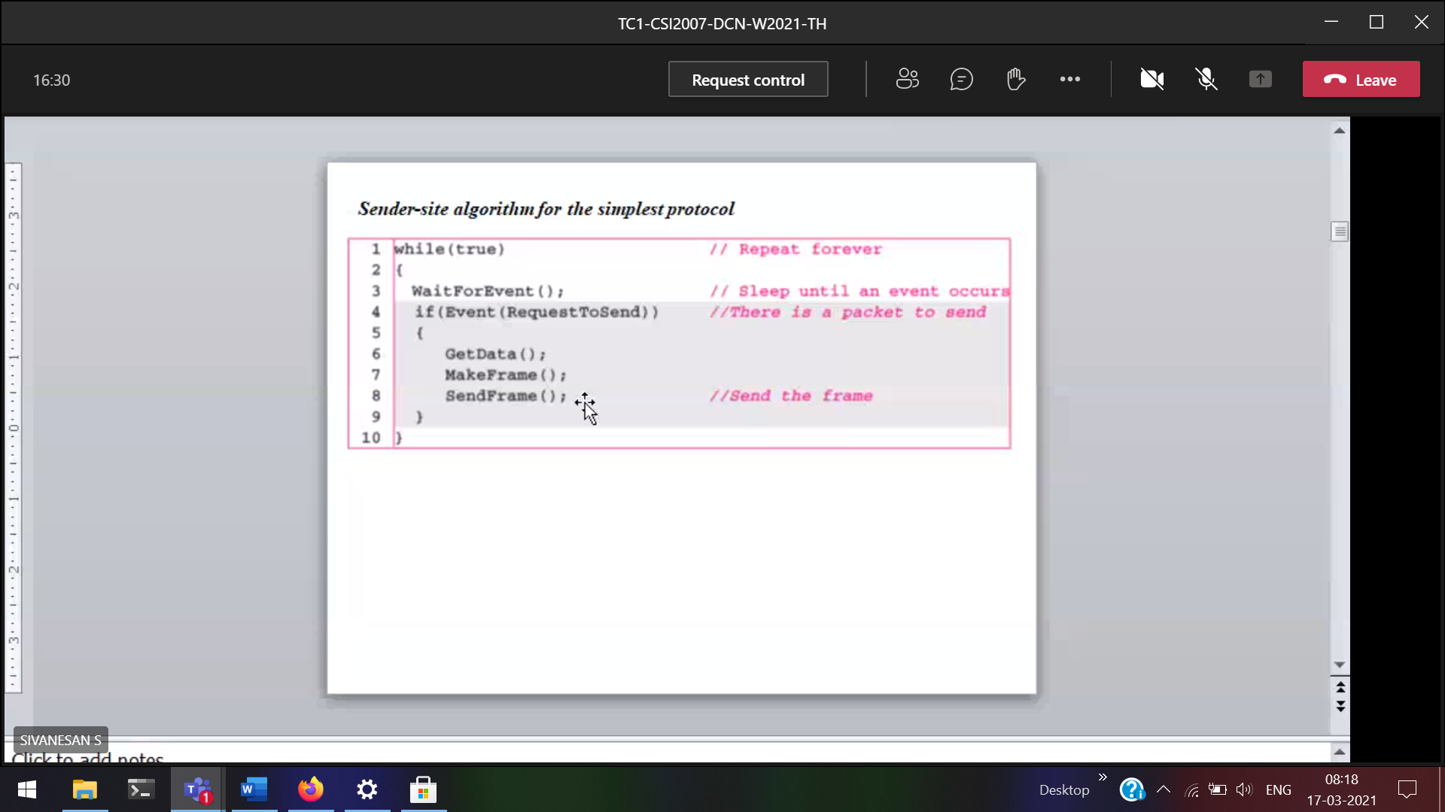

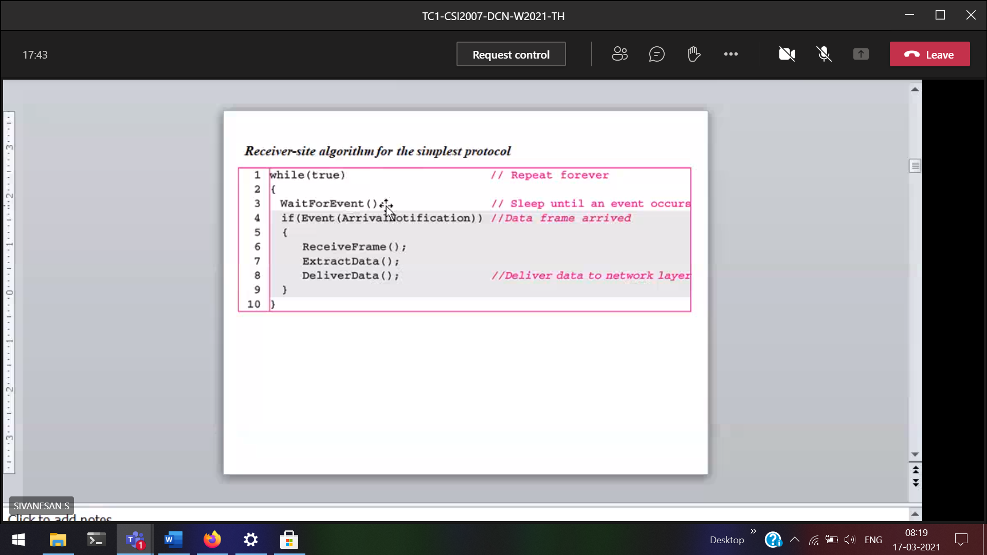

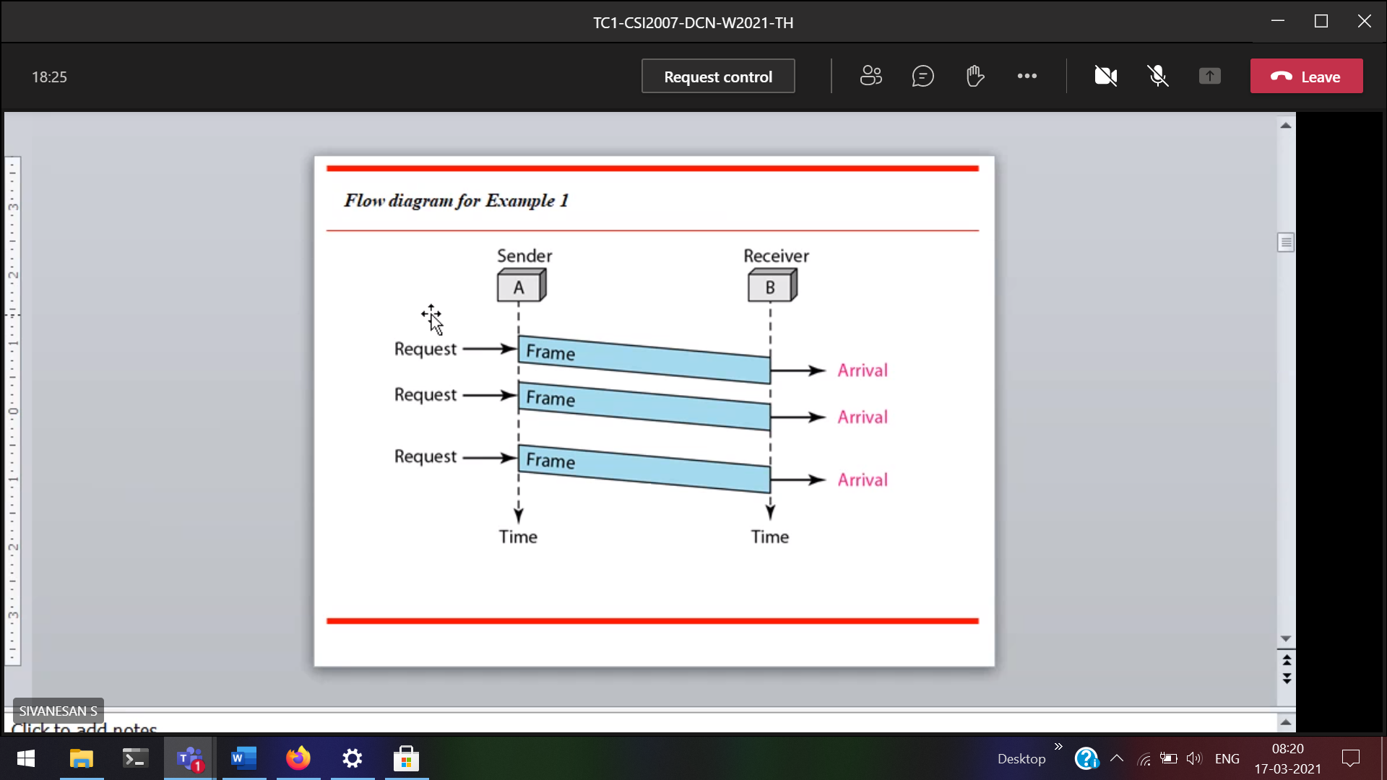

With respect to reliability how it performs????  
Reliability purely based on channel quality.  
There is no frame loss  
When the channel is going to behave

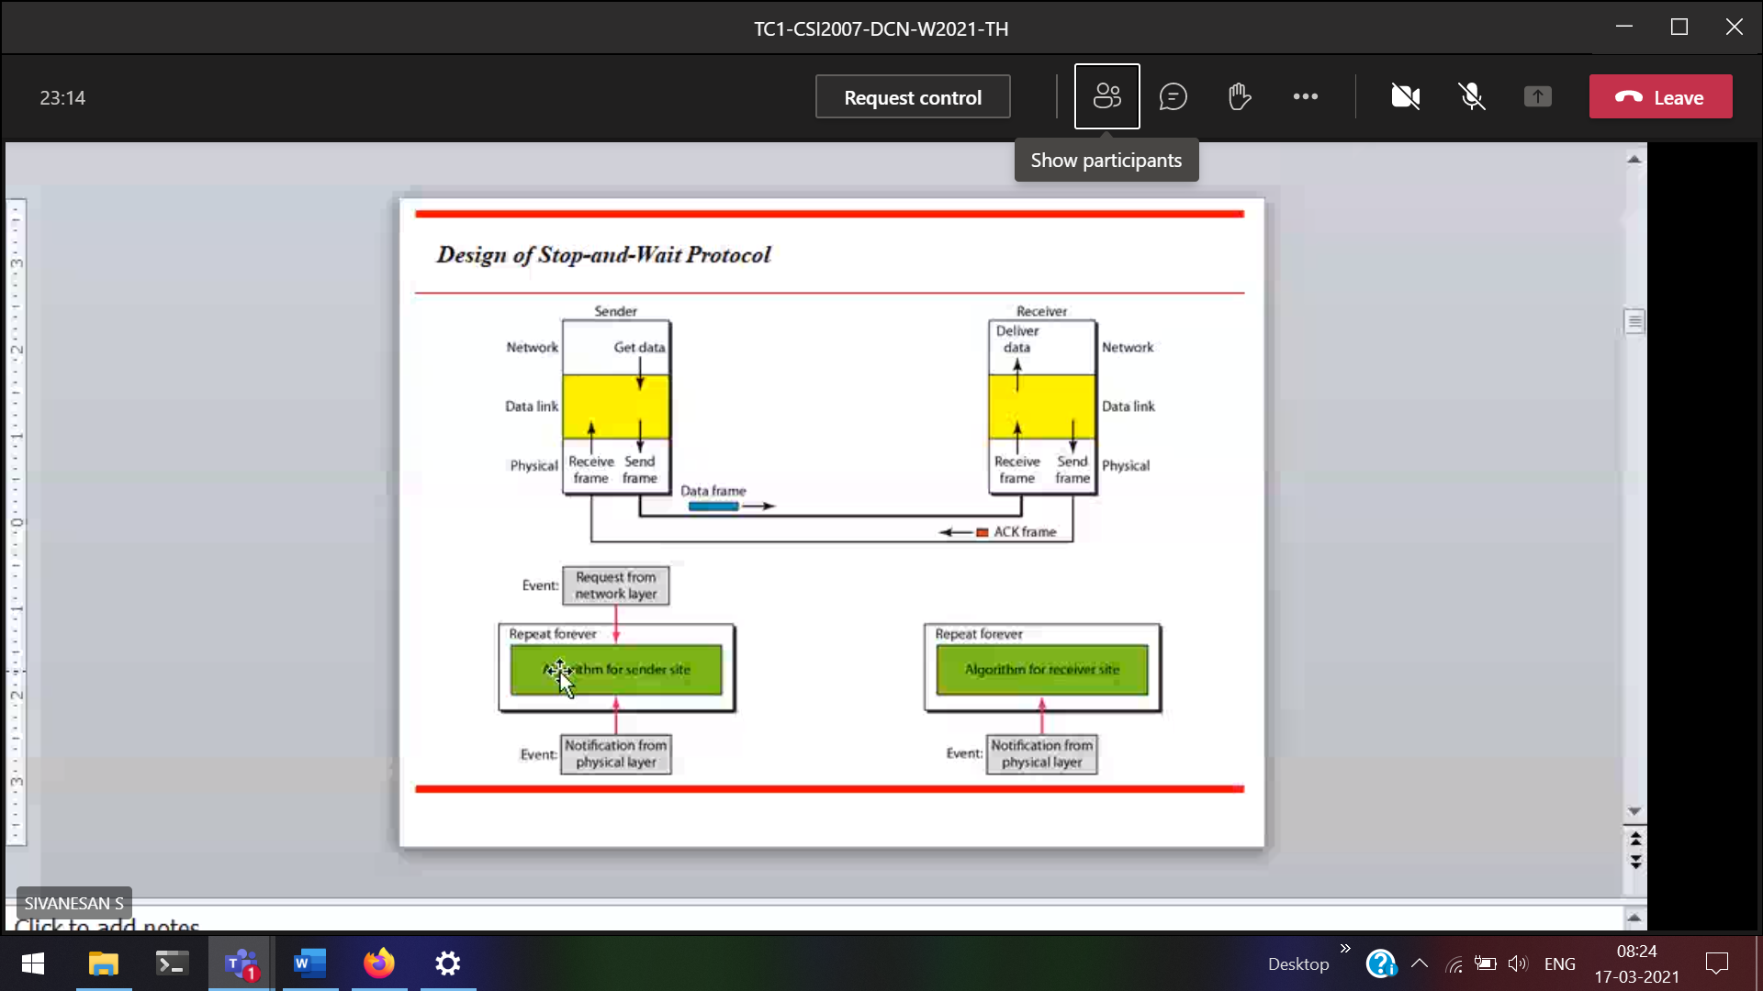

We will get the notification from the physical layer  
Acknowledgement will ne given by the data-link layer in the receiver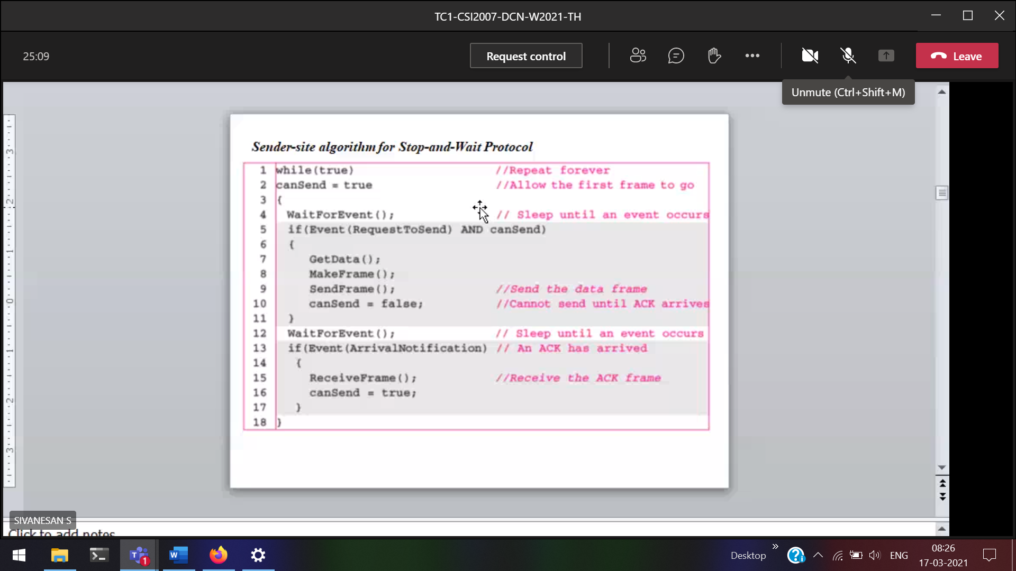

Stop and wait for the acknowledgement

canSend 🡪 for acknowledgement purpose.

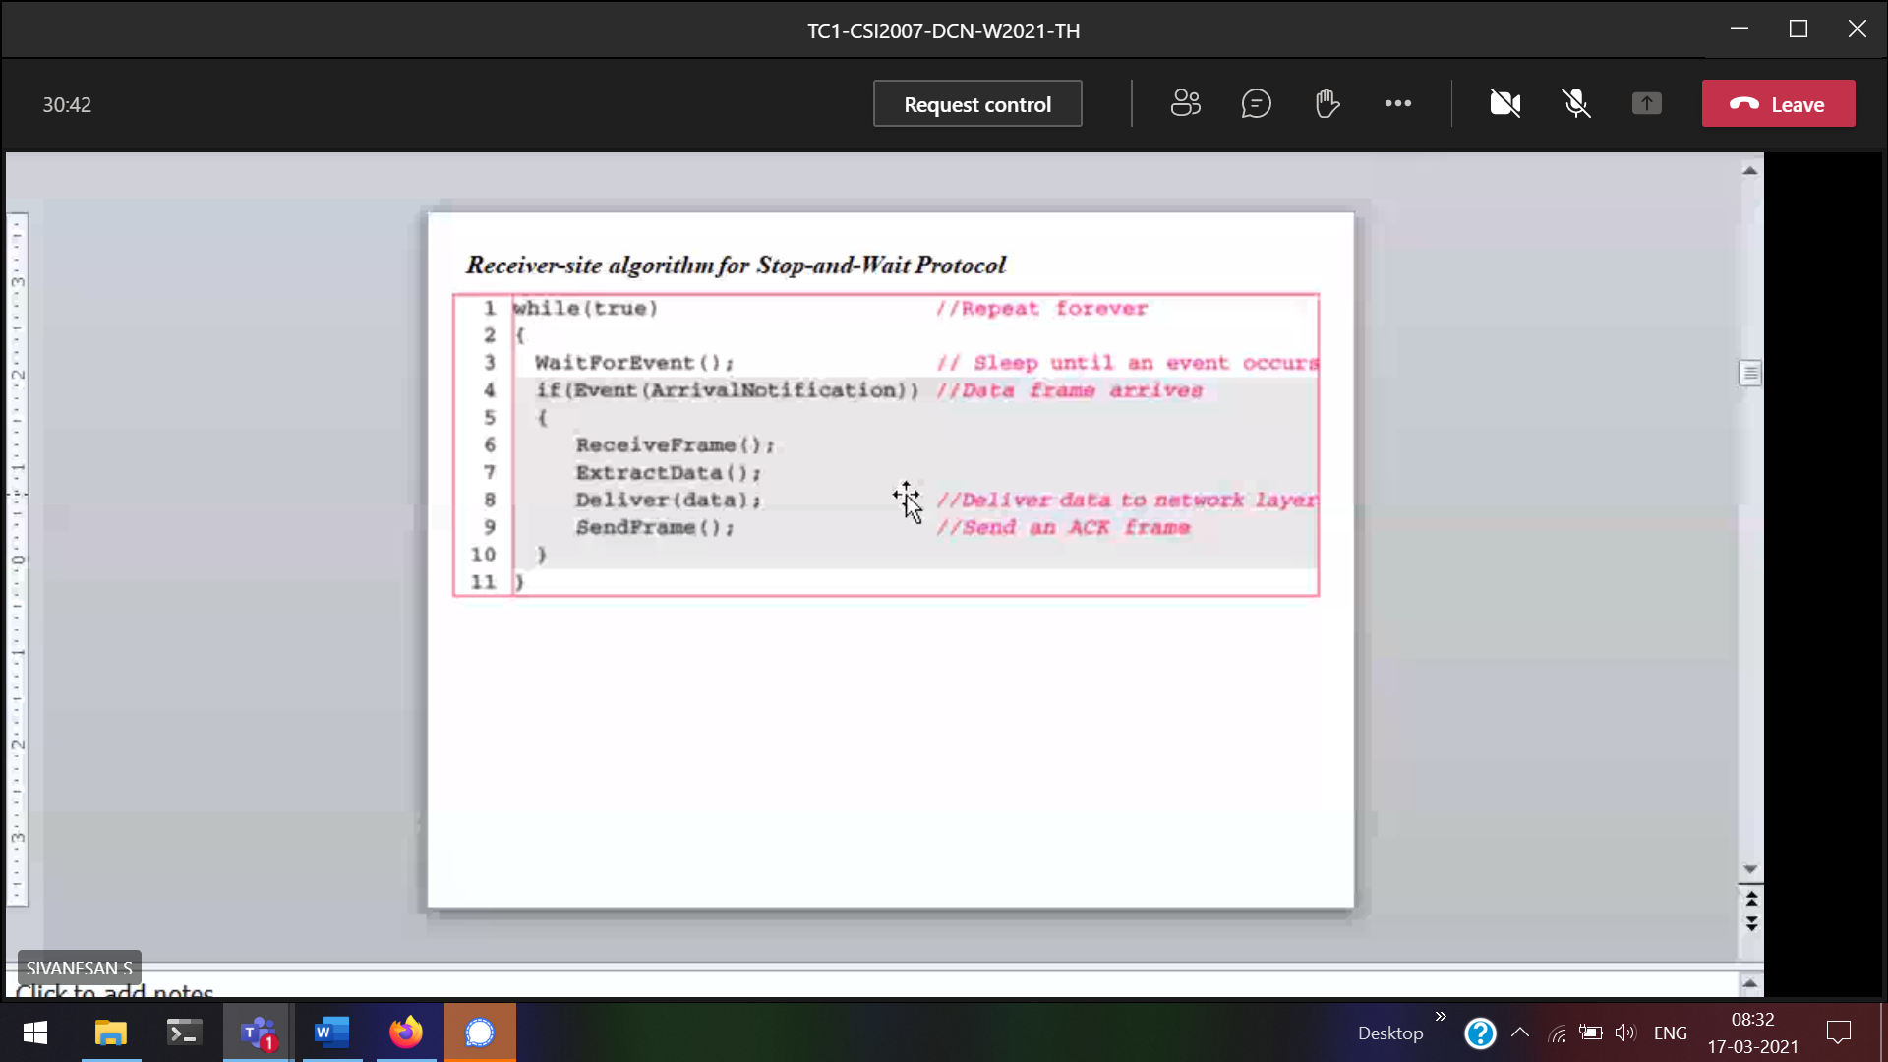

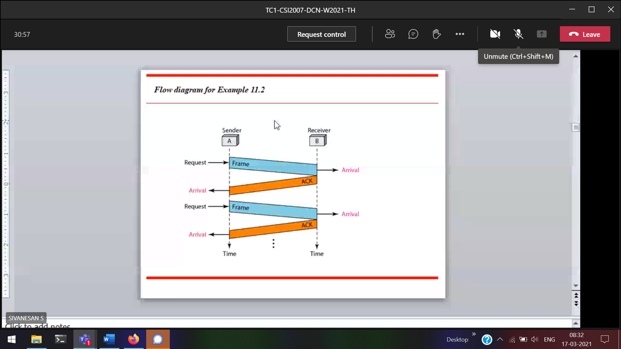

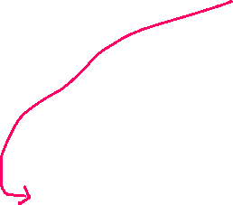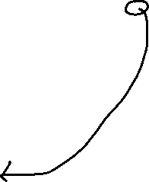

Back and forth flow

Immediate acknowledgement

Frame and delay since it is stopping and waiting.

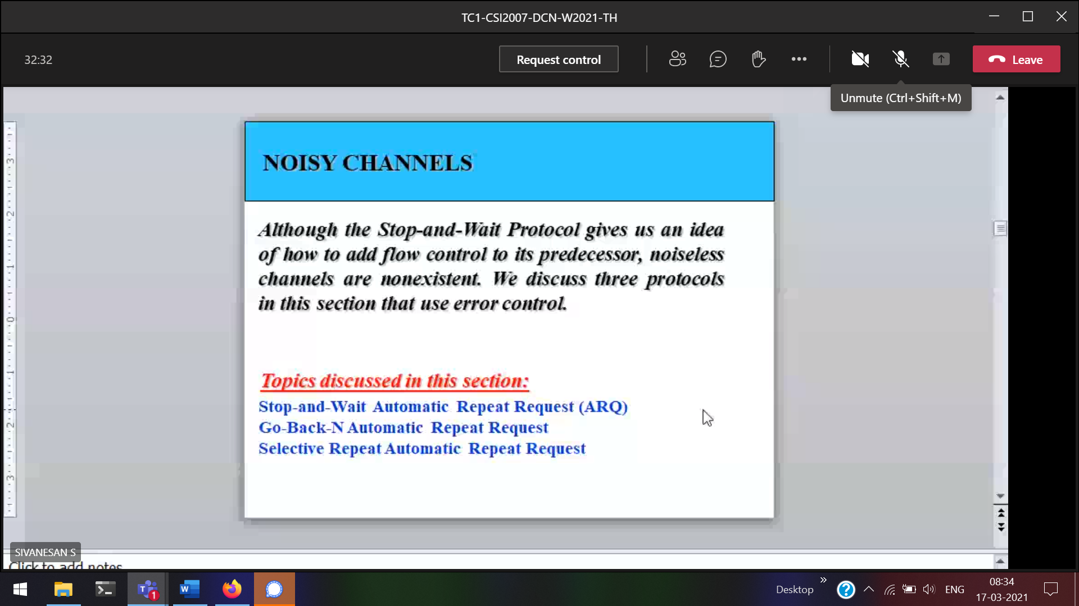

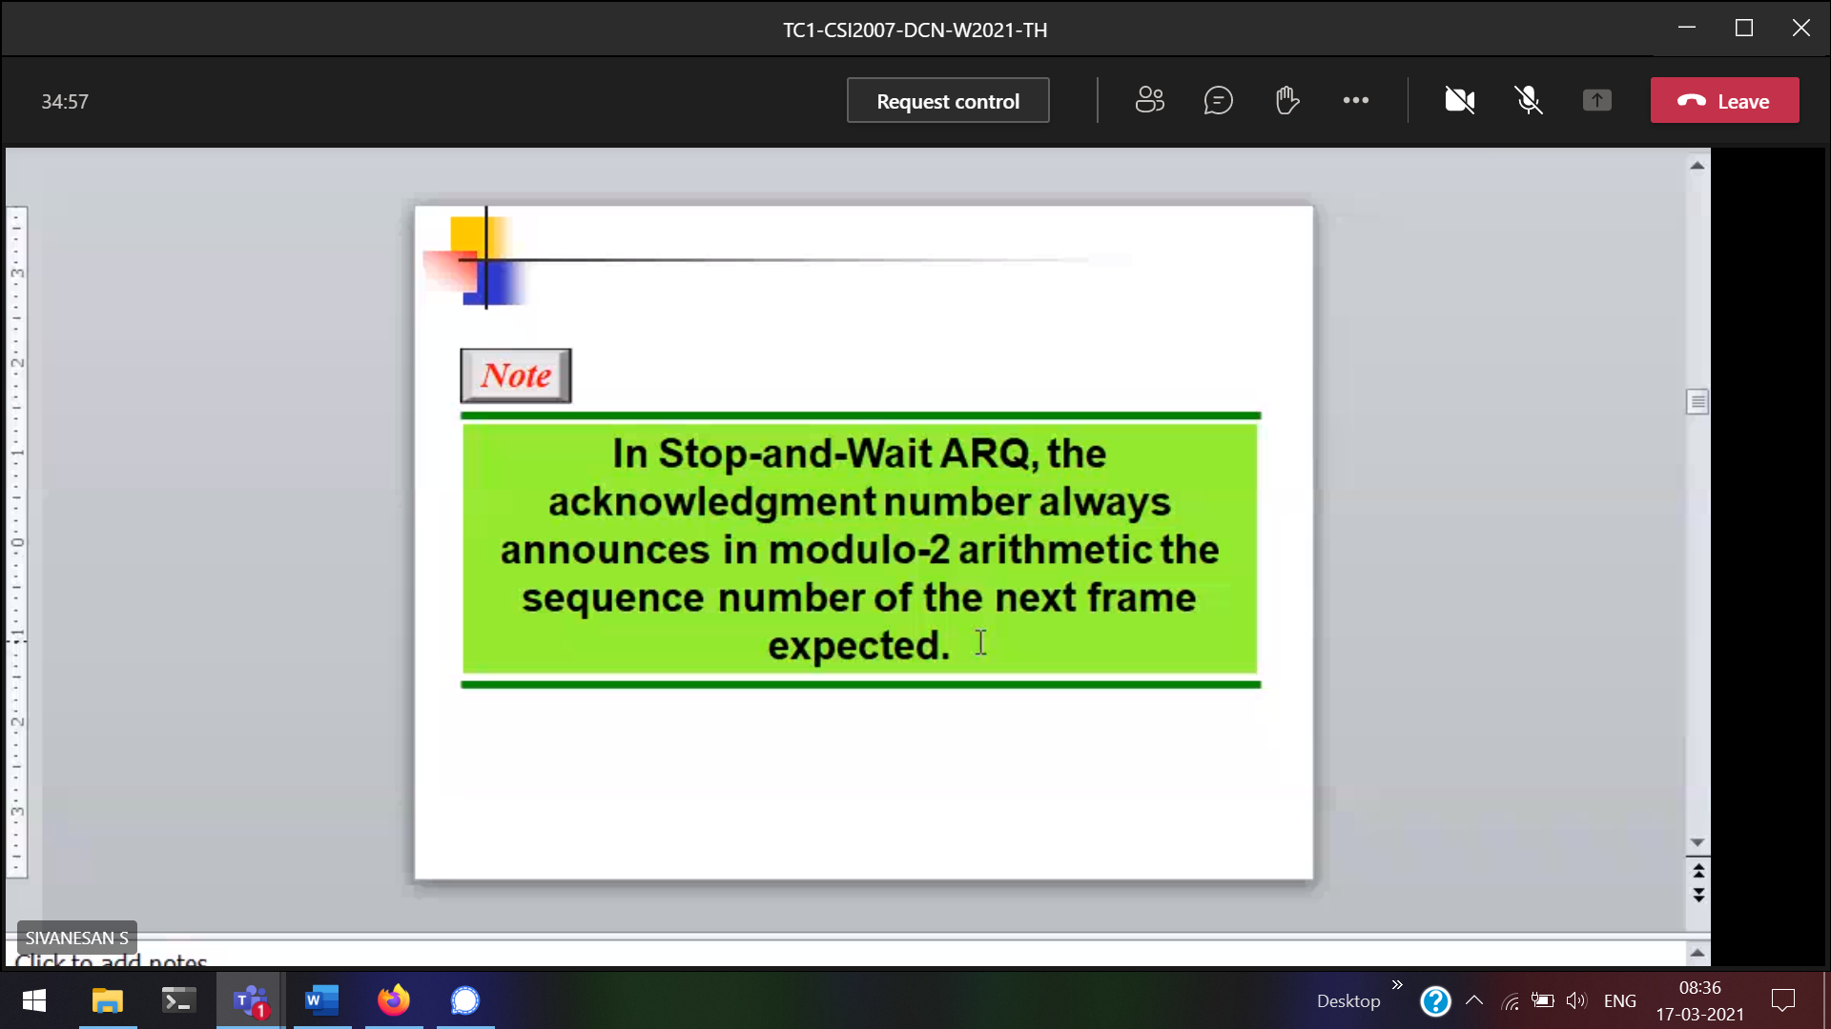

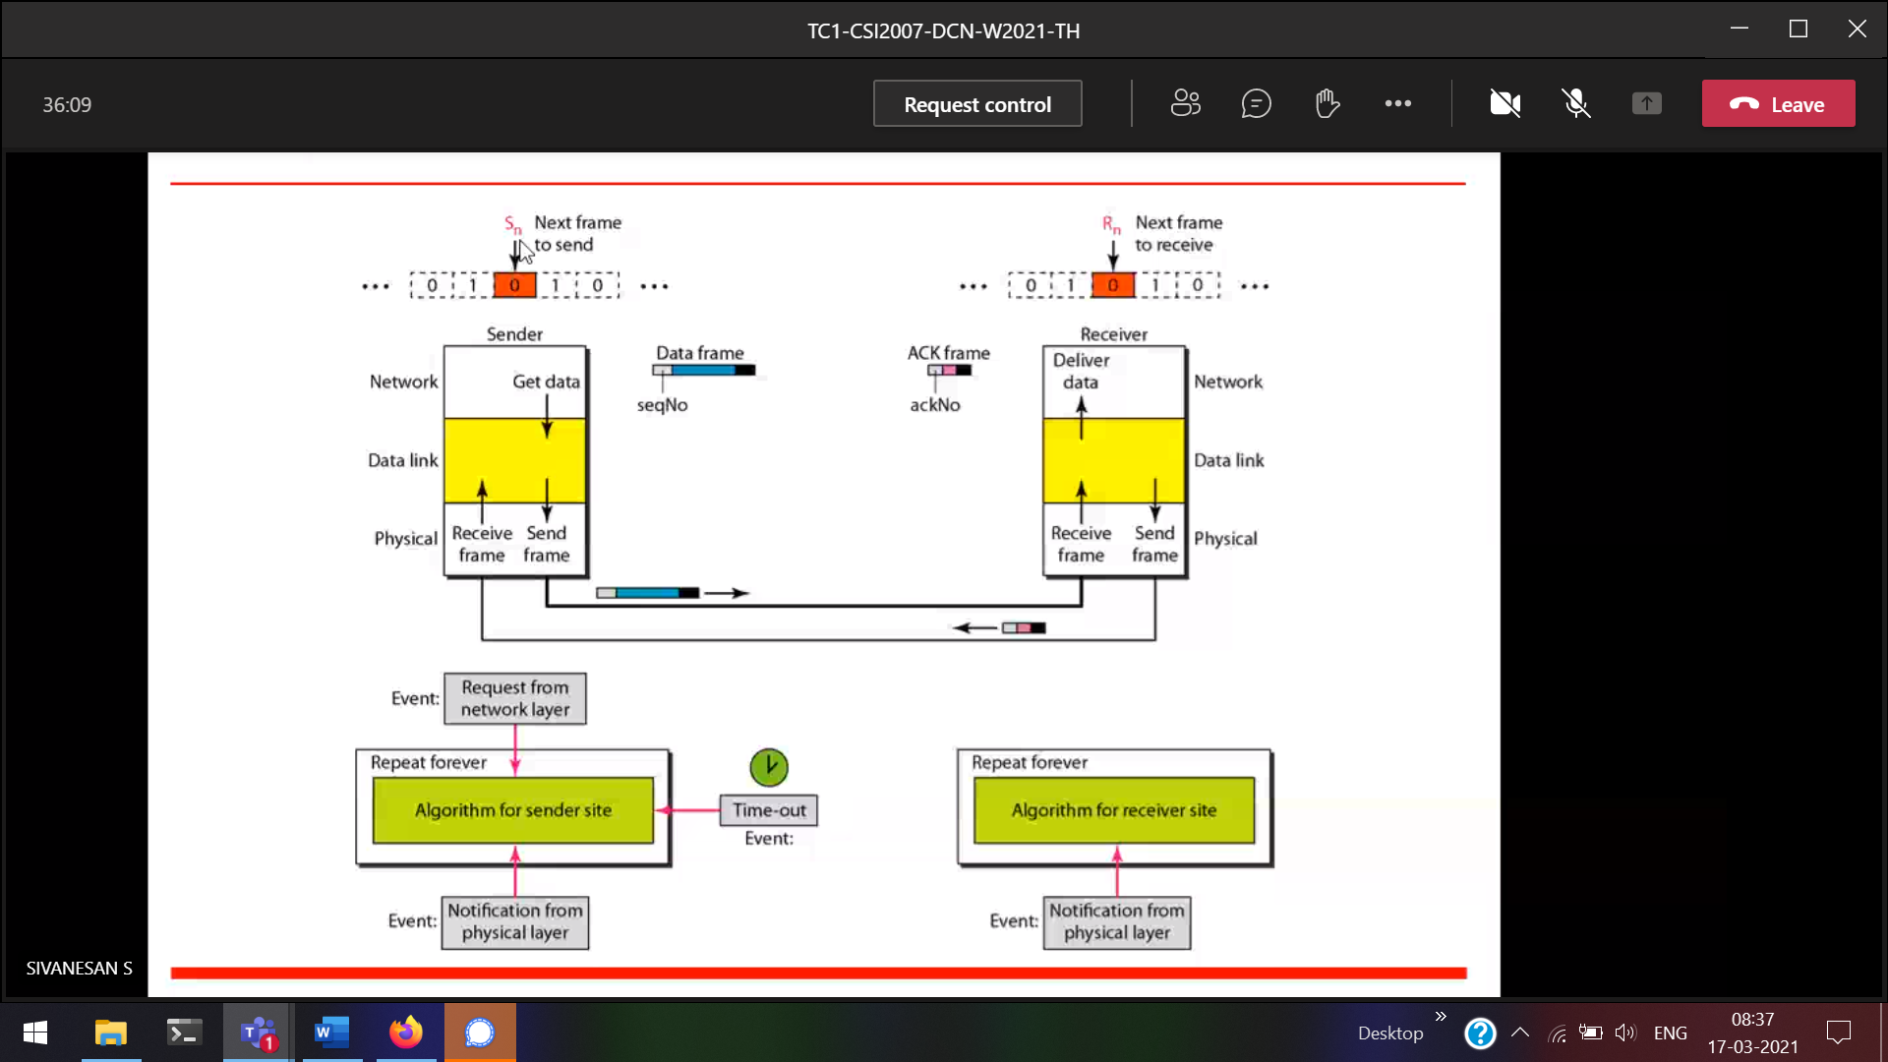

Data-frame 🡪 Sequence number + next frame (1 , 0)  
ACK frame 🡪 next frame (0)

Time out 🡪 must be there

Reason for not getting the acknowledgement  
1) If there is an error, in receiving the acknowledgement from the receiver the sender will wait infinitely.

2) Data is not at all sent to the receiver.  
So timer will be there for 5 seconds.  
IF I don’t receive the acknowledgement within the time period (5s ) sender will send the re-transit the same to the receiver.

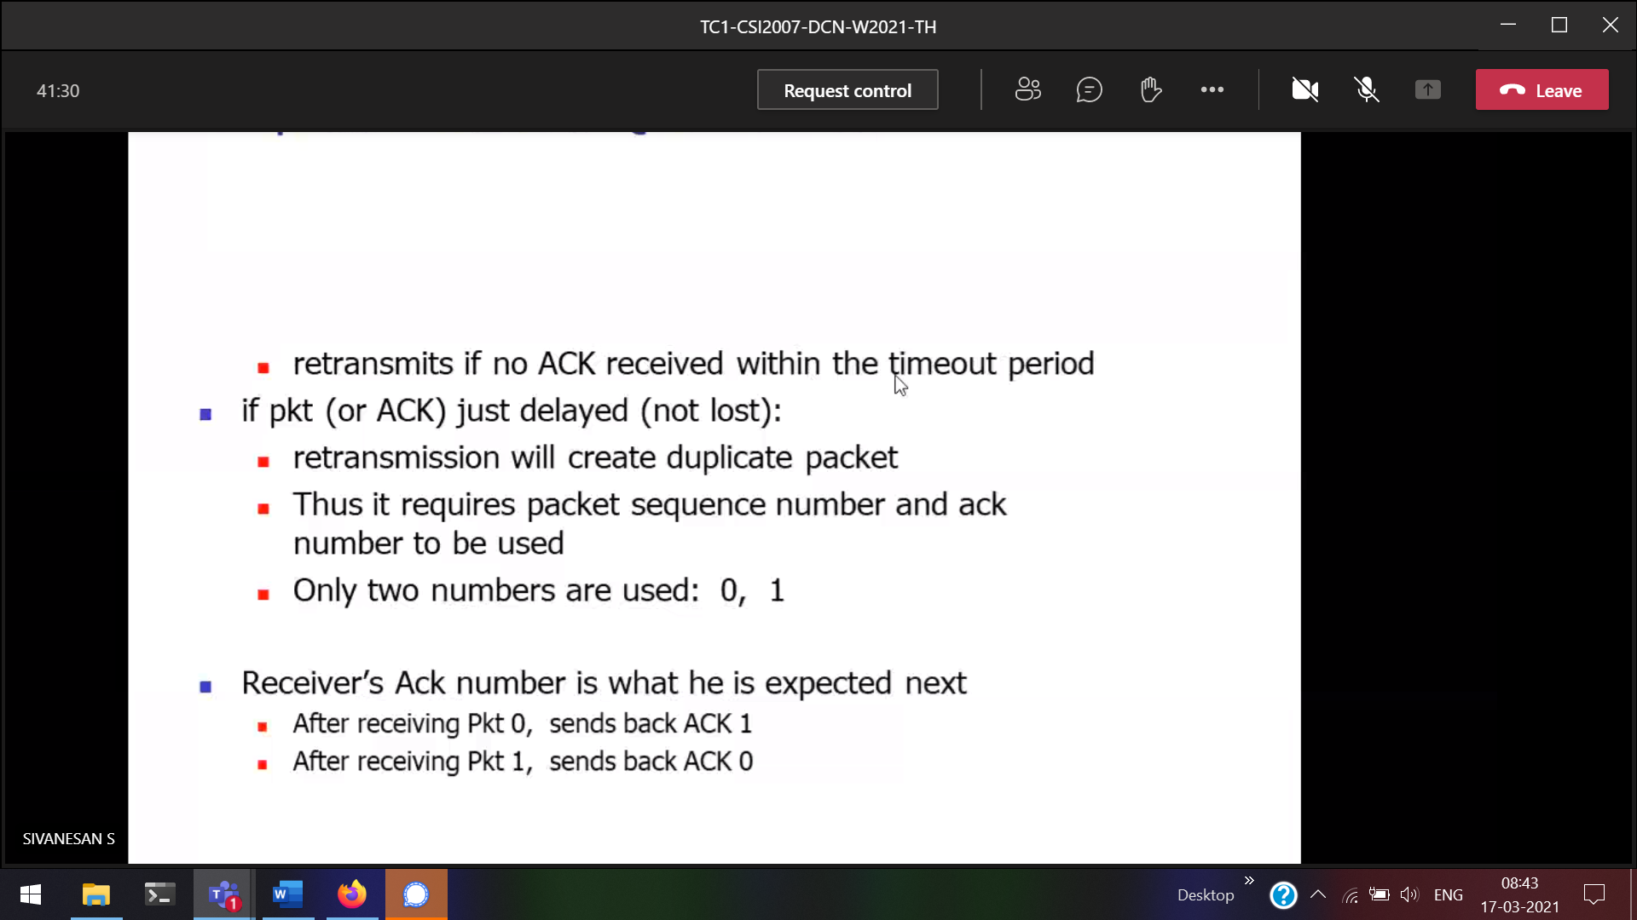

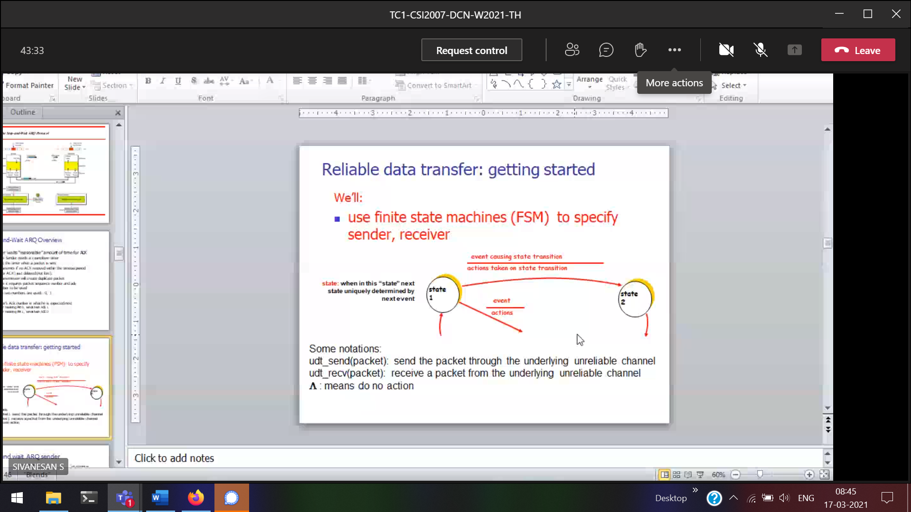

Event 🡪 acknowledgement (to go from 1 state to another state)

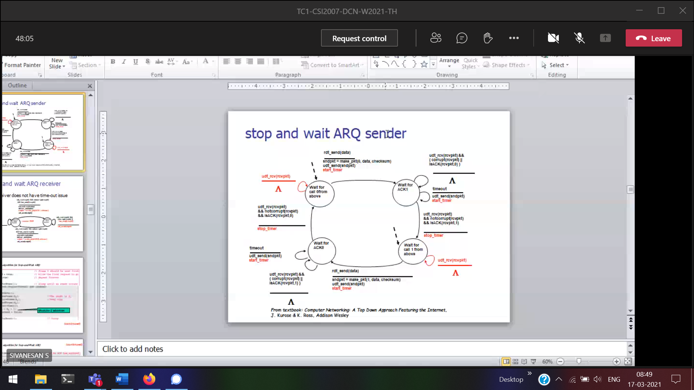

Based on the event the rules will be formed

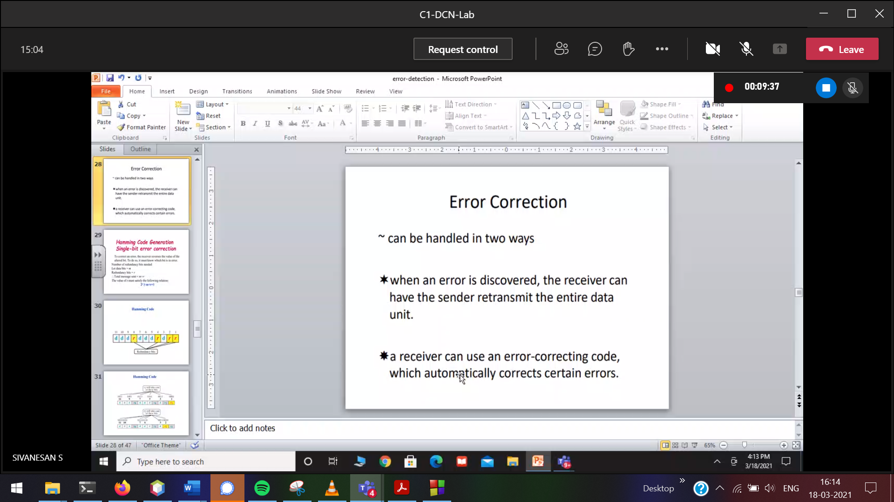

Retransmission 🡪Sender wants to send gain if error  
Auto-correction 🡪 Sender doesn’t want to send gain if error, but should give some extra info/redundant info (i.e parity etc) to remove the erraneous error.

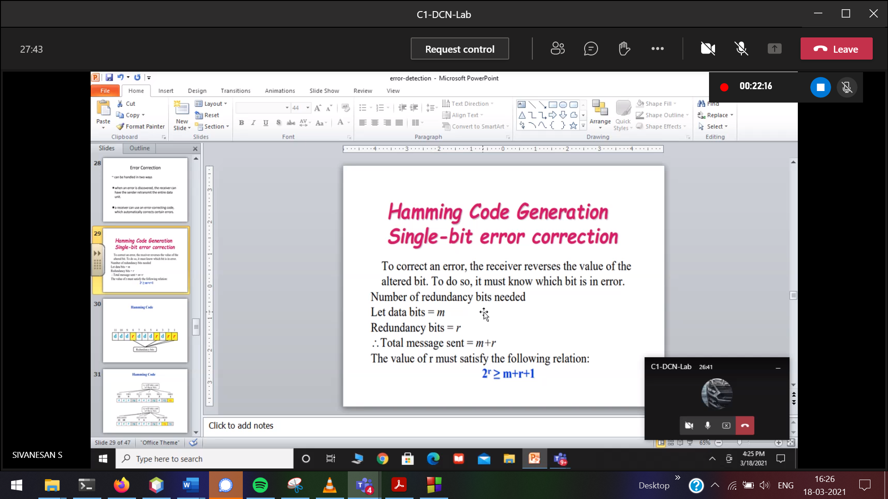

Redundant bits similar to parity bits

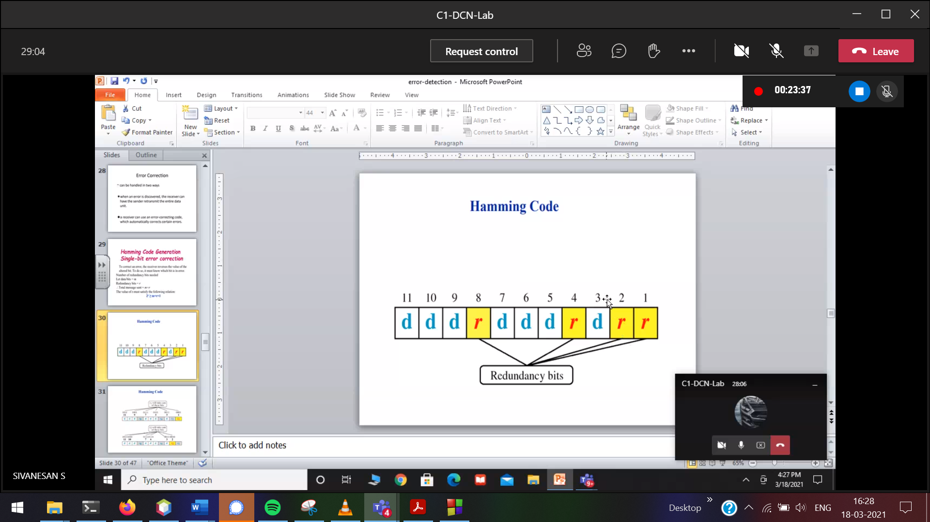

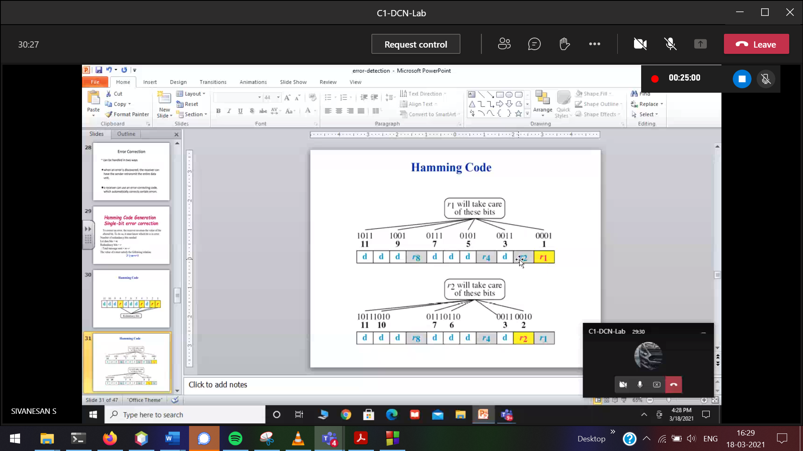 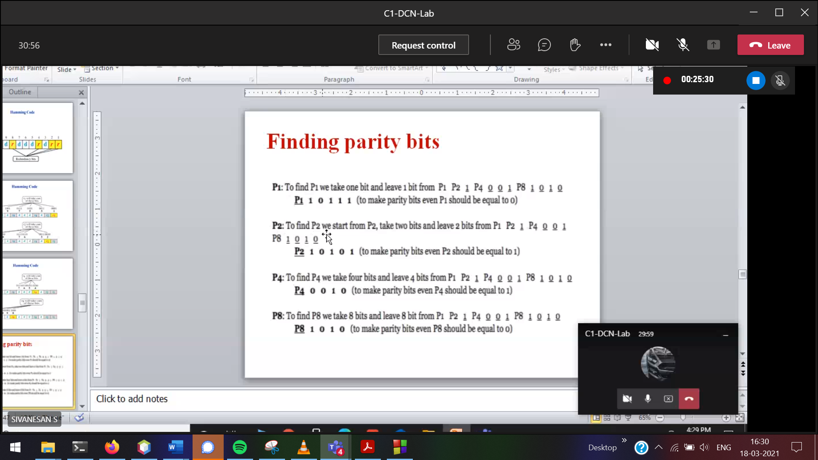

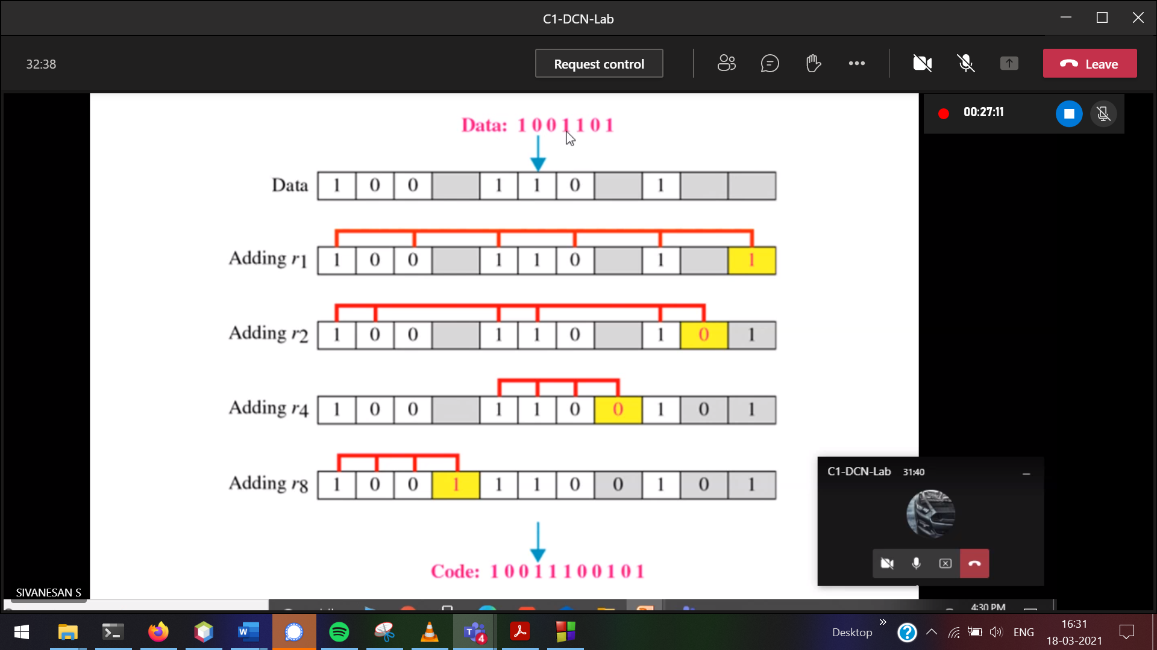



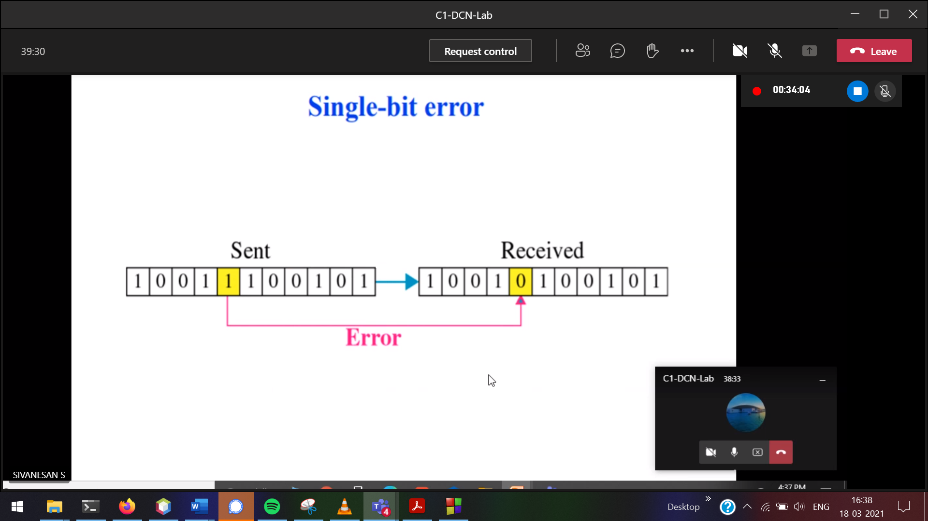

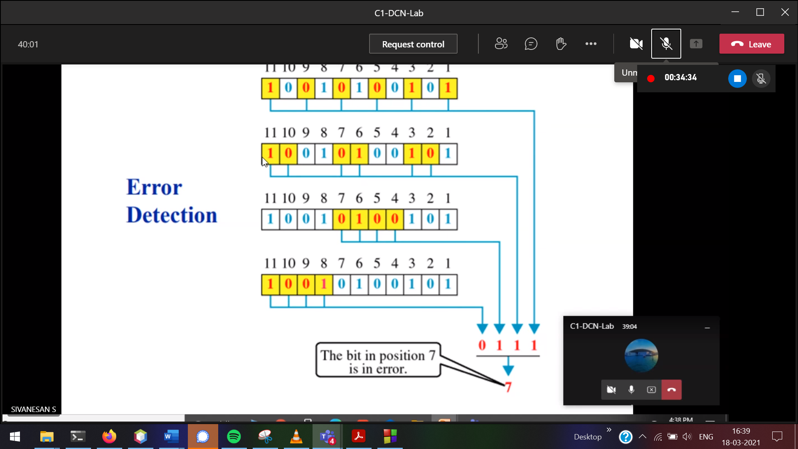

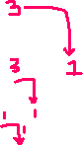

Change the 7th bit in the receiver data ( go from LSB)   
Flip 0 to 1 / 1 to 0

In binary we changed   
Bu what to do in decimal???

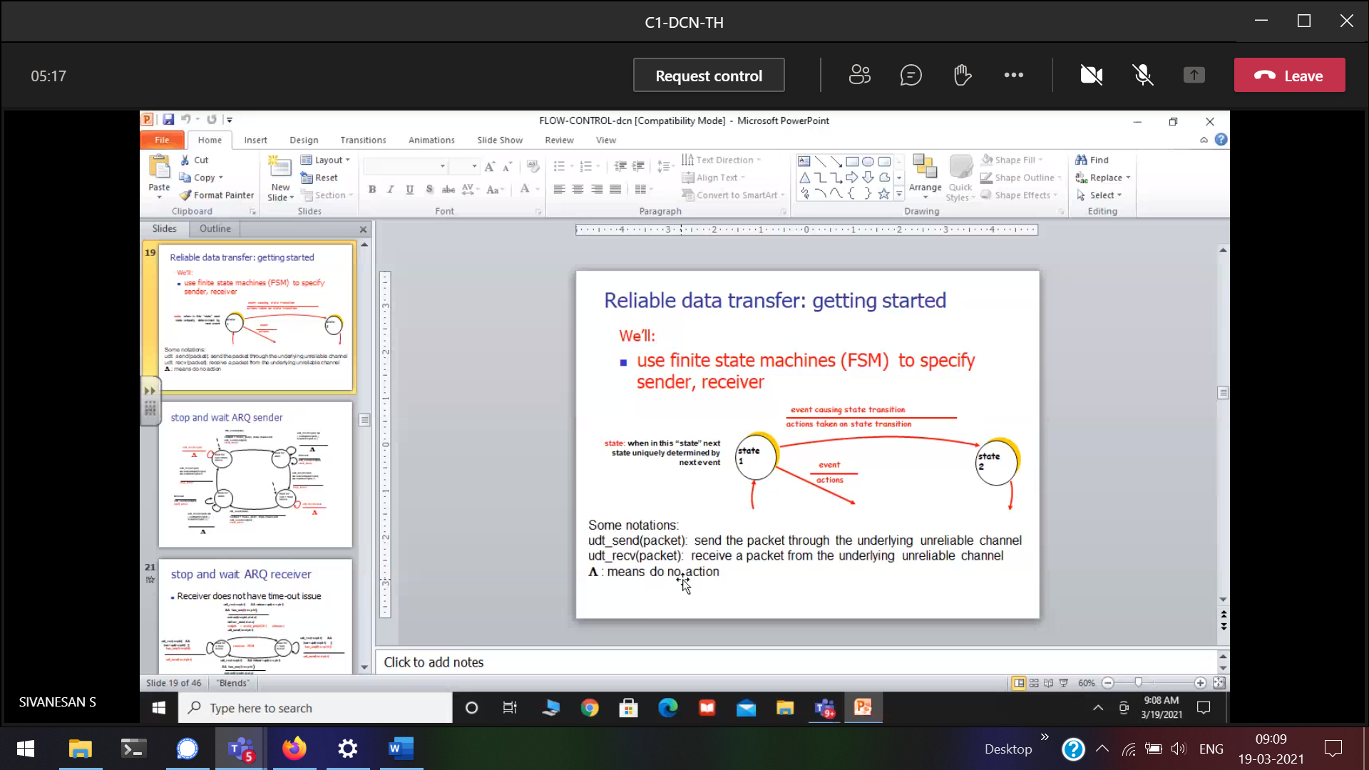

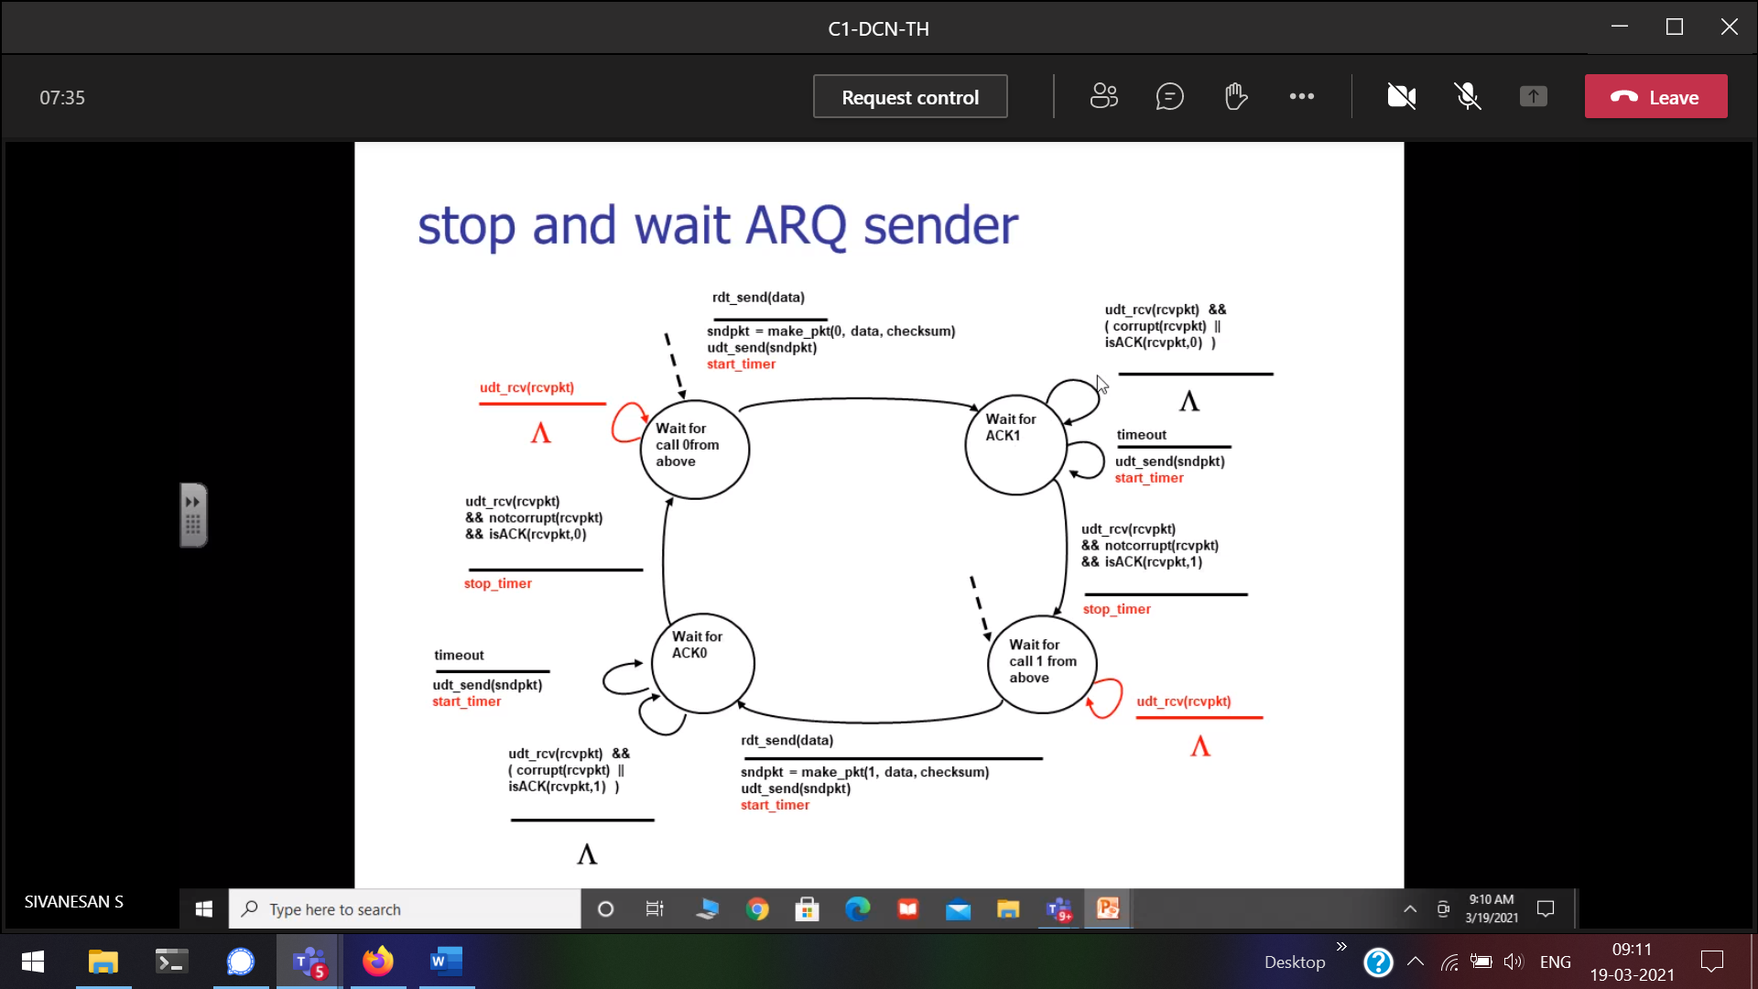

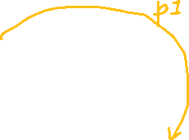

Above 🡪

Literal meaning 🡪 no difference. But technically the difference,  
stop 🡪 not going to continue to send the frame, will not look for acknowledgement.  
wait 🡪 wait for acknowledgement

Sender 🡪 network to physical   
Receiver 🡪 physical to network

The moment your going to send a frame 🡪 start the timer

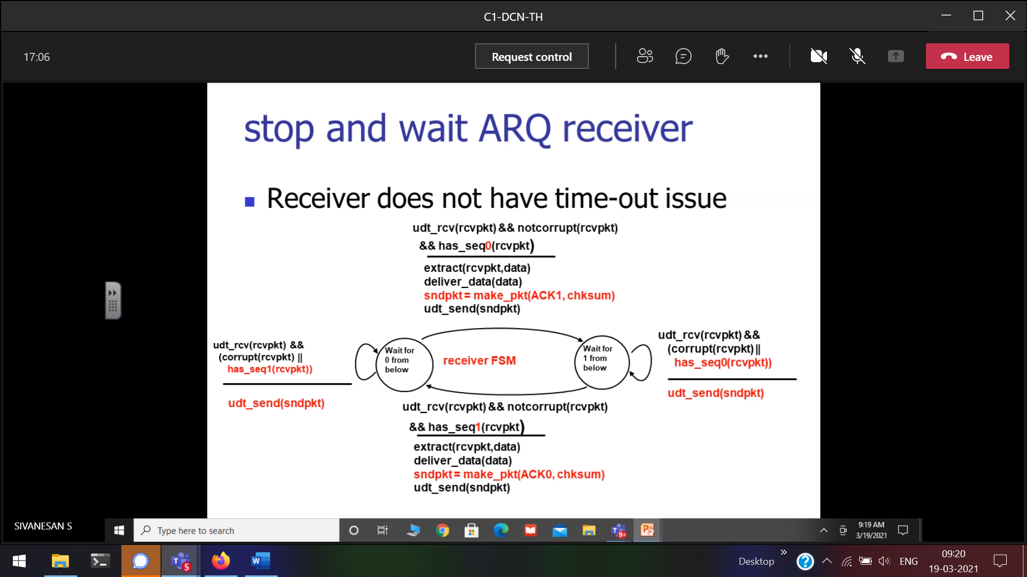



Below 🡪 physical layer

Receiever will check if the data is correction free, no time lag problem, no problem of acknowledgement

deliver_data

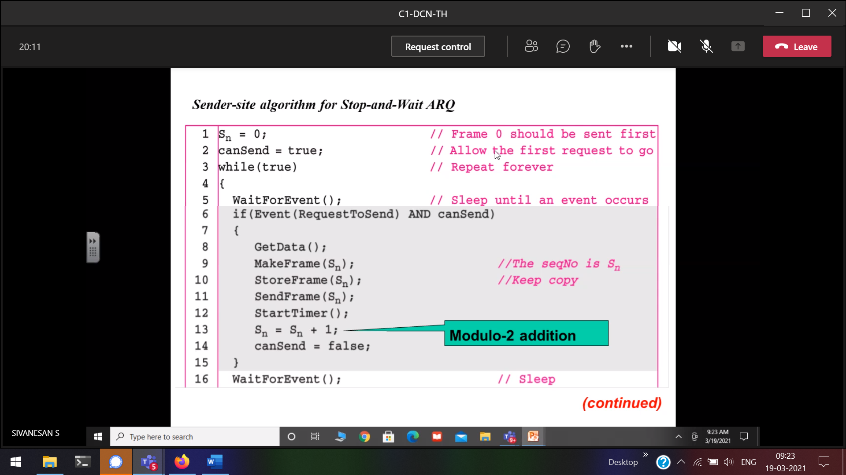

If I make cansend = false, without acknowlegemenet sender will sen the data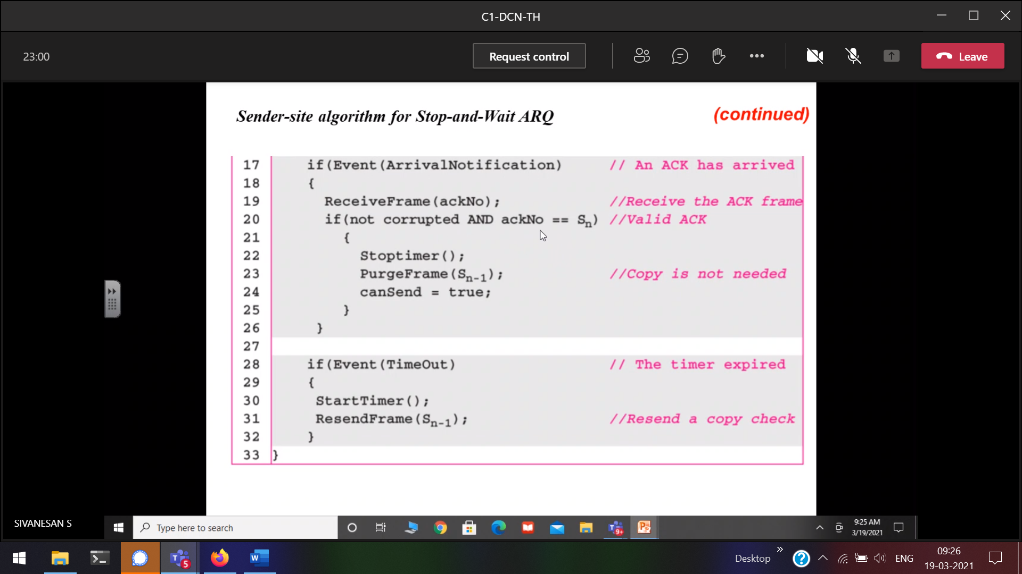

PurgeFrame(Sn-1) 🡪 removing the frames from the queue

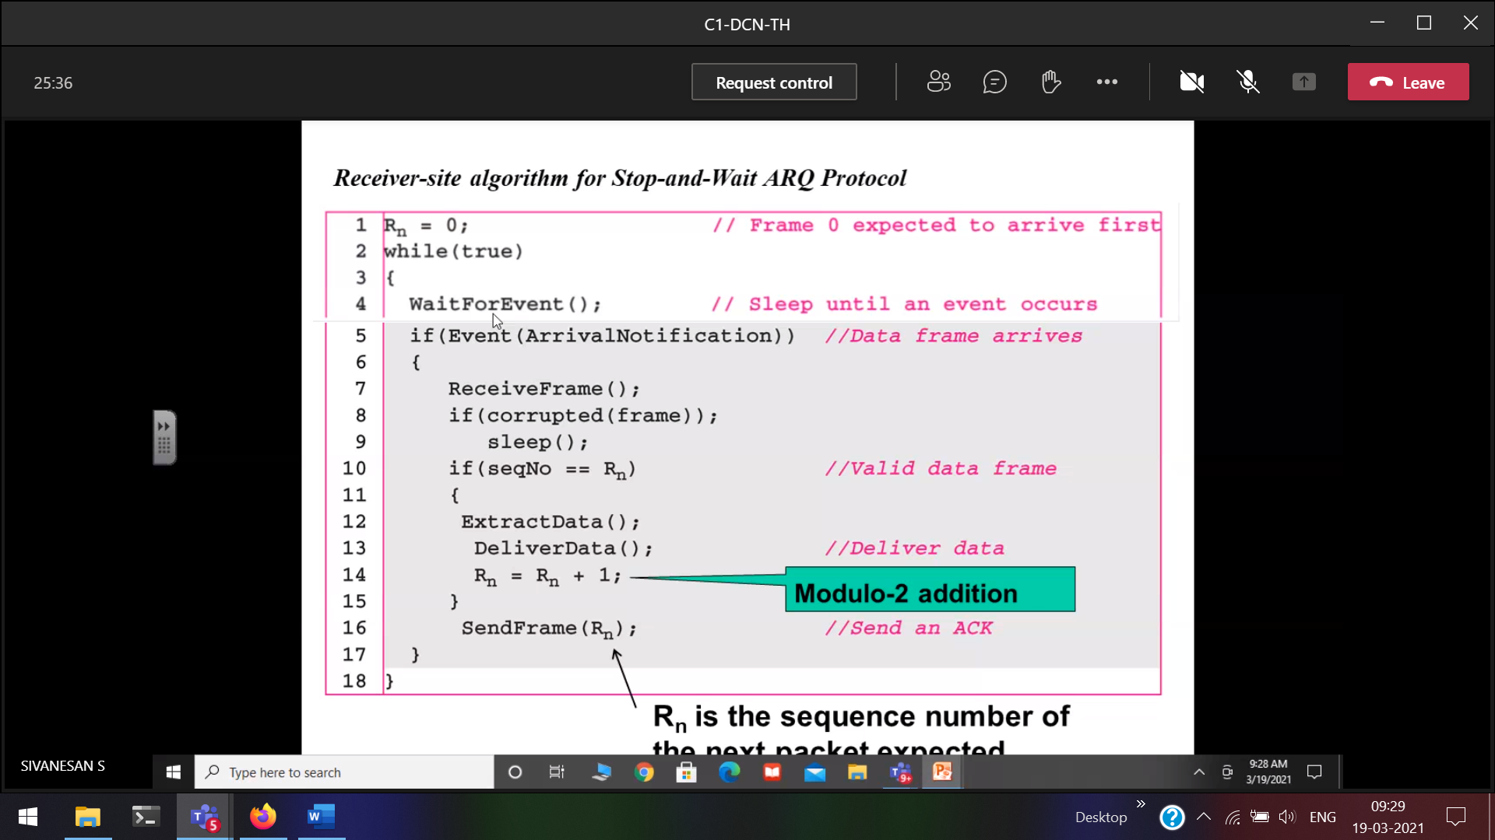

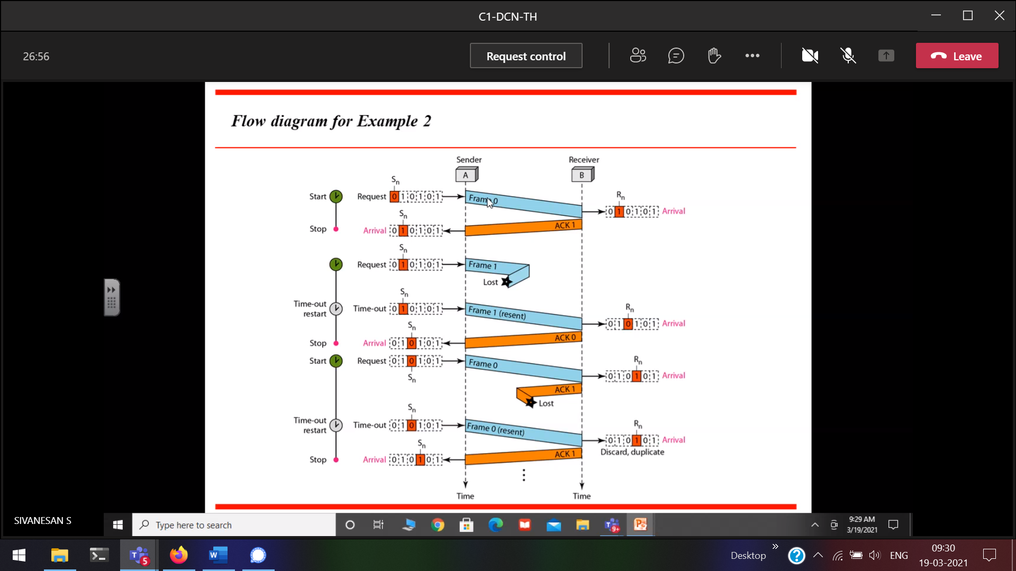

Rn 🡪 will decide the acknowledgement

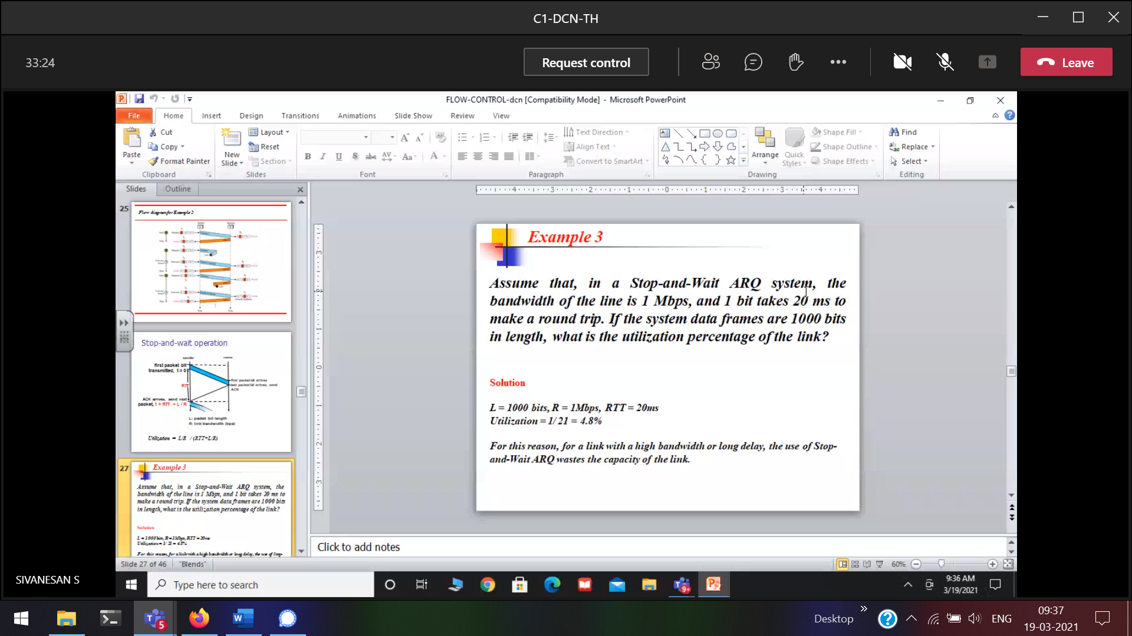

Roundtrip moving from sender to receiver , from receiver to sender

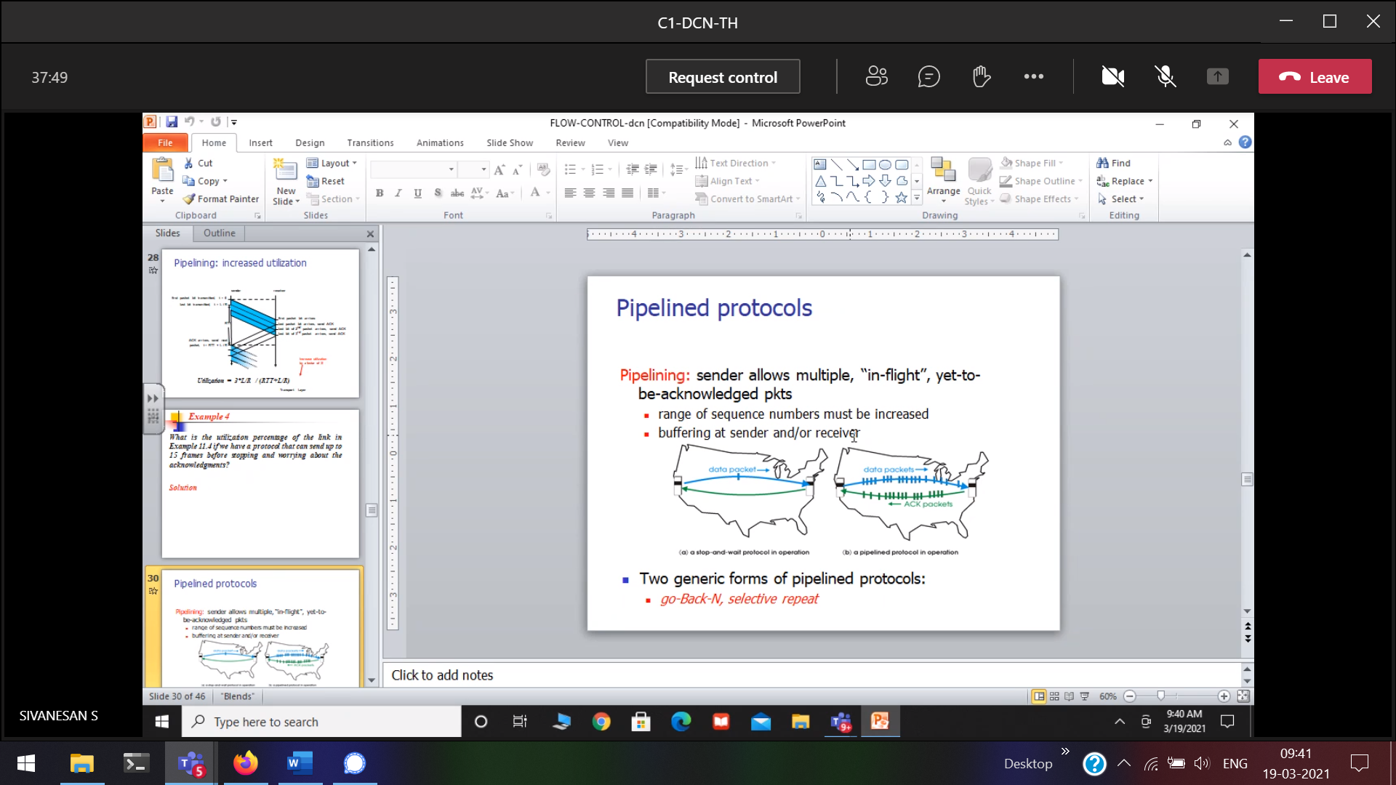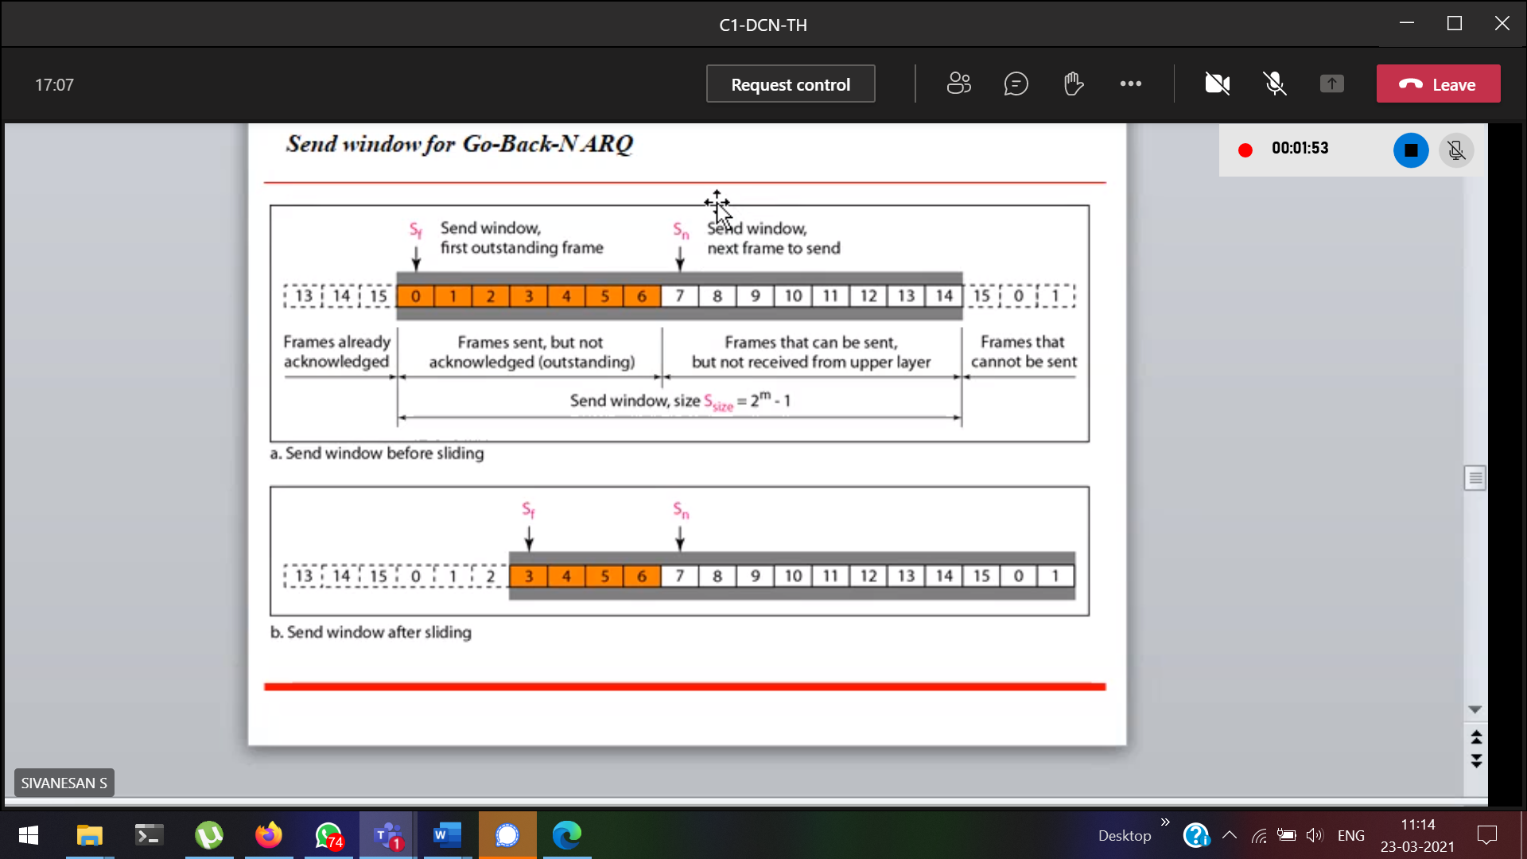

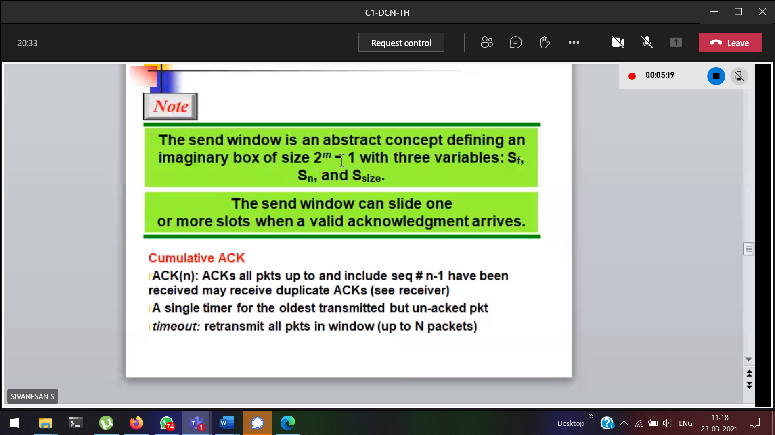

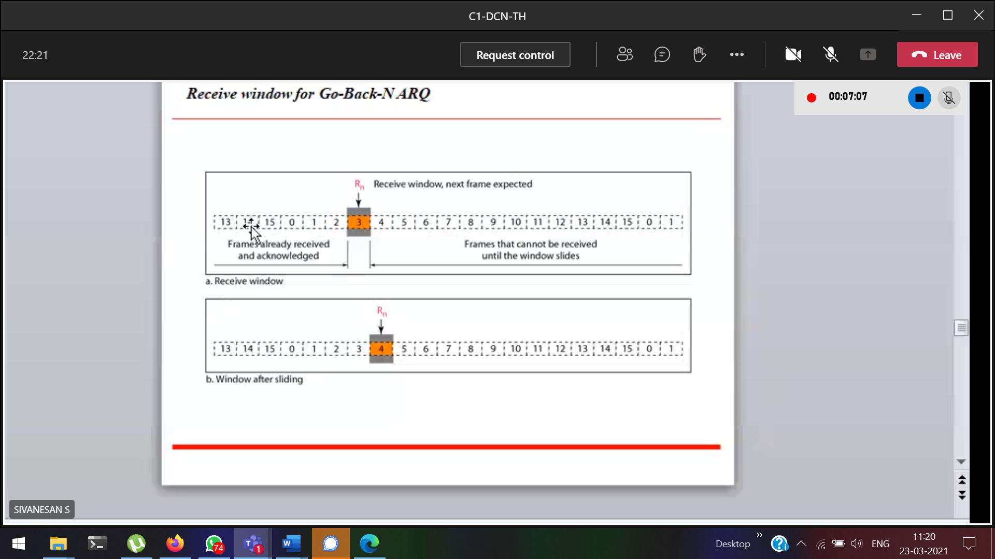

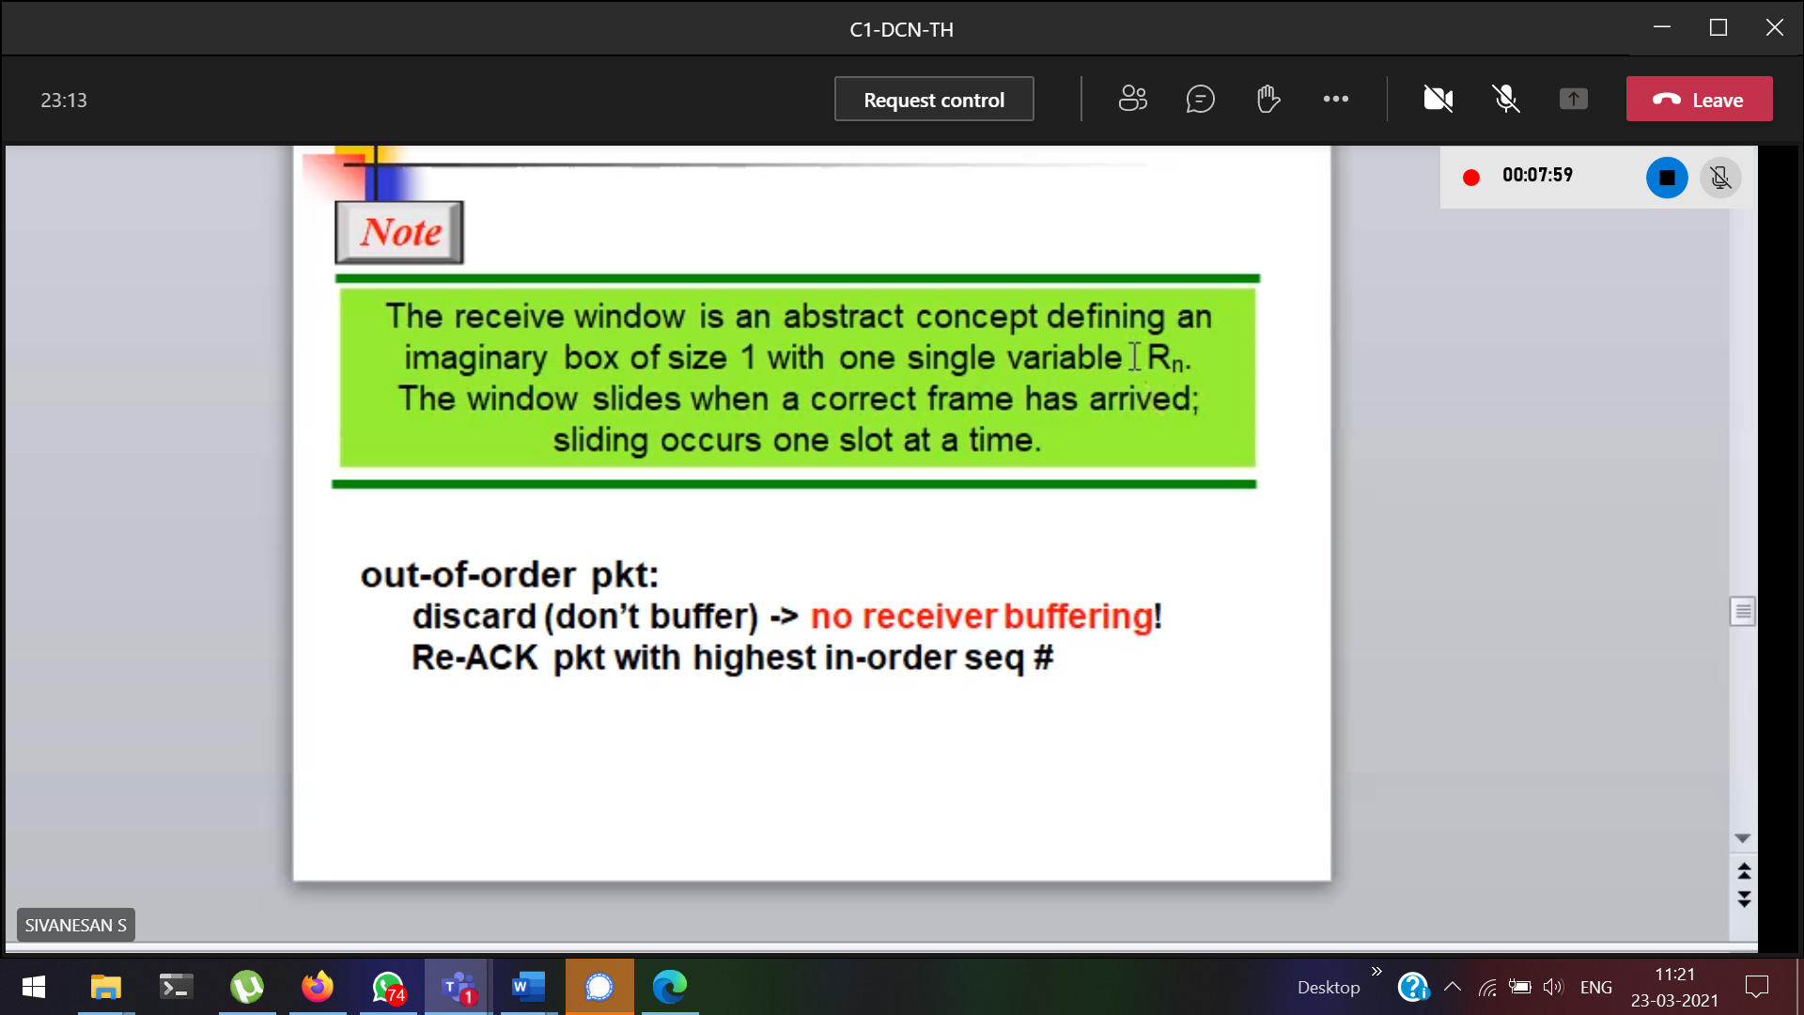

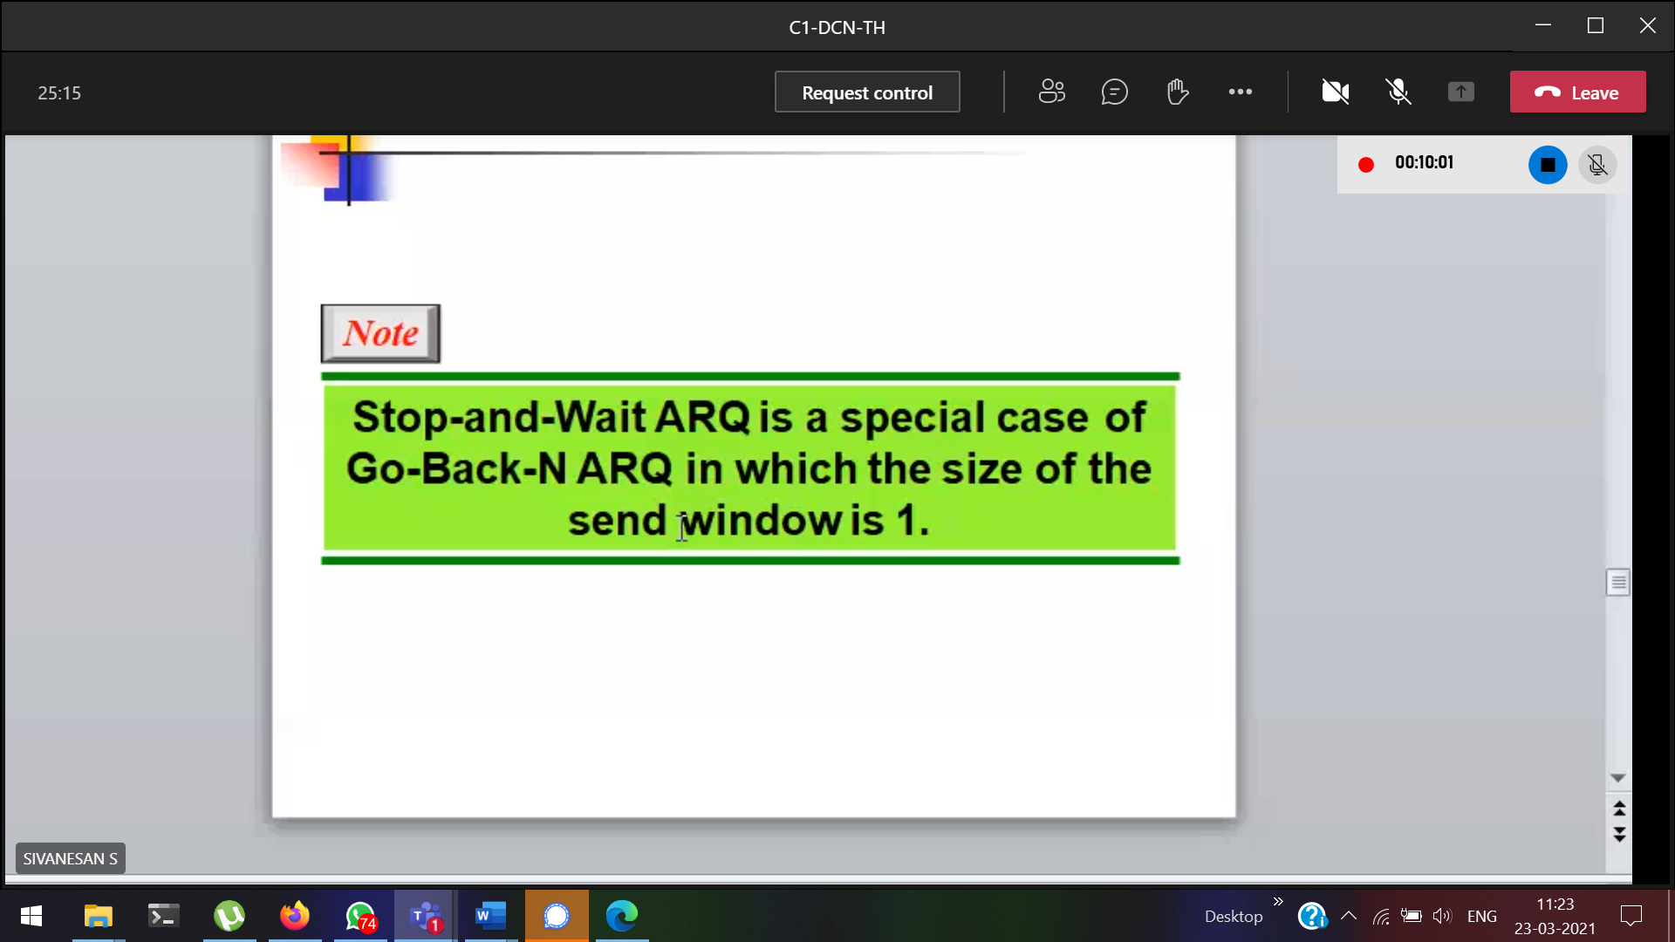

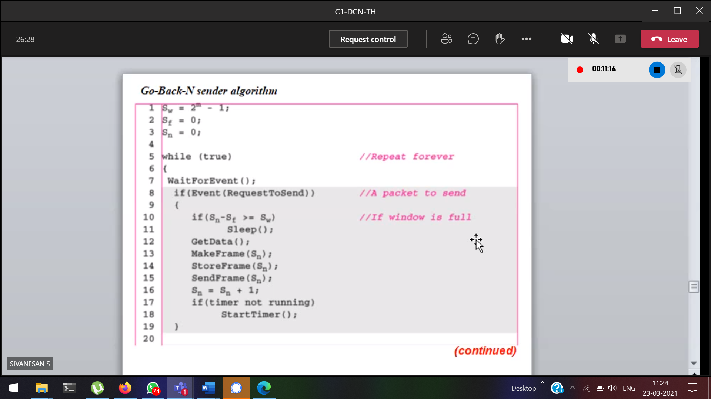

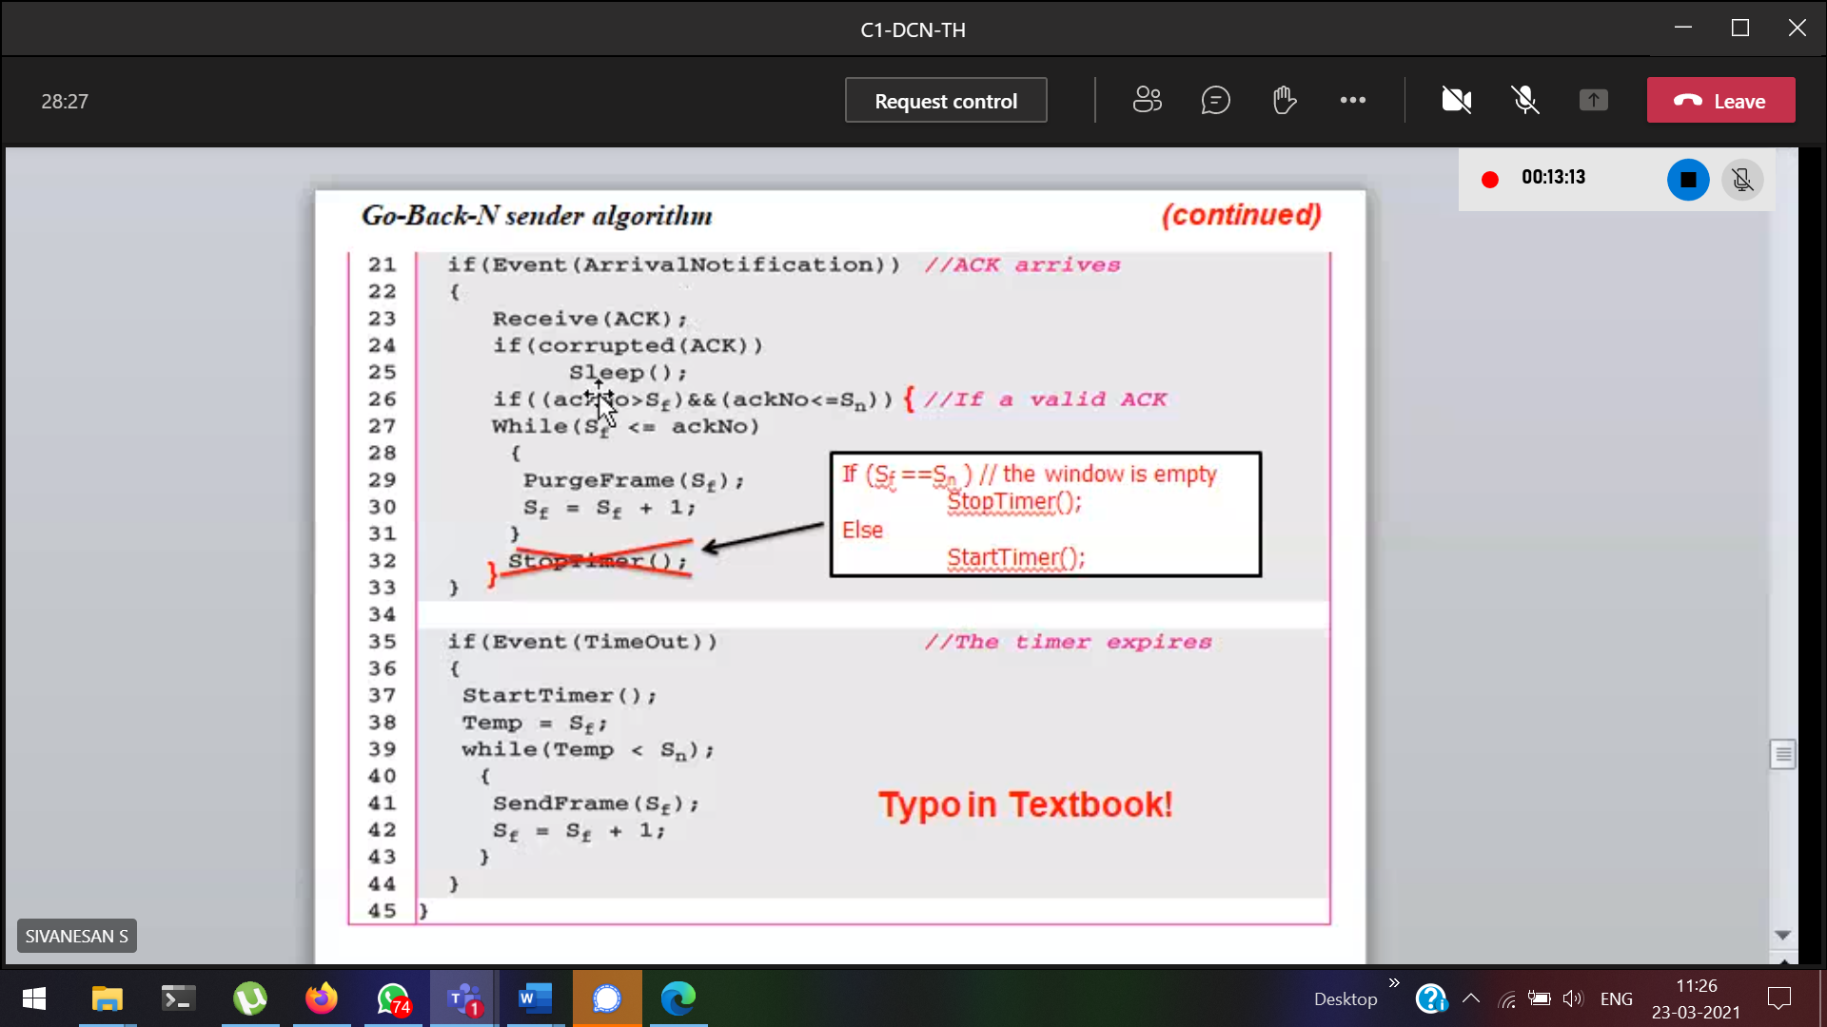



For sending frame0, we received the acknowledement as 1

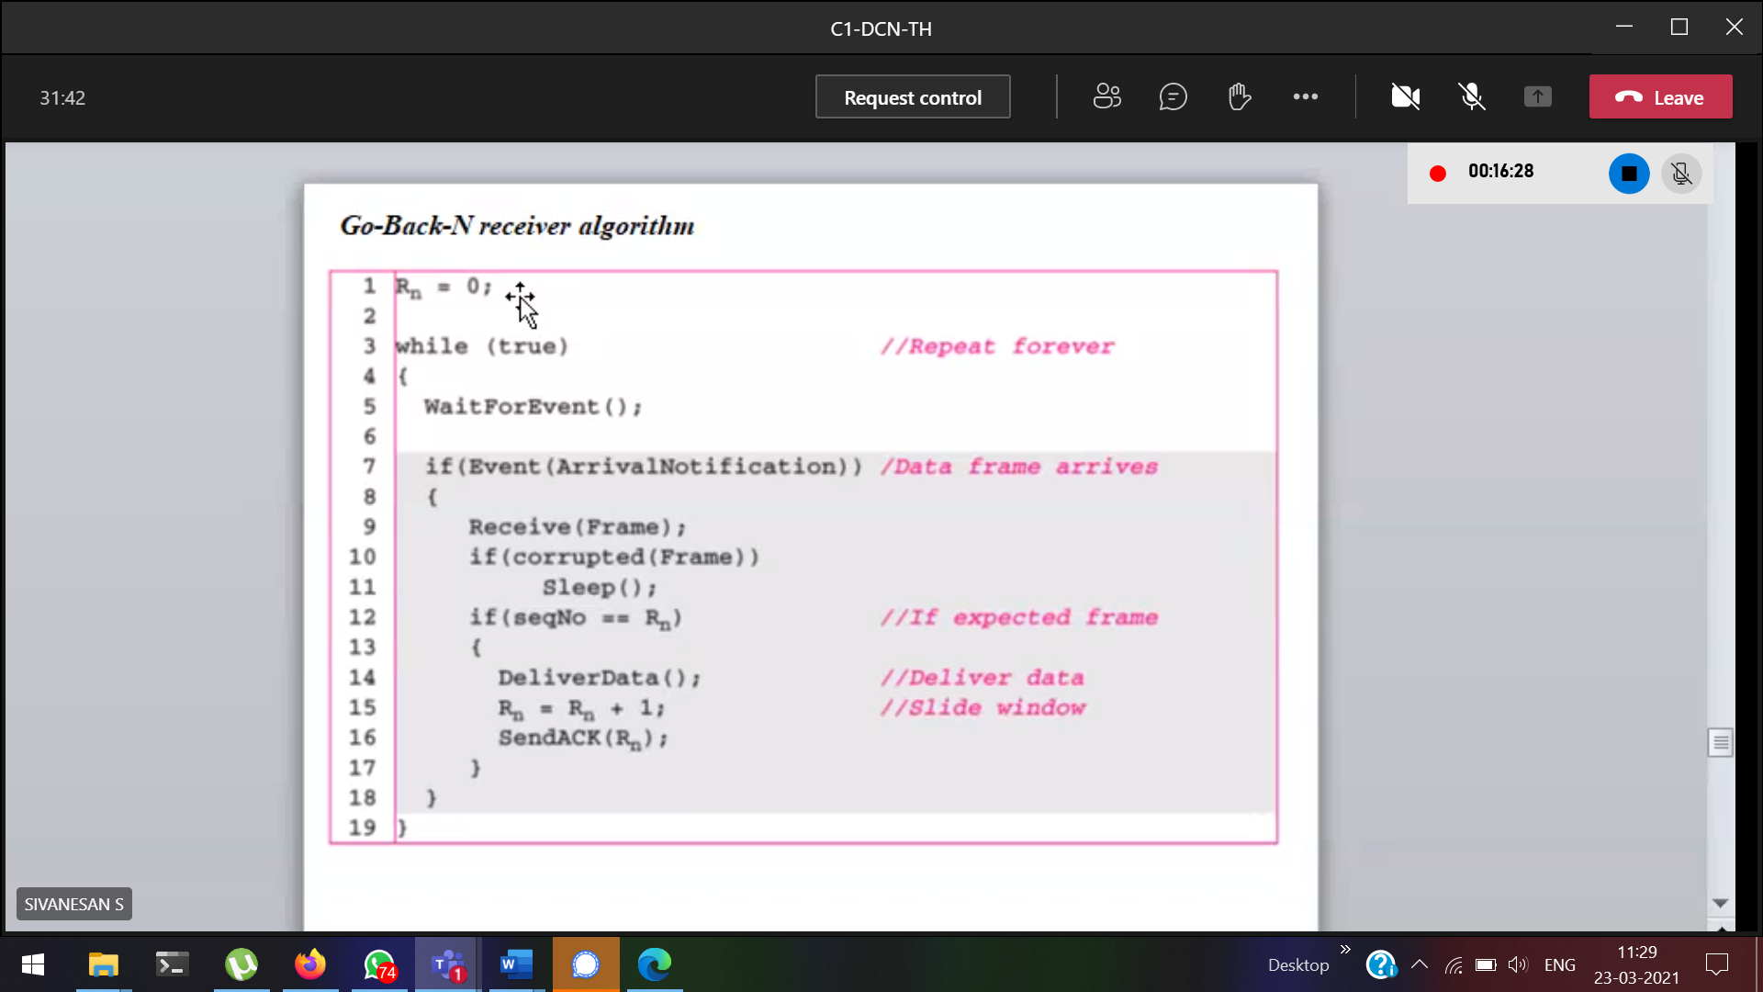

Received the frame 0, and sending acknowledement as 1

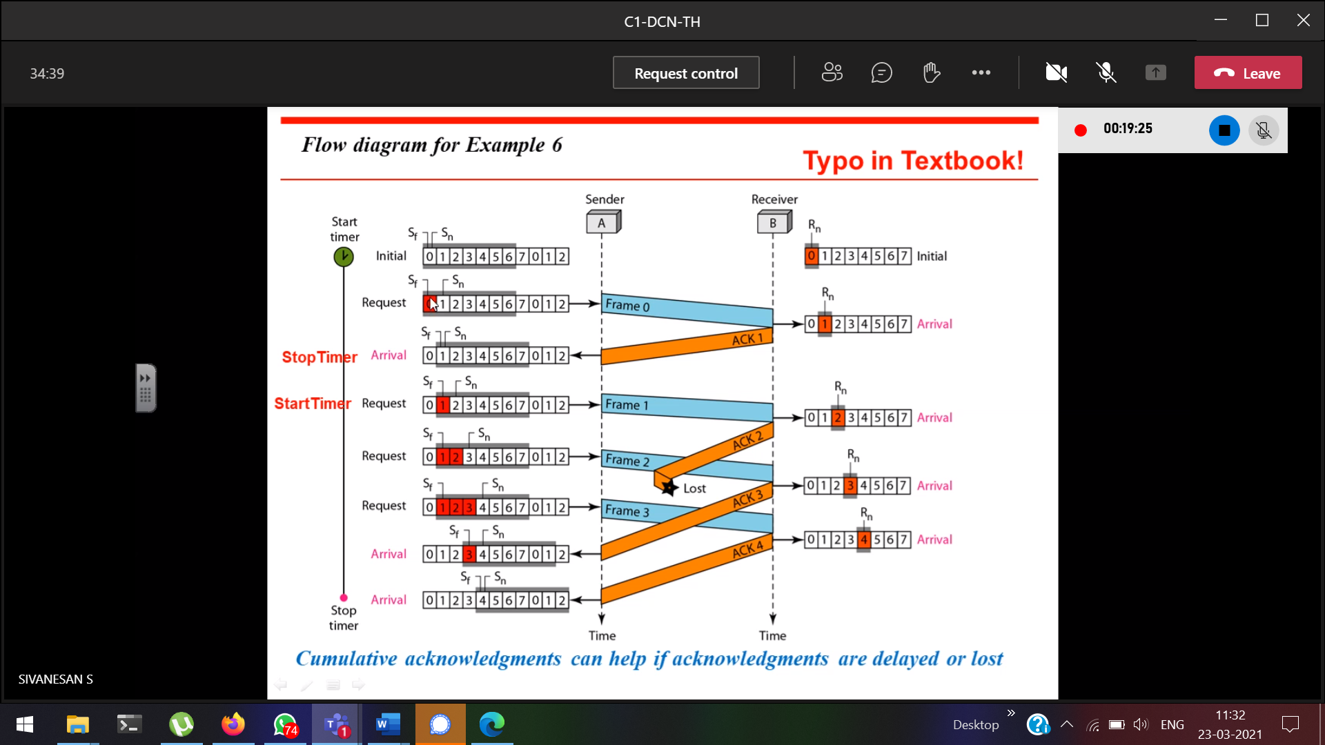

Sf 🡪 frames where we didn’t receive the acknowledgement

After receiving 3,4 the sender can assume that 2 also will be received. Though we didn’t get the acknowledgement for 2.  
Rn will keep the track whether we received the data

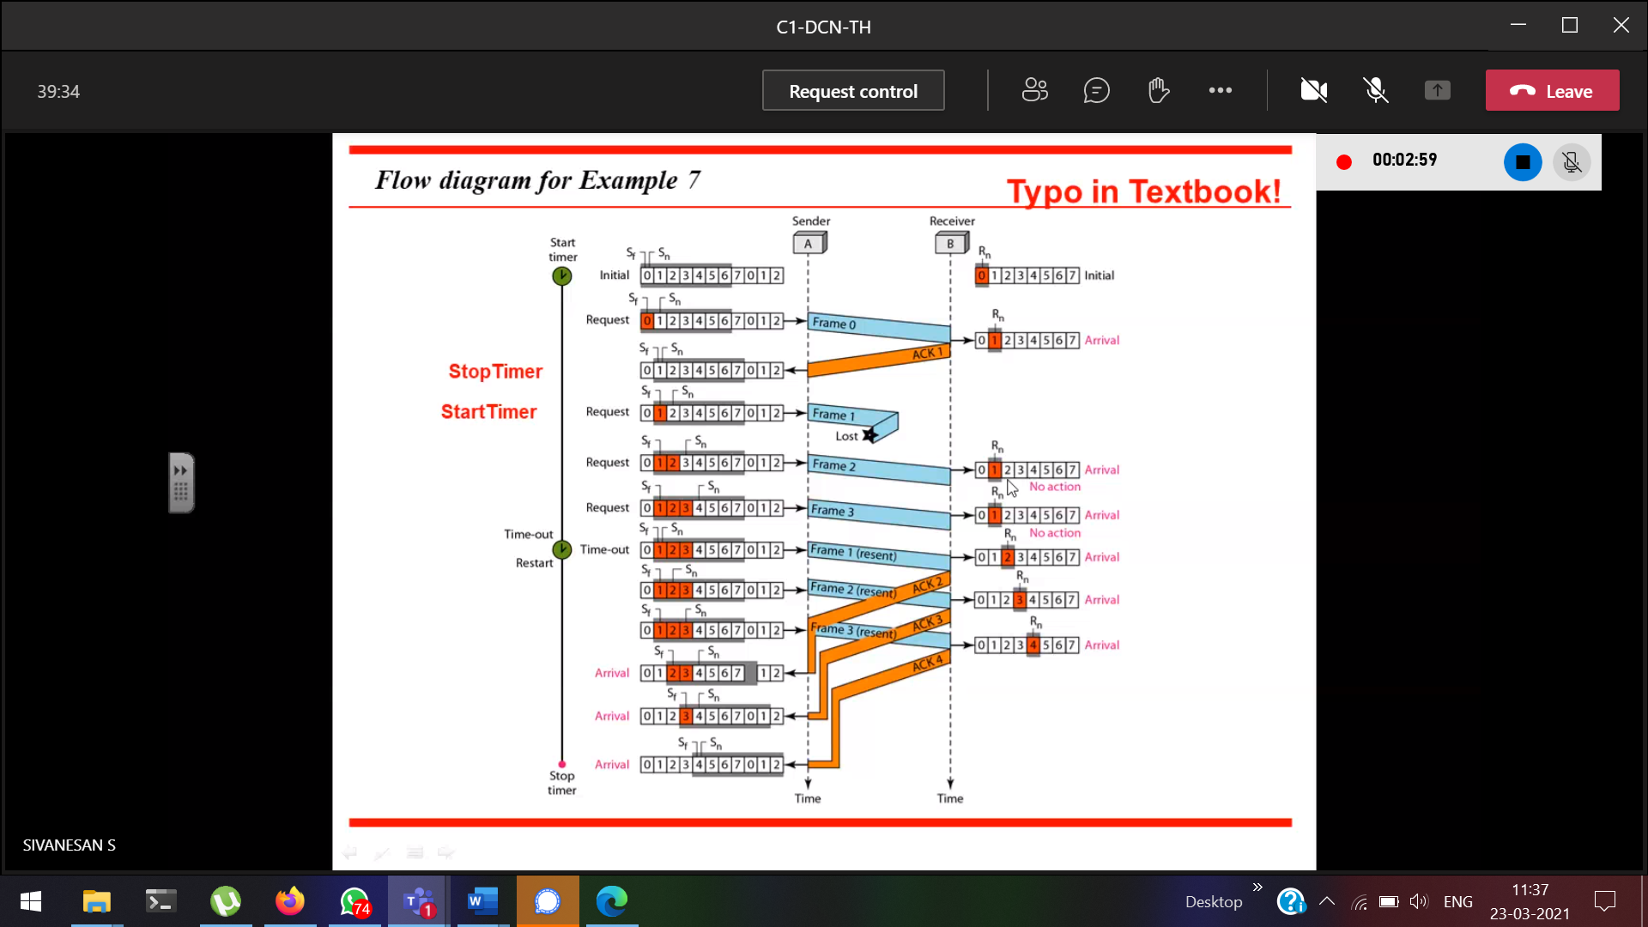

With Sf and acknowledgement number, we can resend the frame.

When loss of frame 🡪 duplicates are sent  
When loss of acknowledgement 🡪 no problem

Sf will point to the frame where the acknowledgement hasn’t received  
Sn will point to the current frame which has to be sent next.

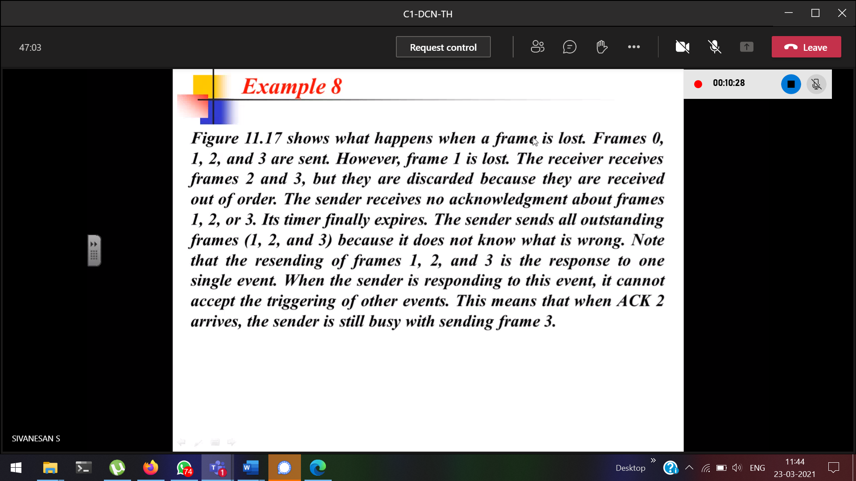

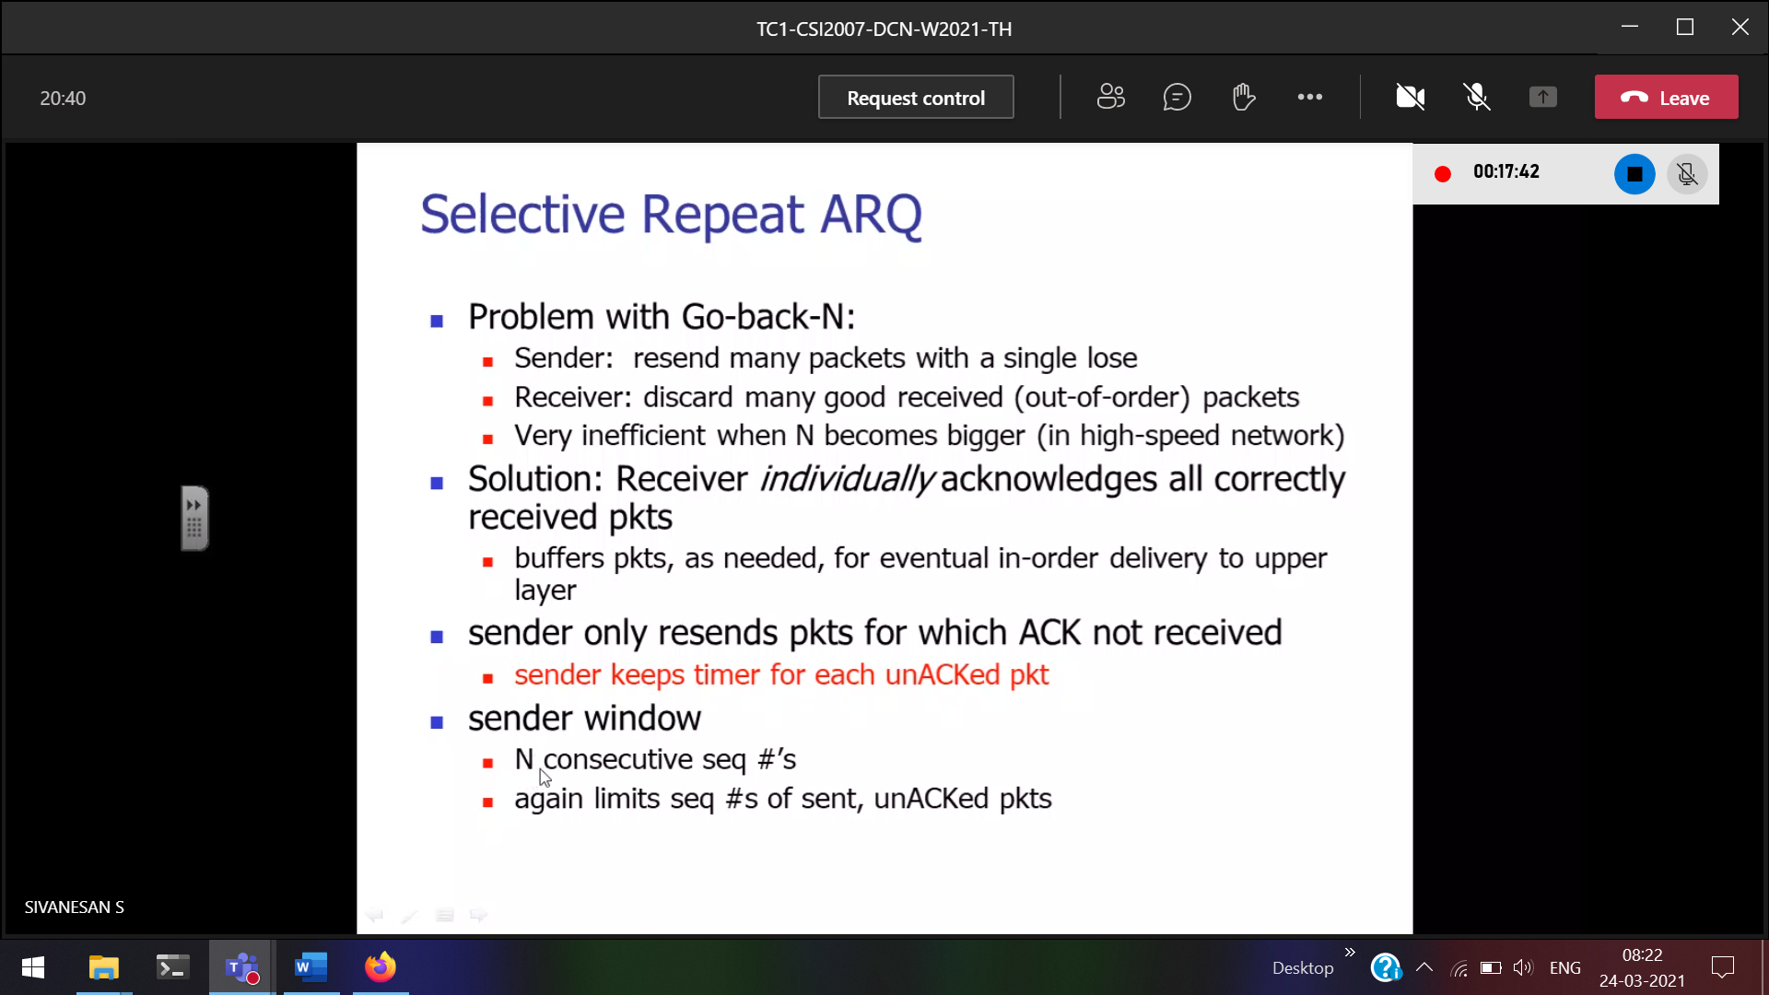

20 frames in a window 🡪 if 1st frame is error all the 20 frames should be sent again.

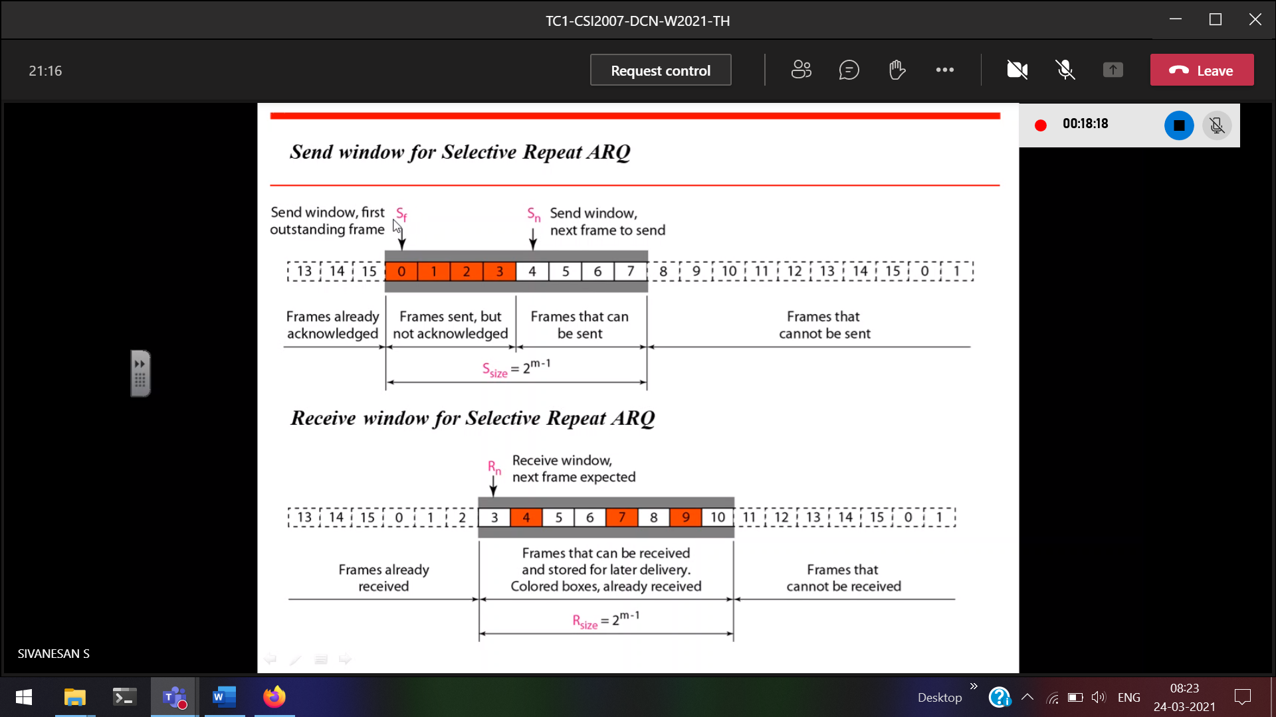

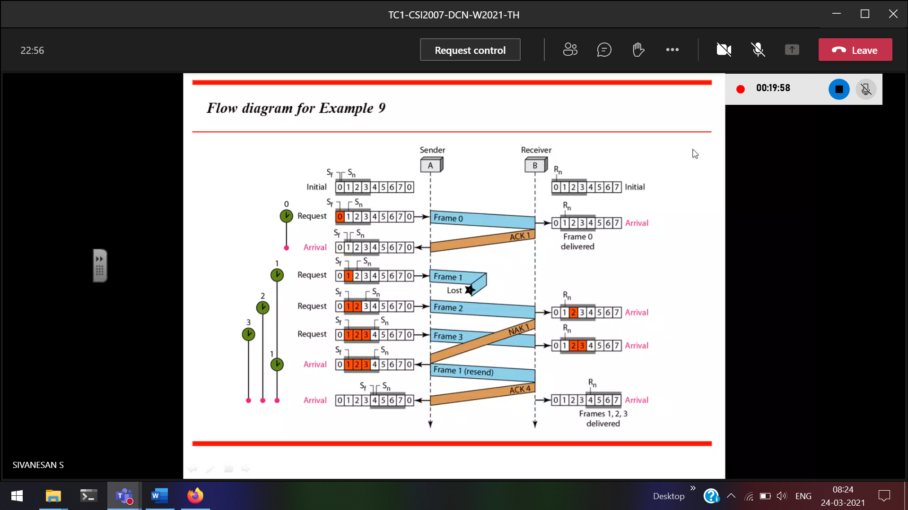

For each and every frame, timer will be there

+ve acknowledgement 🡪 after receiving every frame tell the sender I received. (after successful reception of a frame)

-ve acknowledgement 🡪

Before flow control

Now Access Control

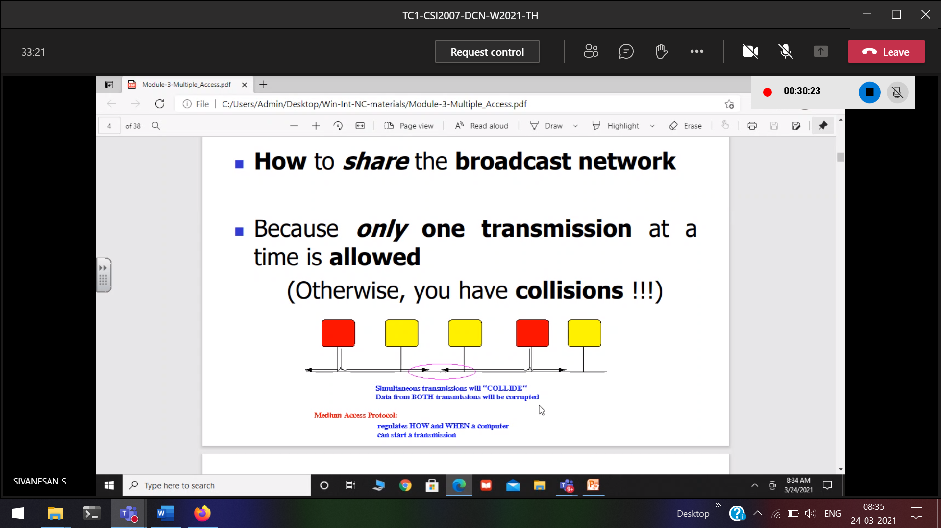

How to avoid the collision?   
How to survive with the collision?

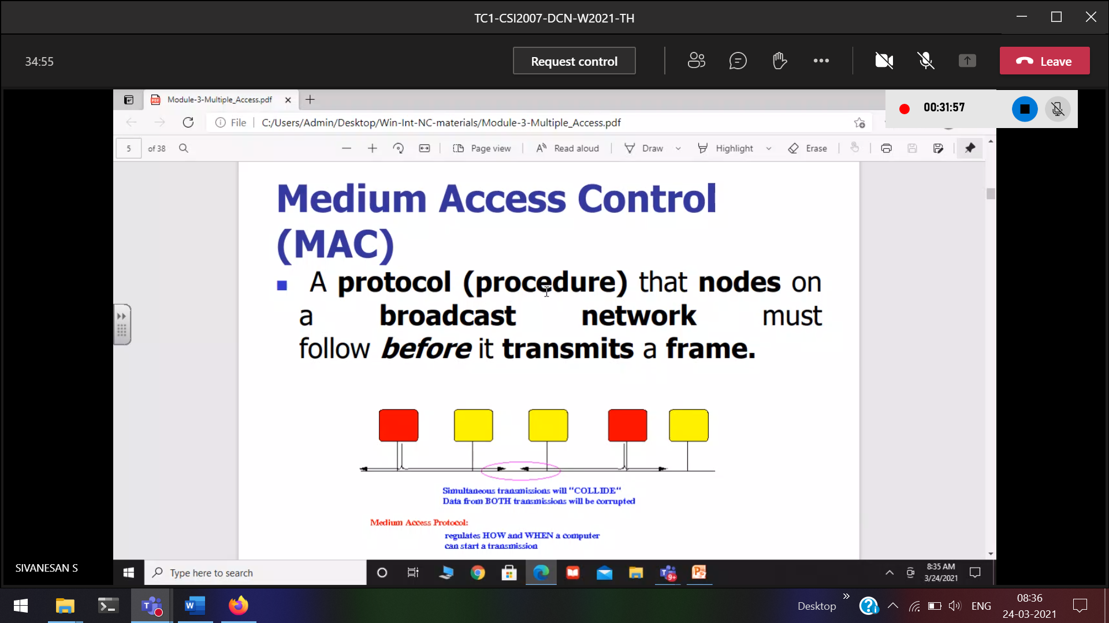

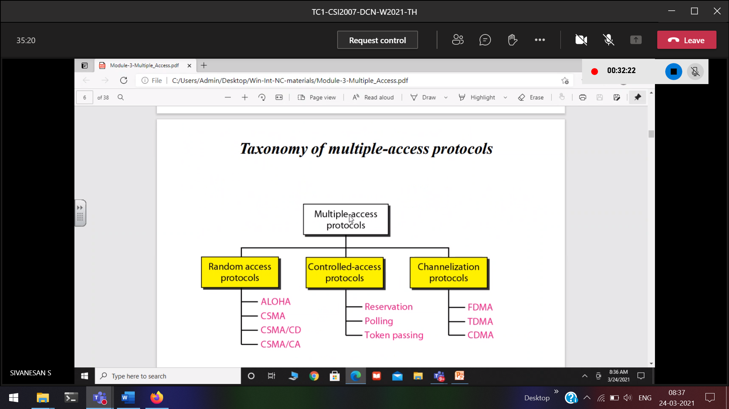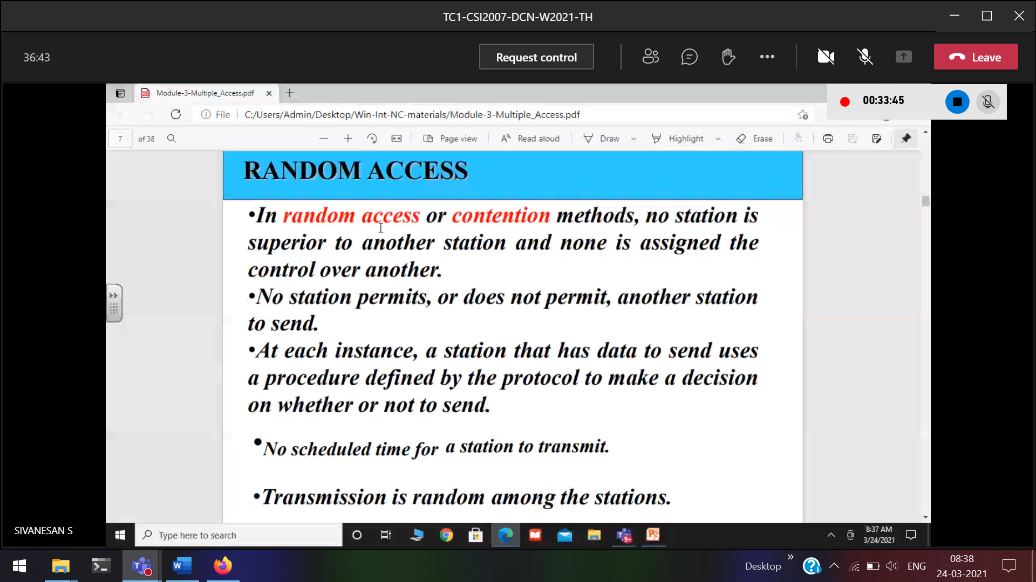

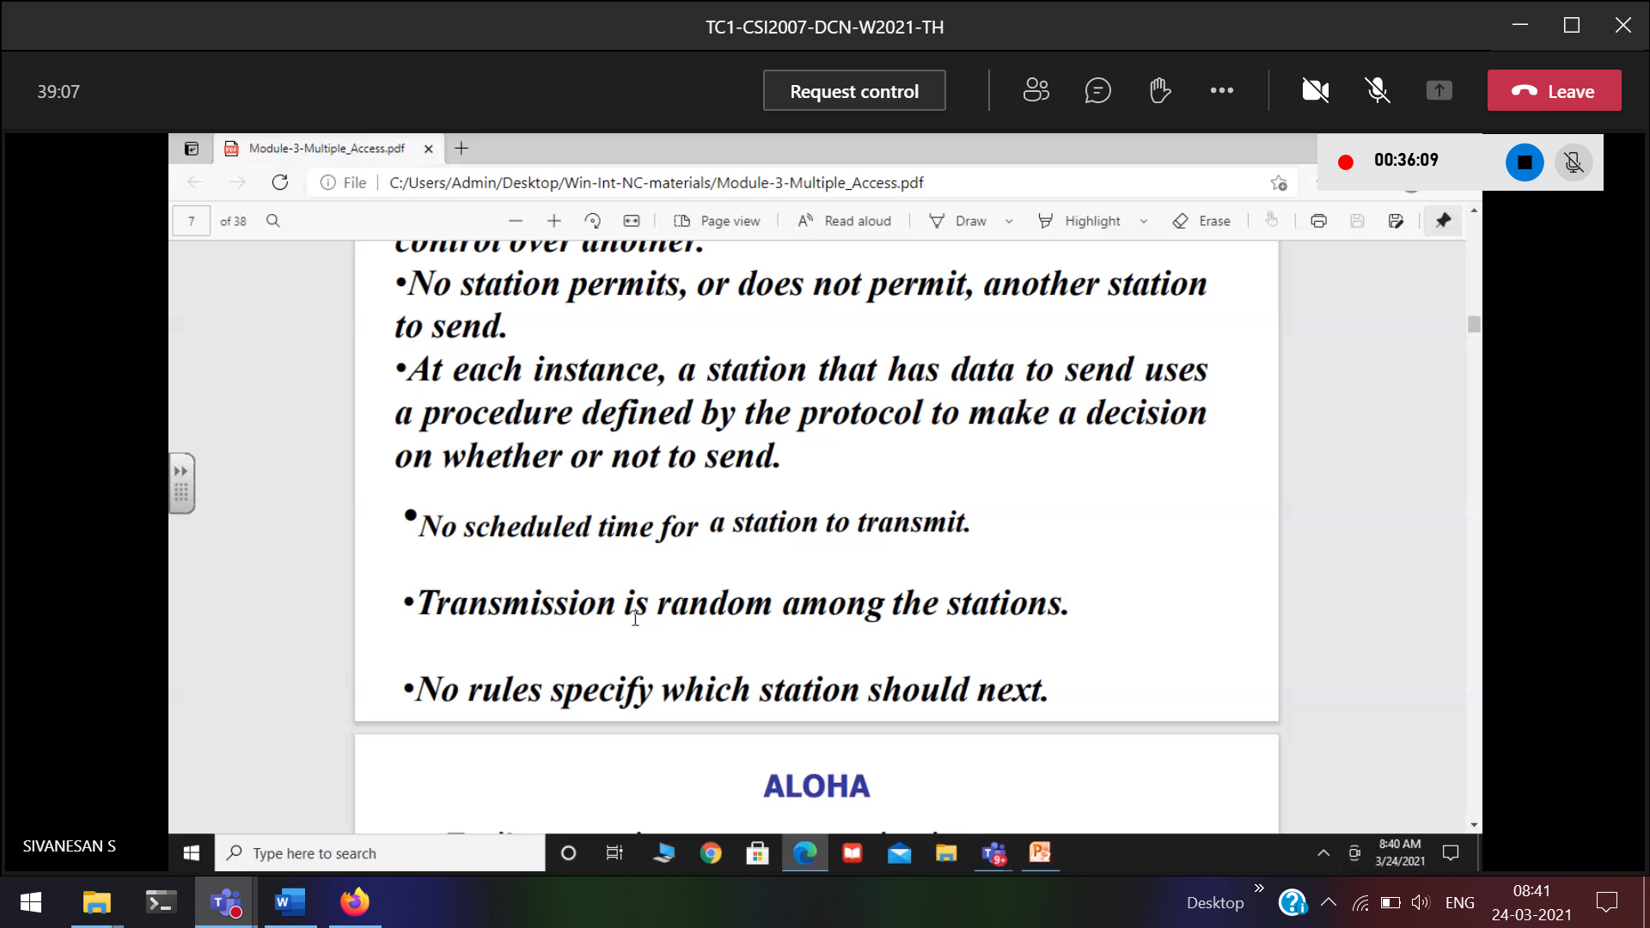

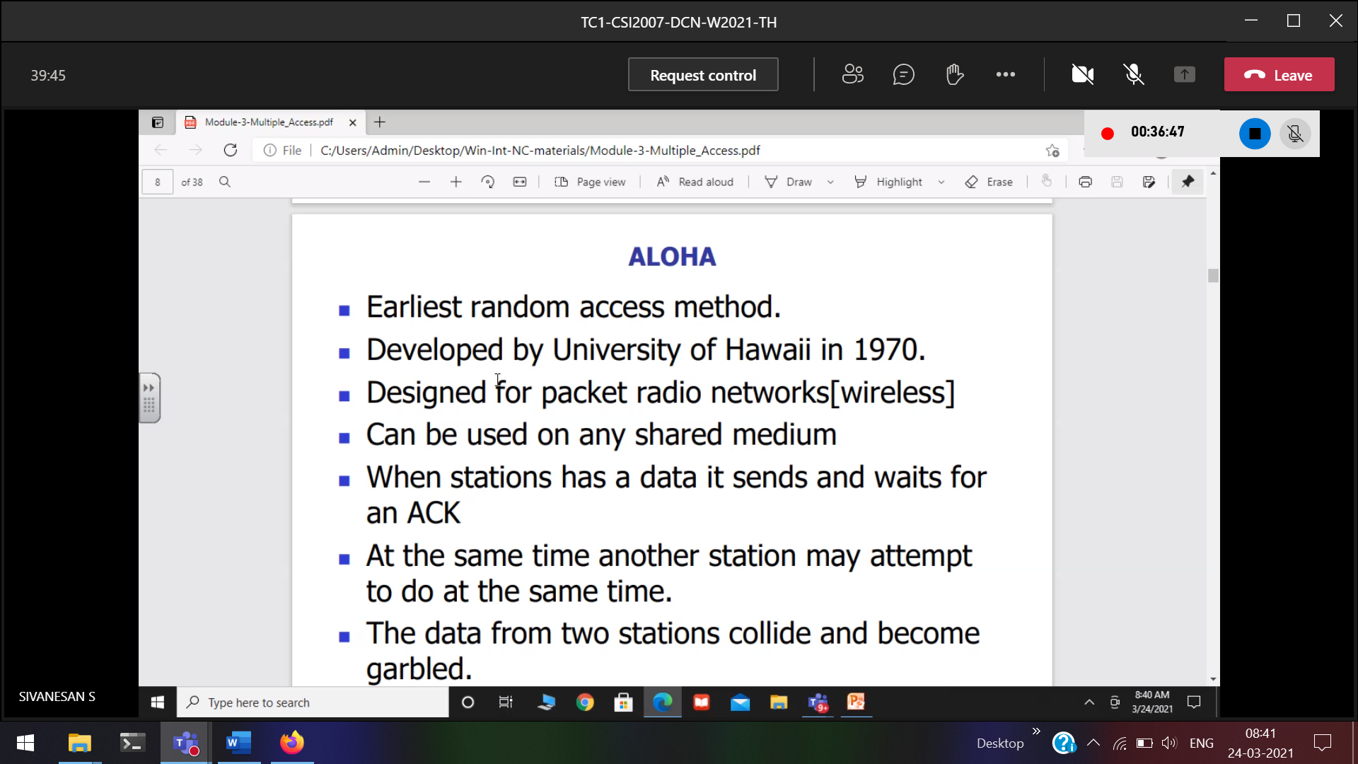

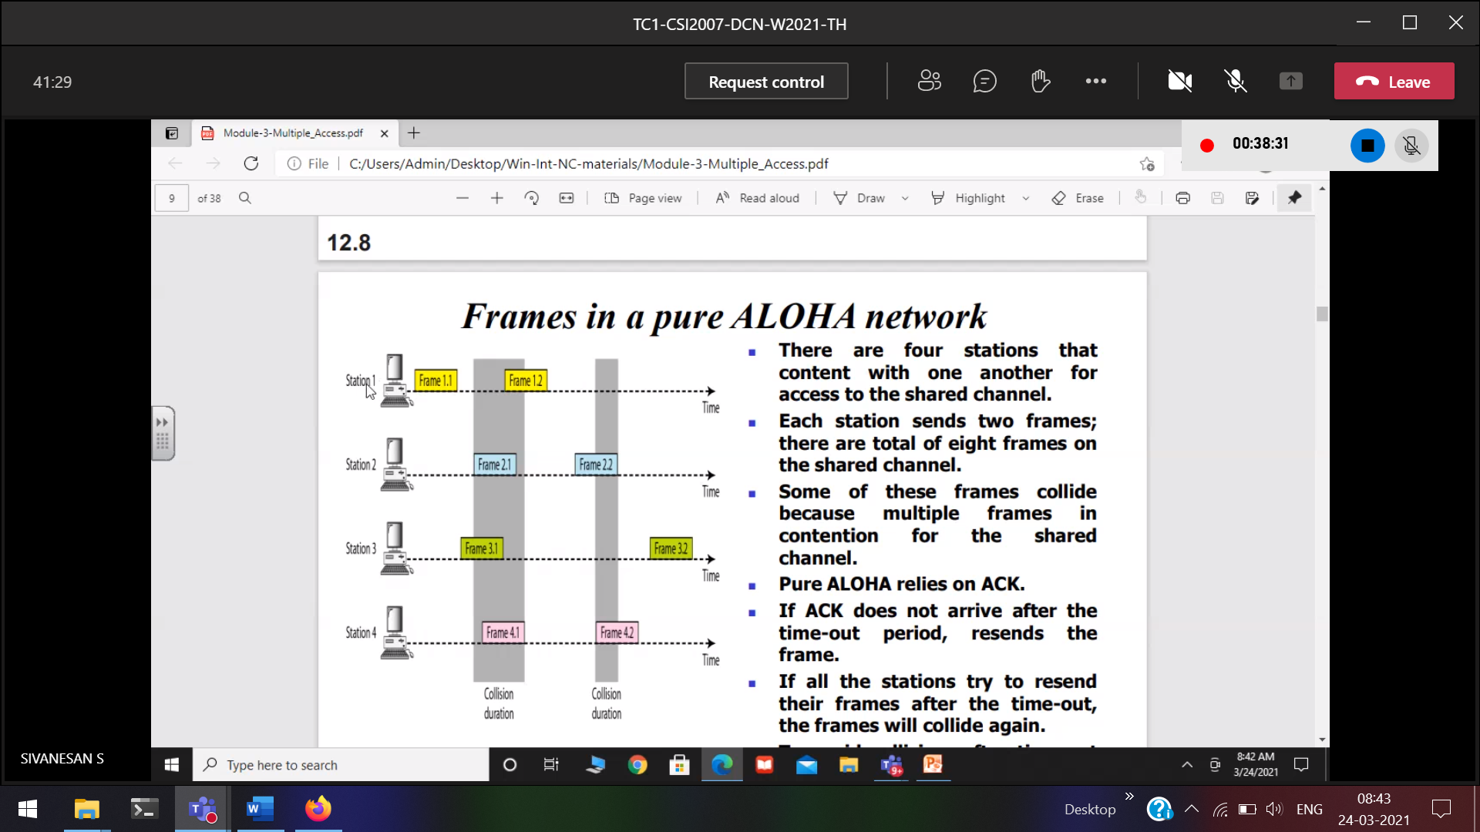

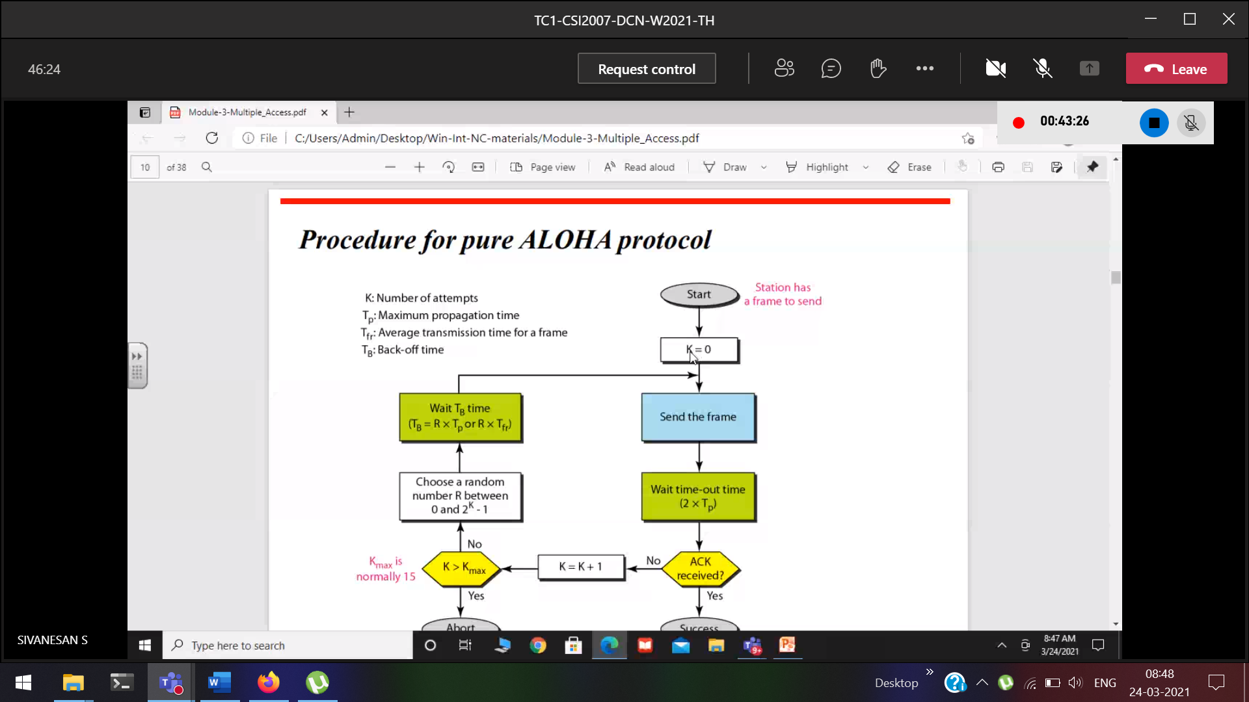

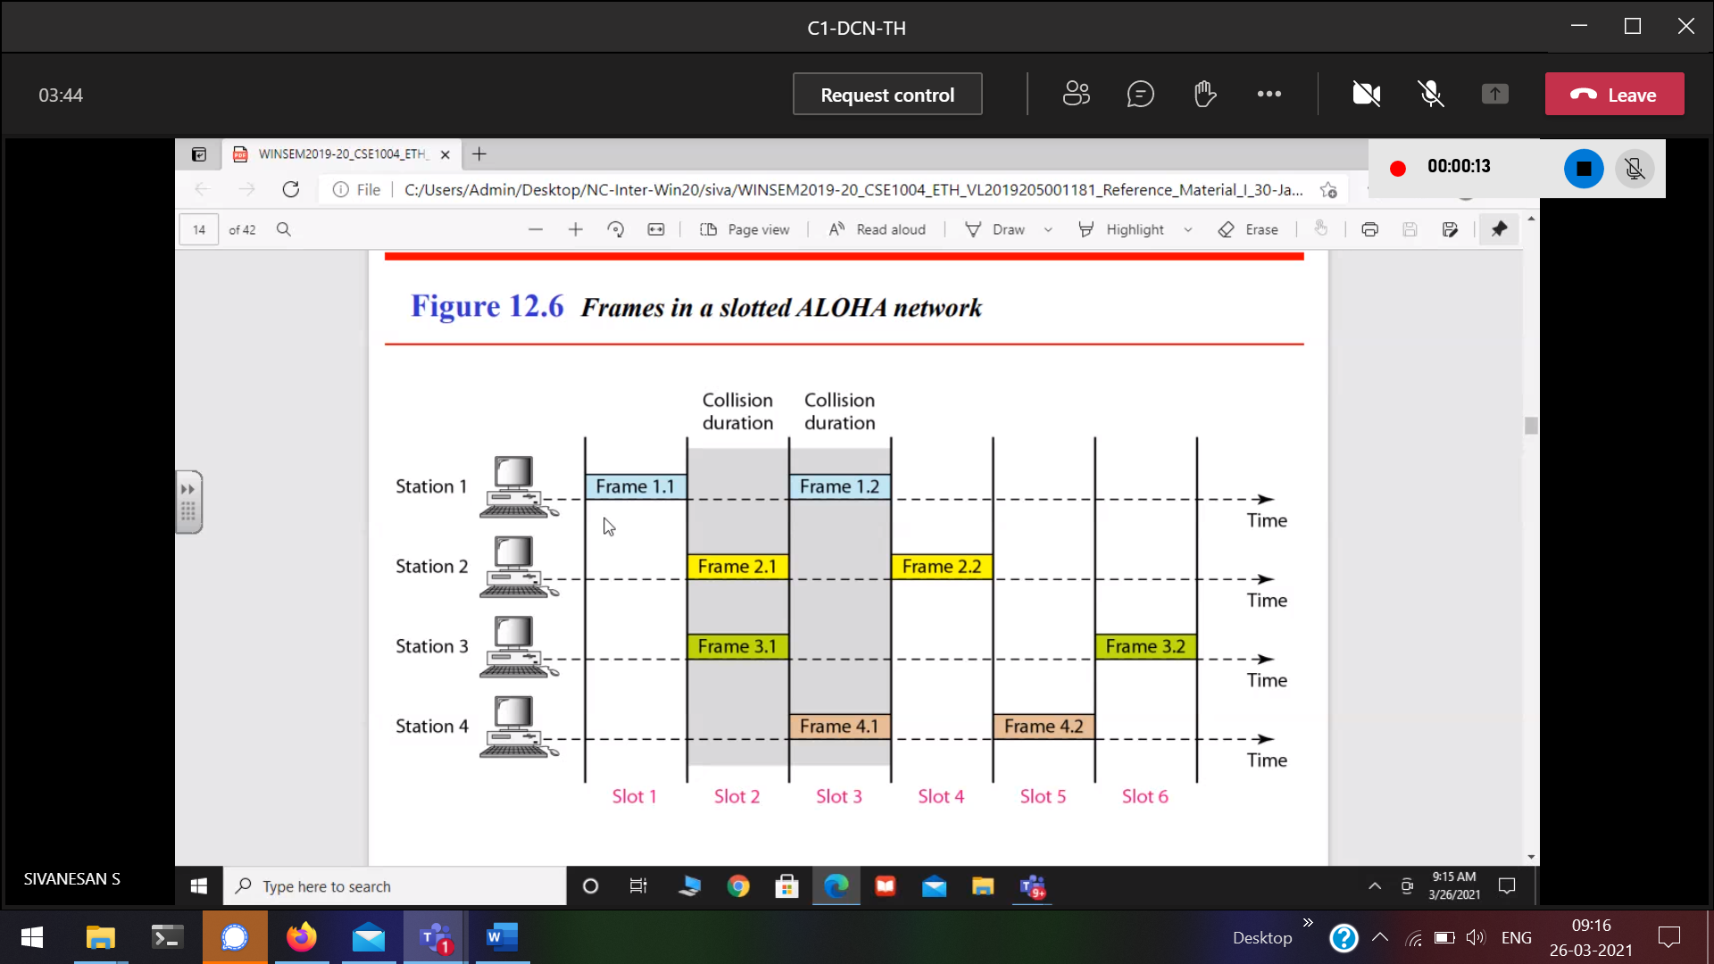

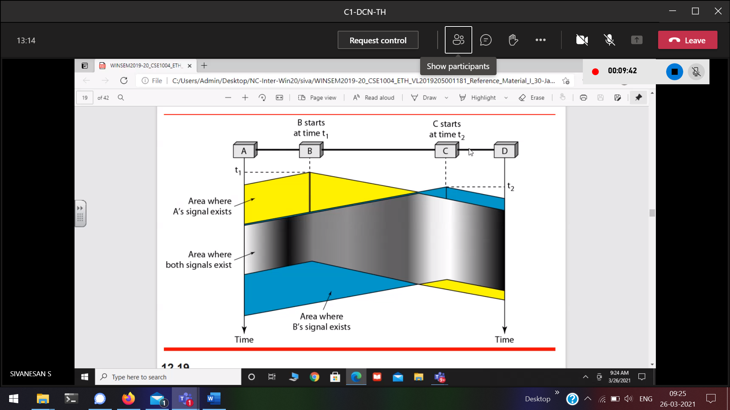



With respect to A , C and D 🡪 far-end collision

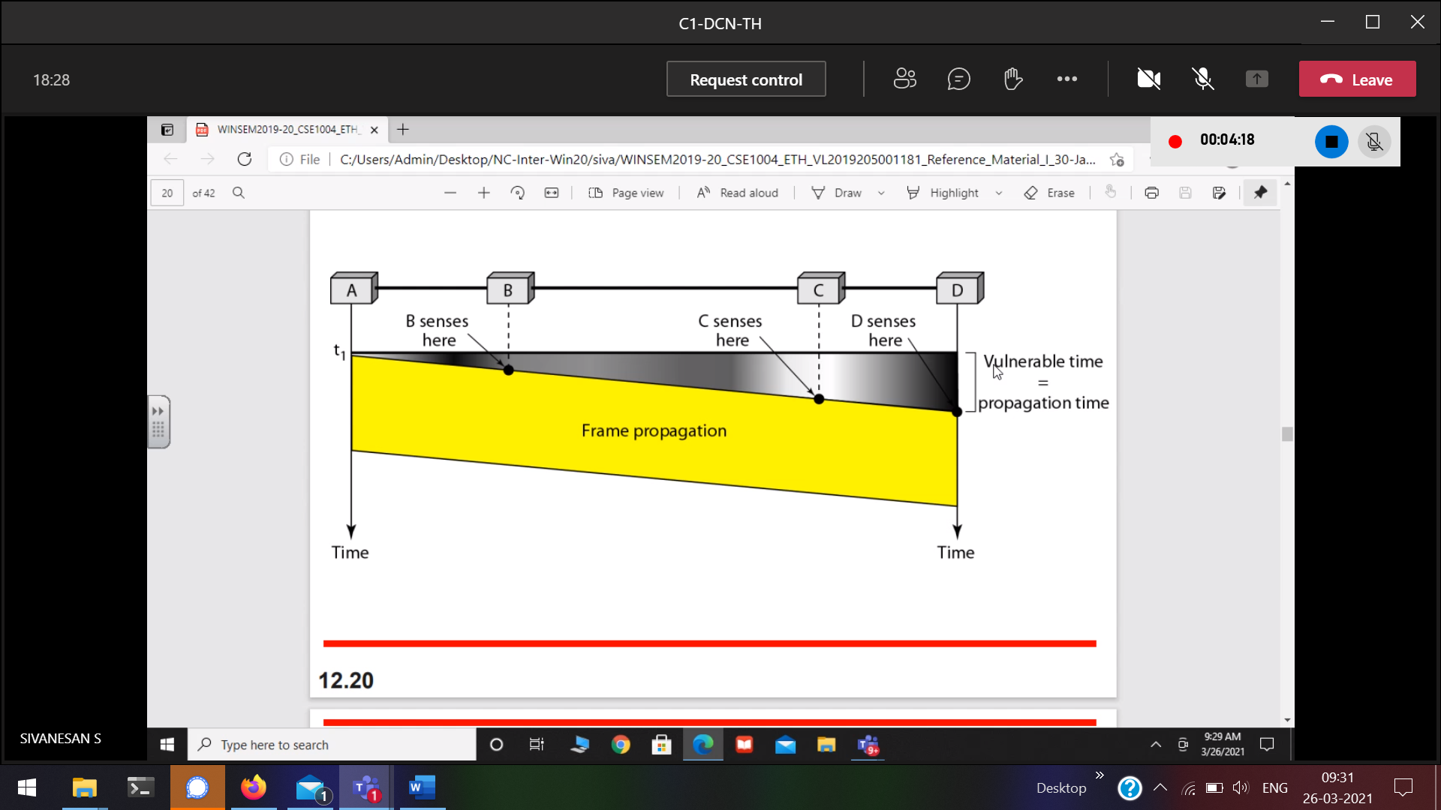

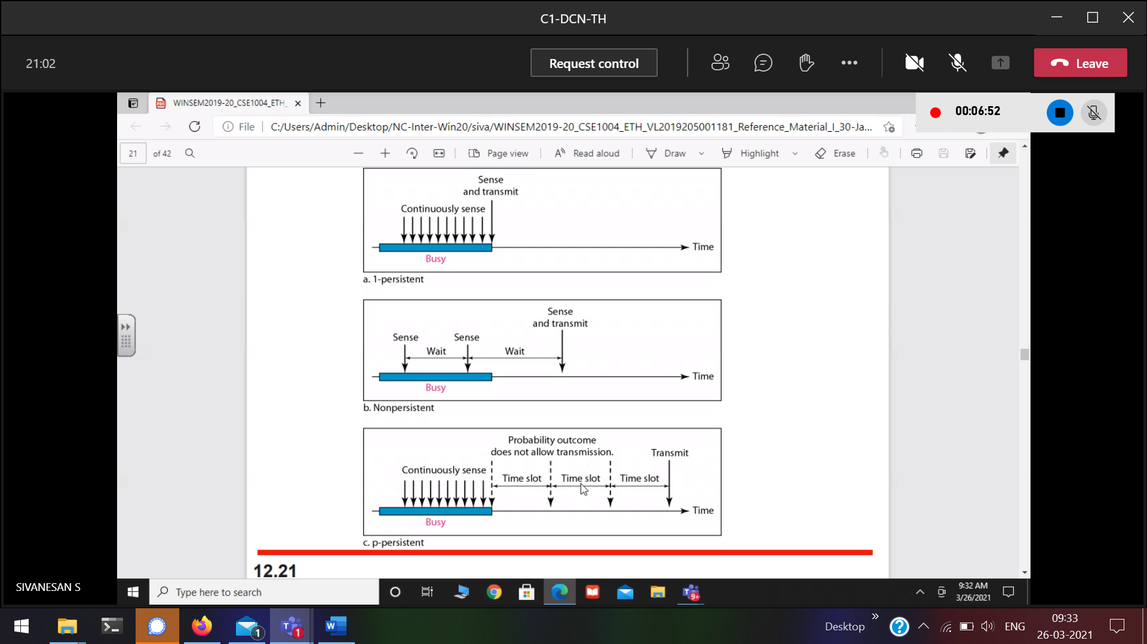

p-persistent 🡪 hybrid and uniform time slot

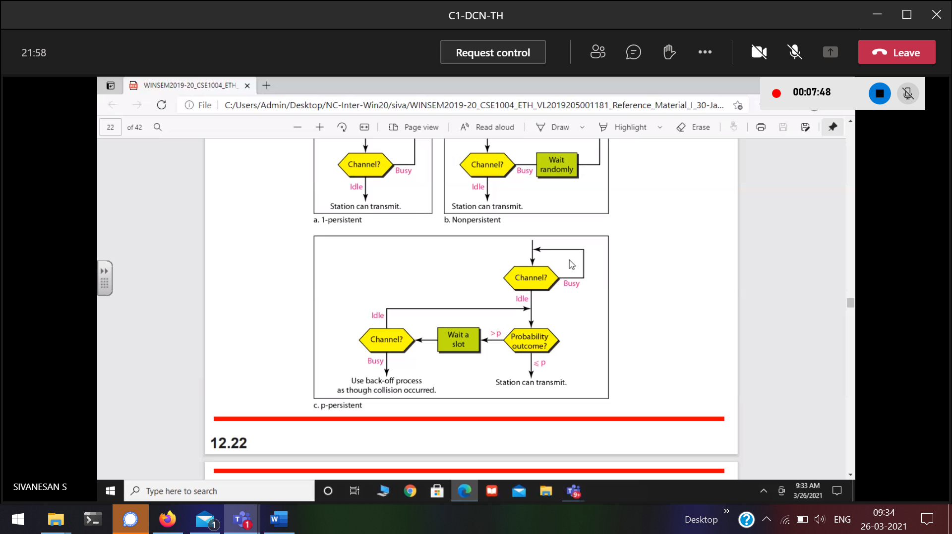

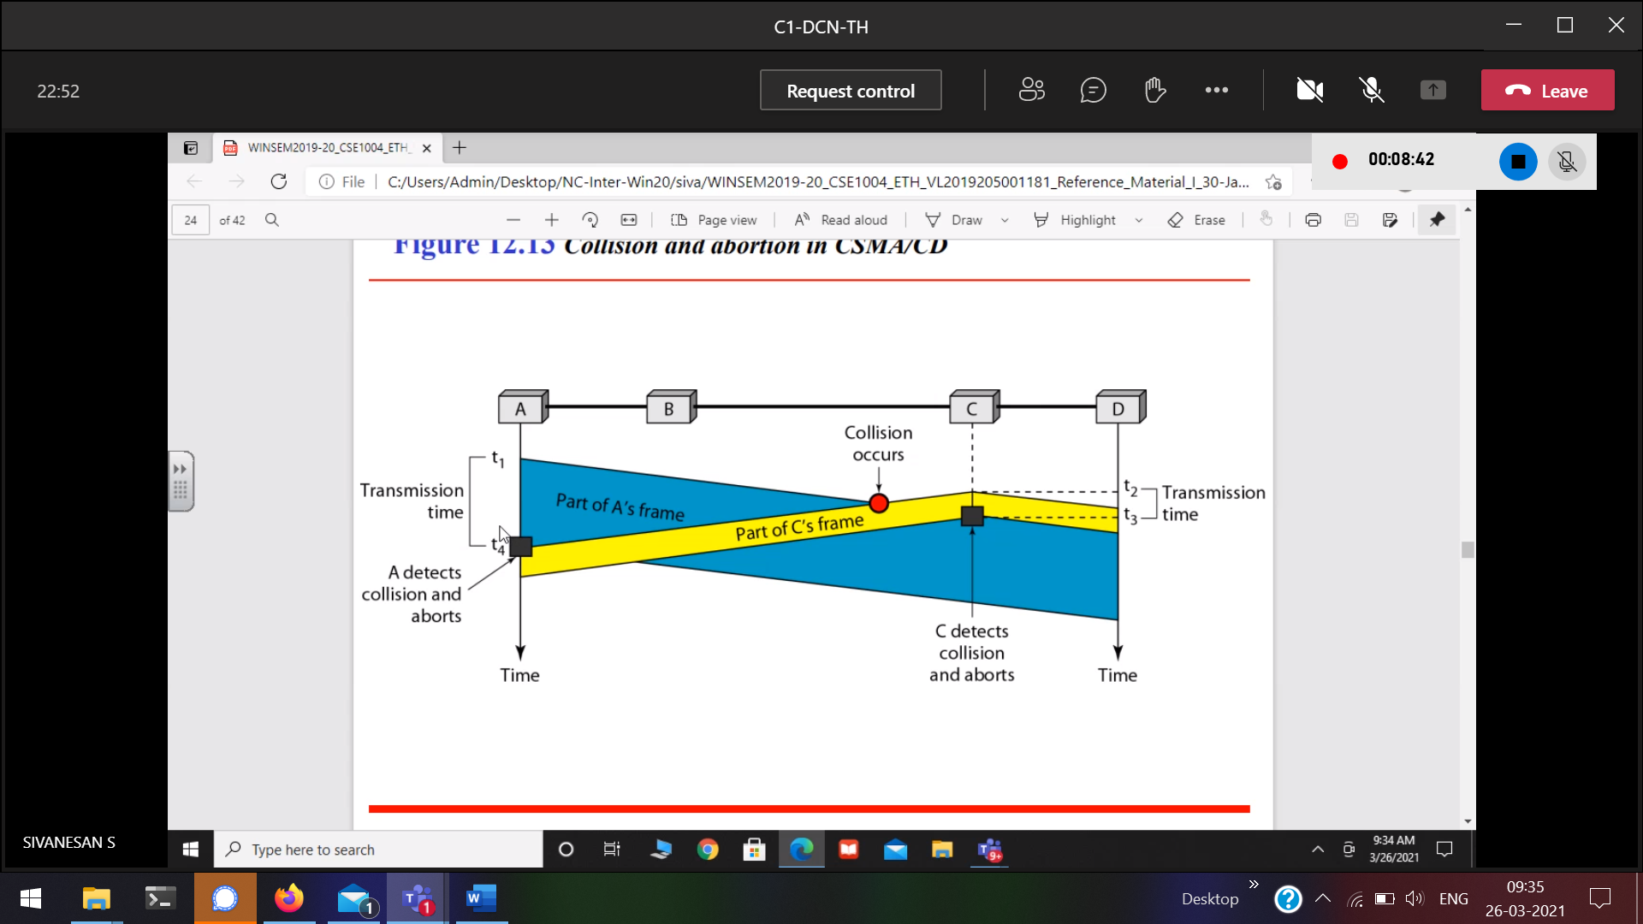

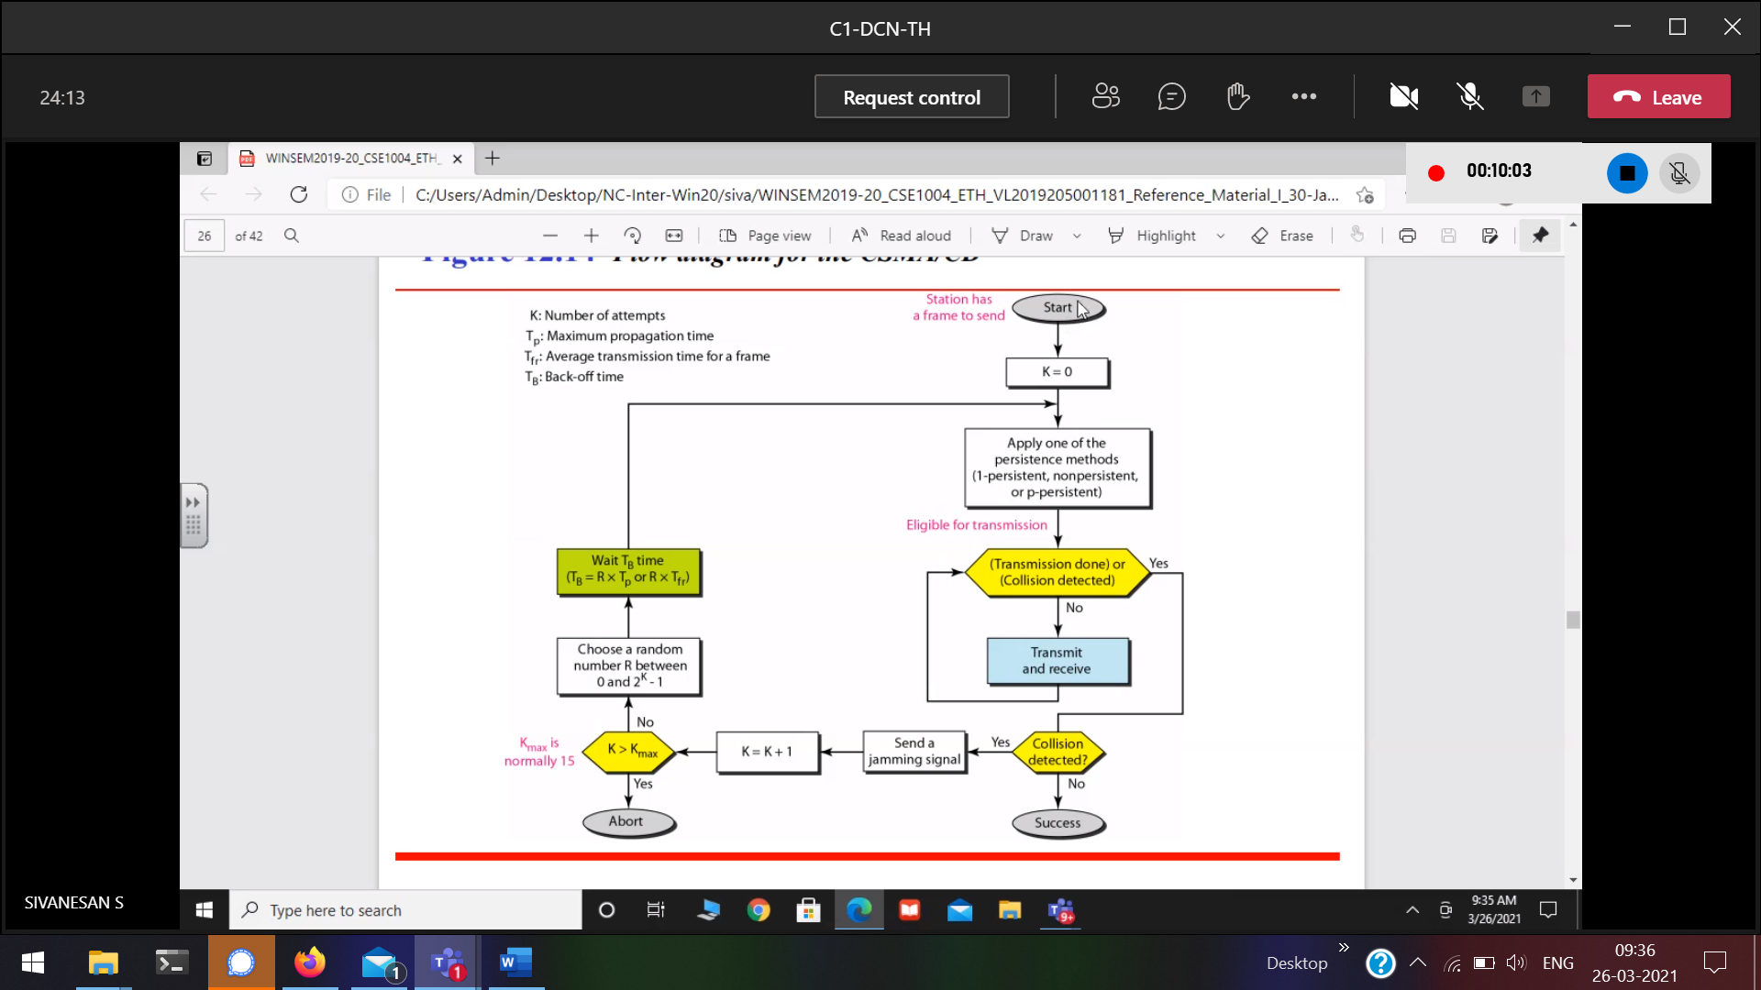

We are not trying to eliminate the collision, we are trying to reduce the collision

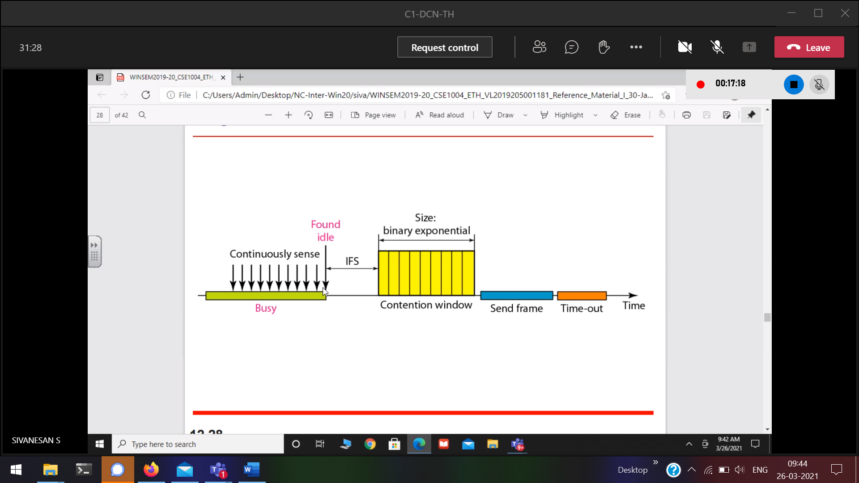

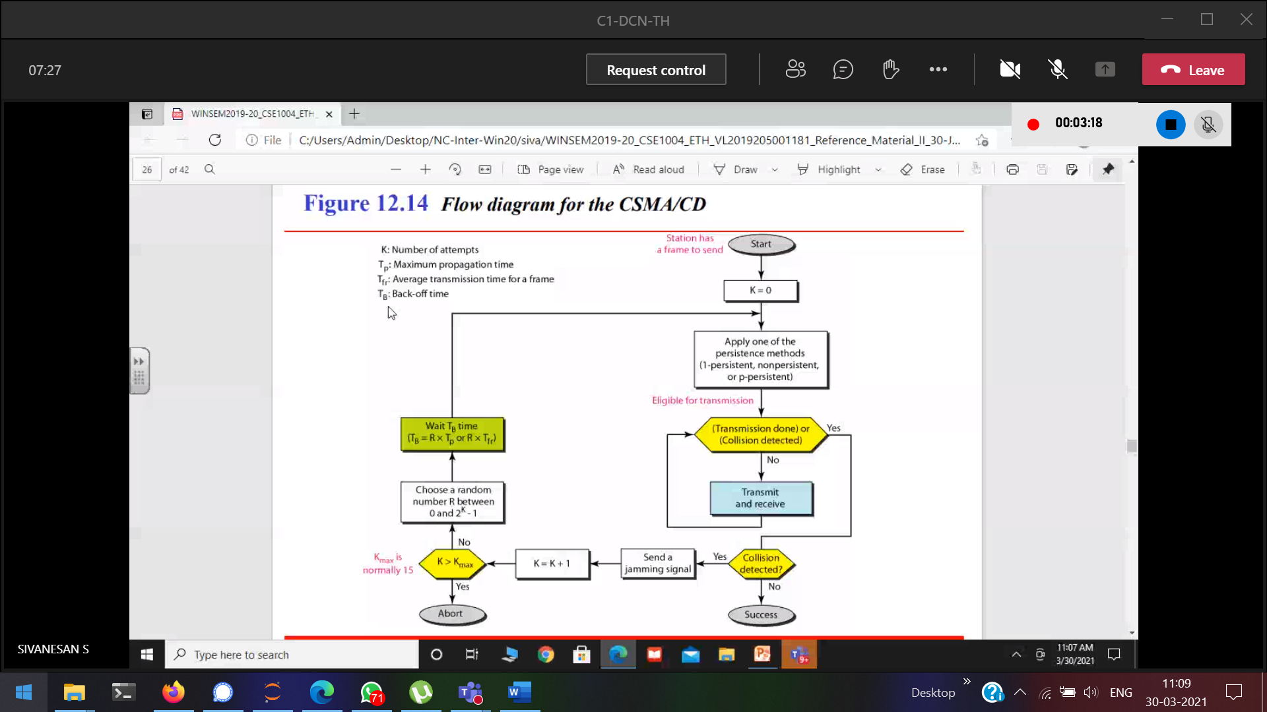

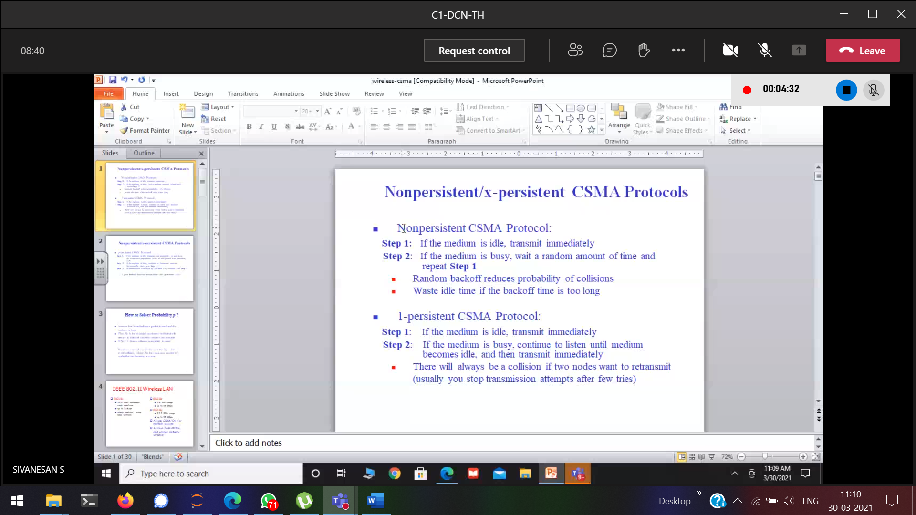

Eventhough channel is available due to fixed time, the person must wait.

In-order to overcome the above, p-persistent comes into picture

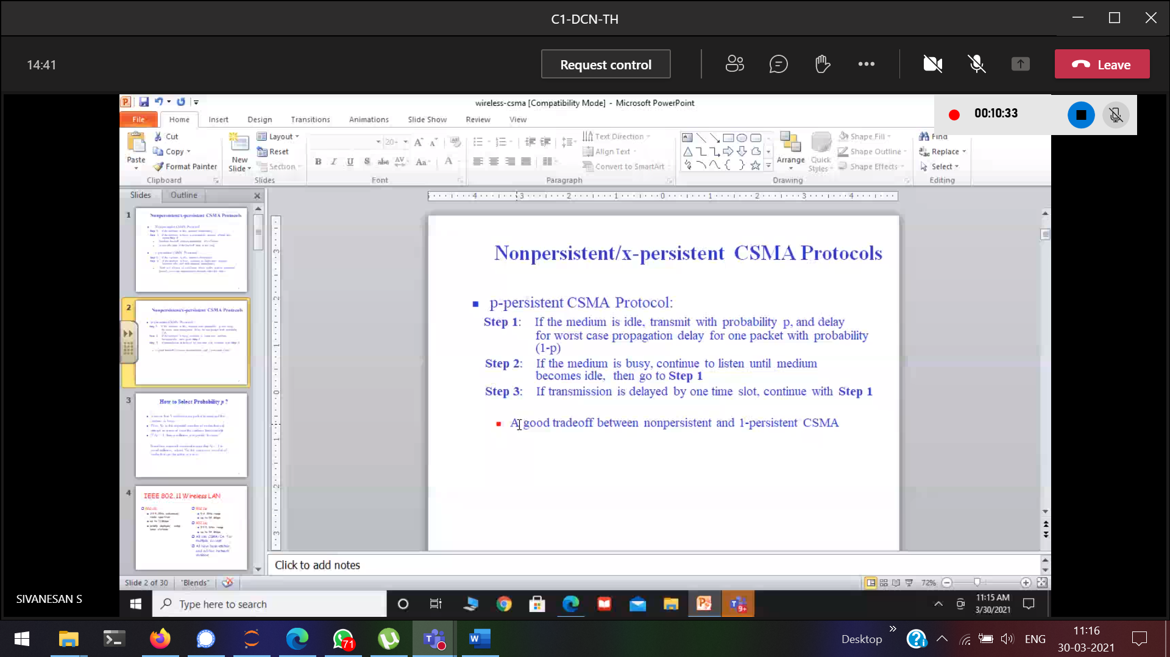

Collision avoidance for Wireless network

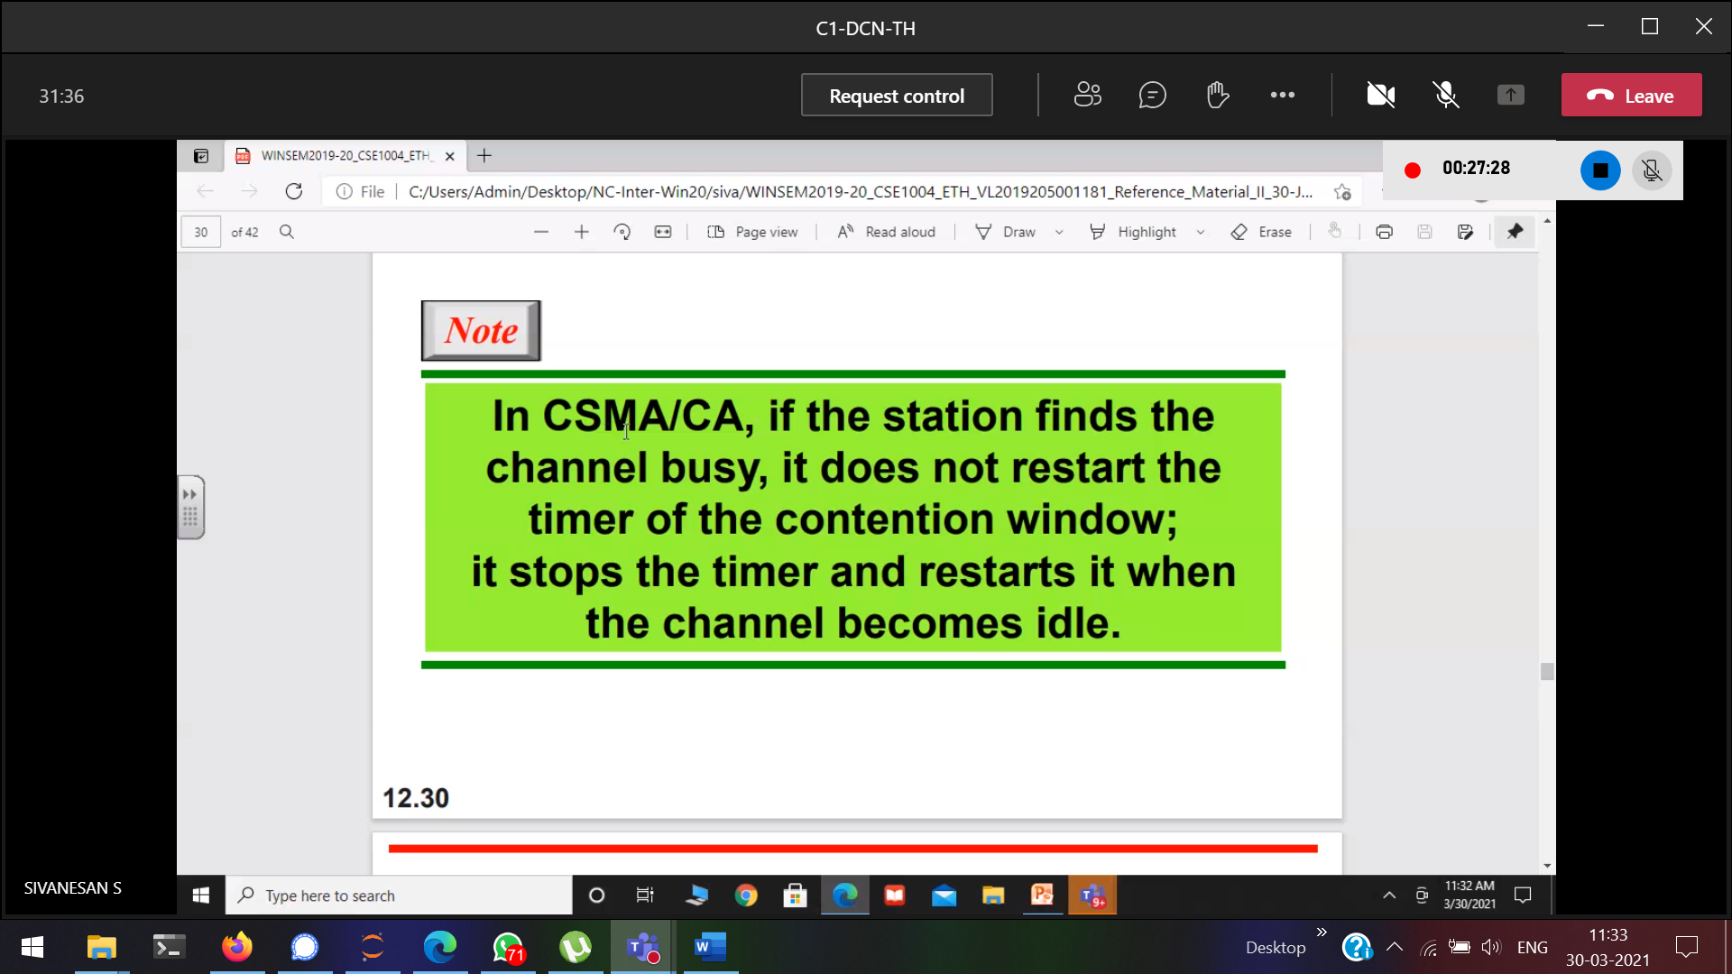

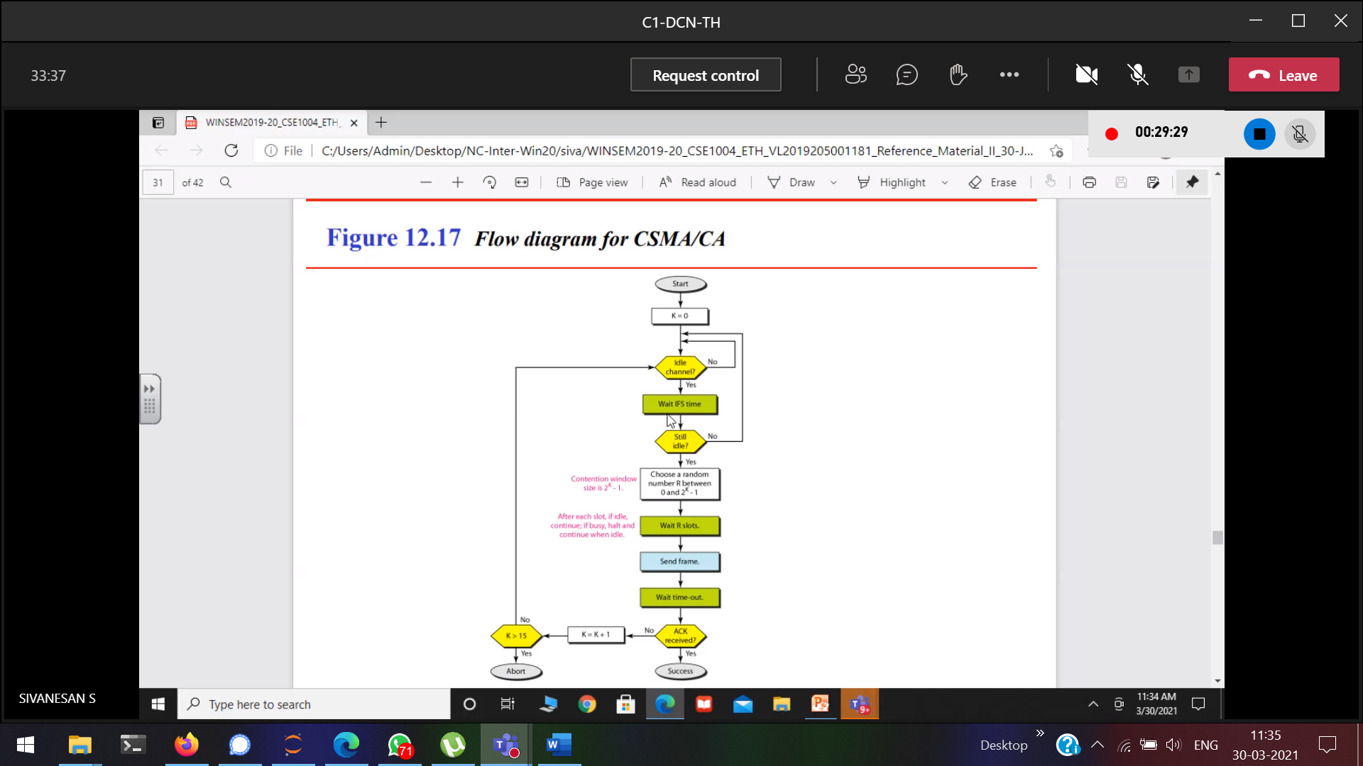

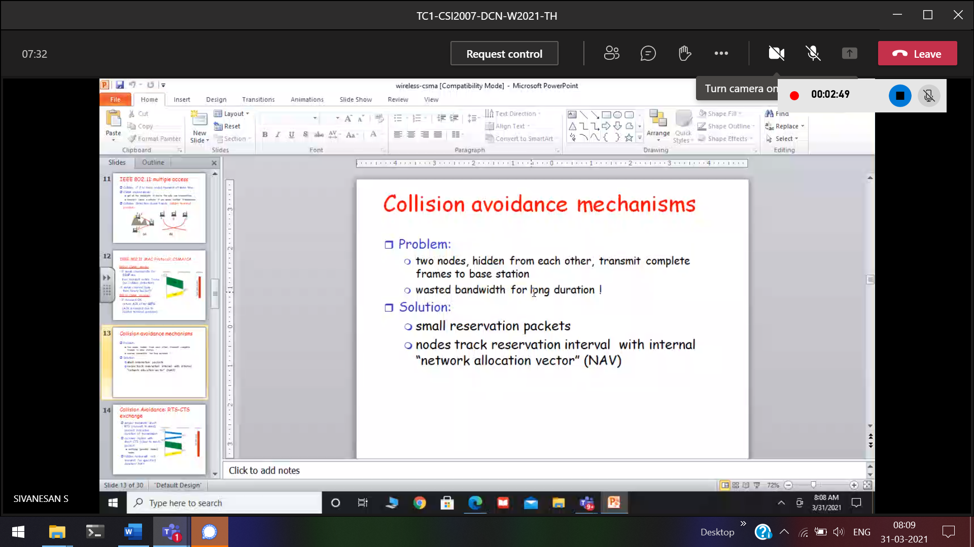

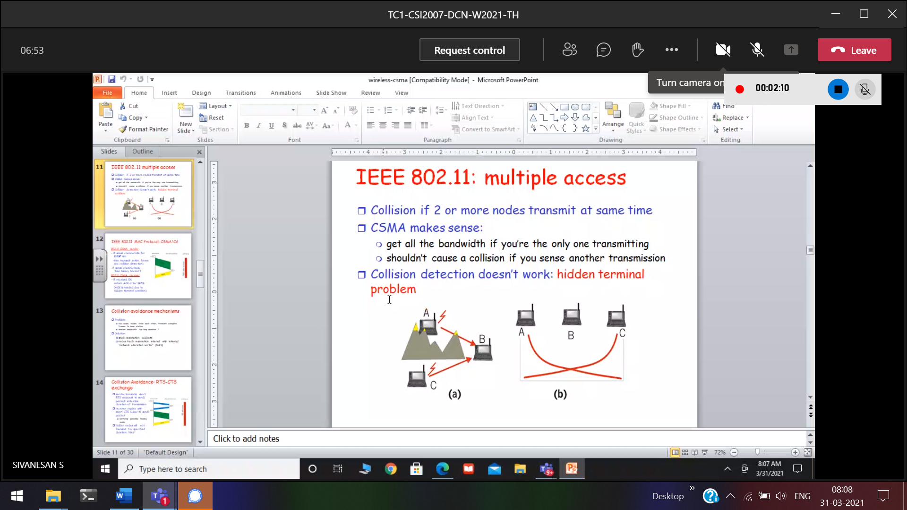

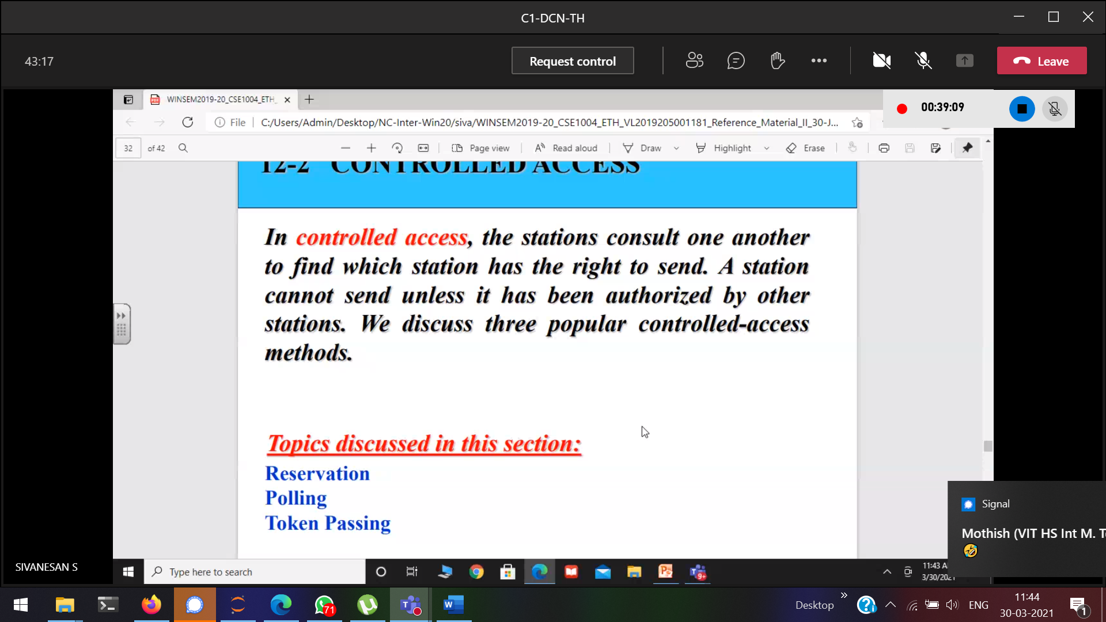

Before there is not at-all control, but now on-wards in all mechanism some control. The above can be used in wired network.

Cd 🡪 wired and Ca 🡪 wireless

All the three 🡪 to avoid collision

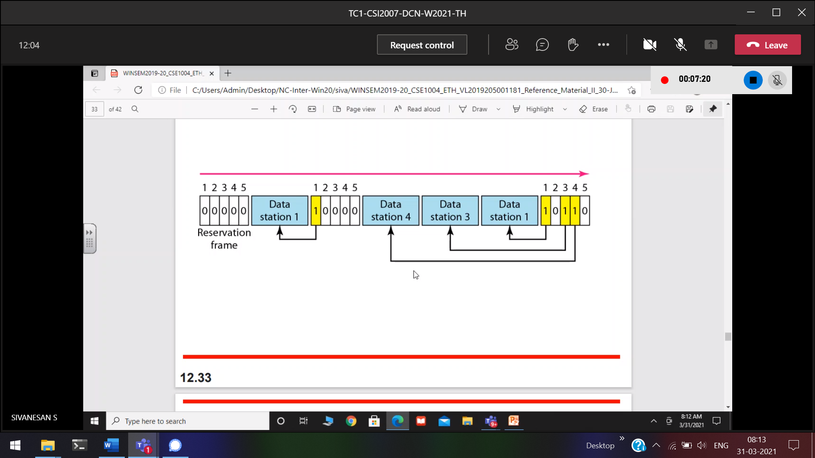

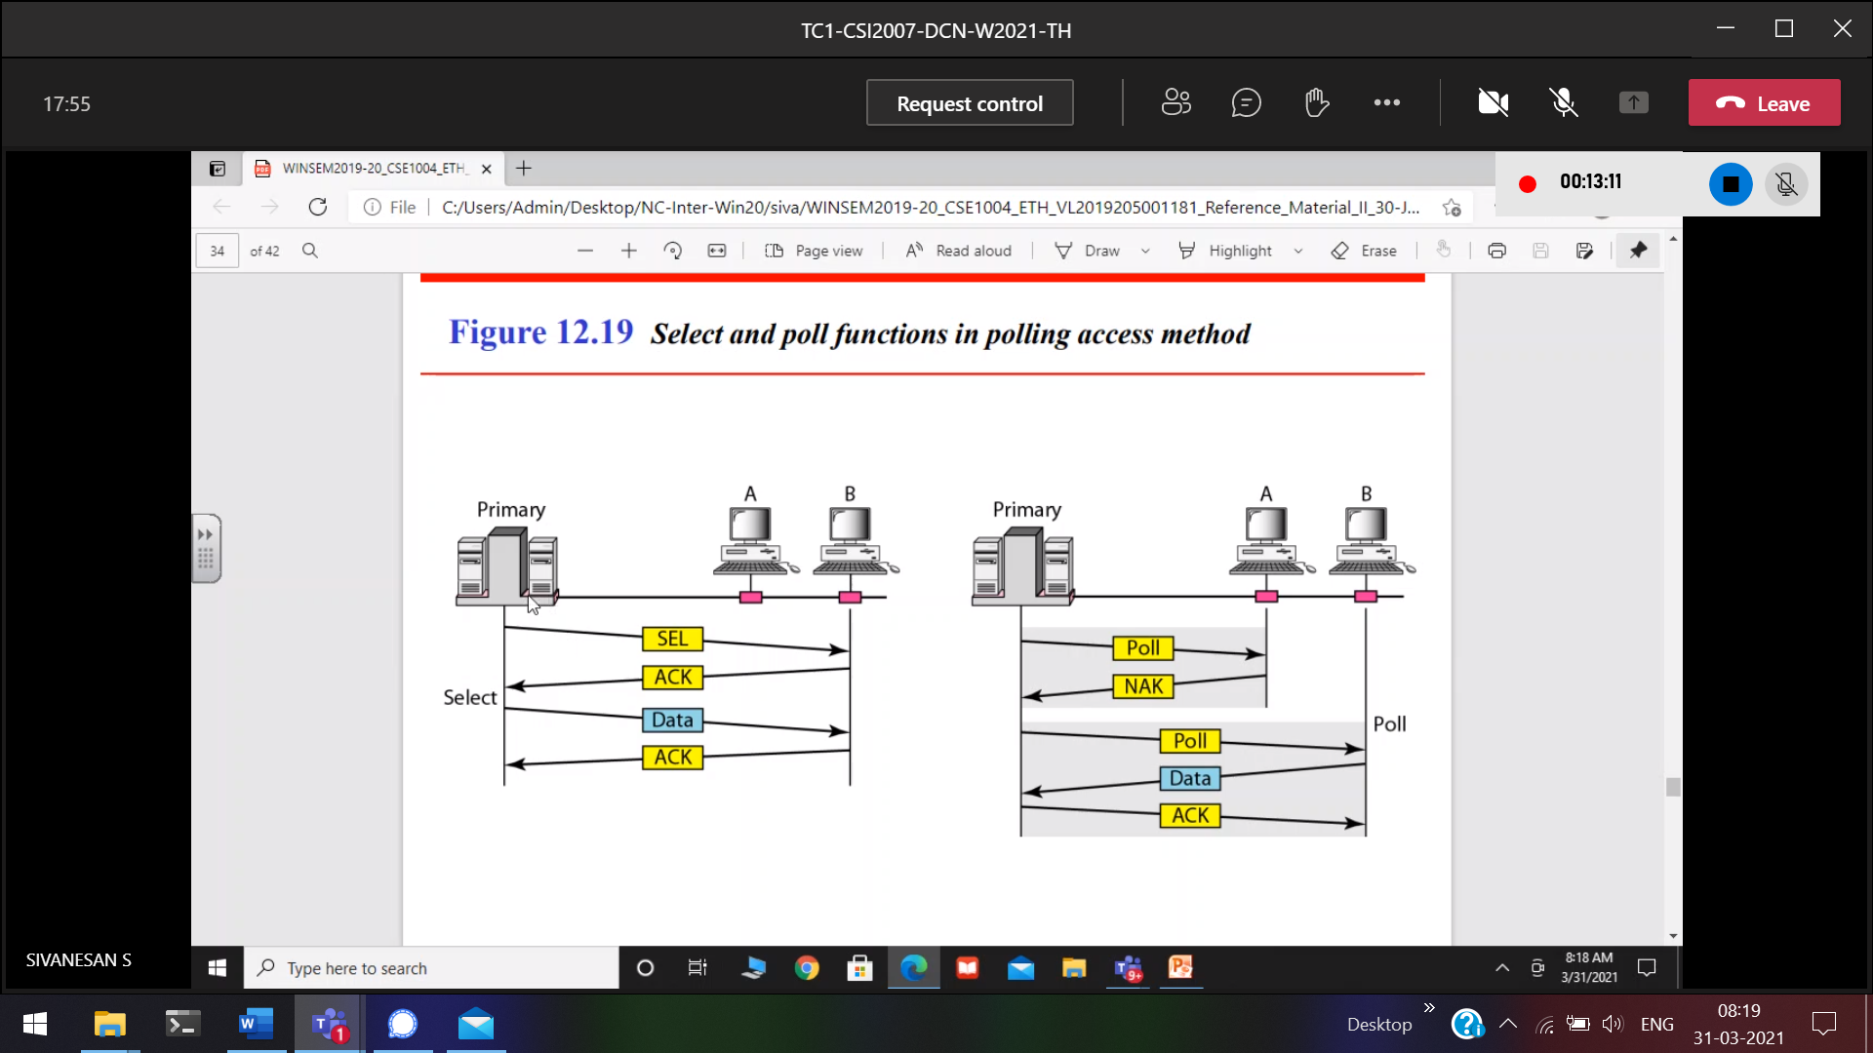

Yellow 🡪 controlled   
There will not at-all collision.

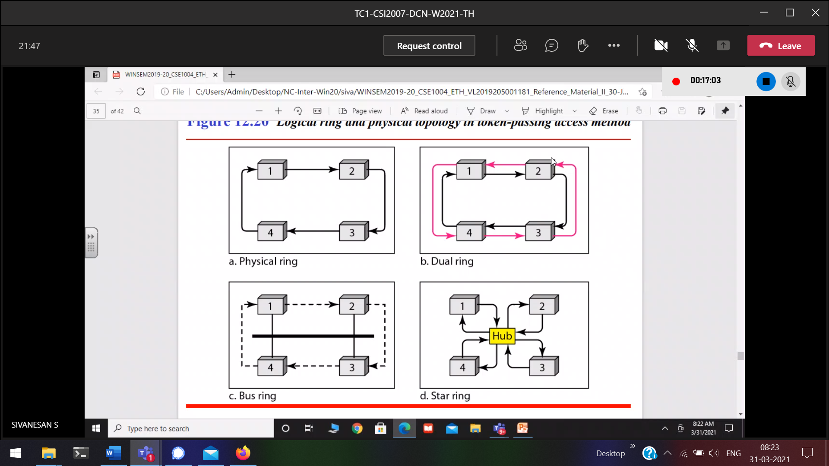

Difference between start-ring and start network???

Here dynamic reservation, who-ever wants to send and having token can send.

Is it possible to avoid collision in wired networks ????

Channelization

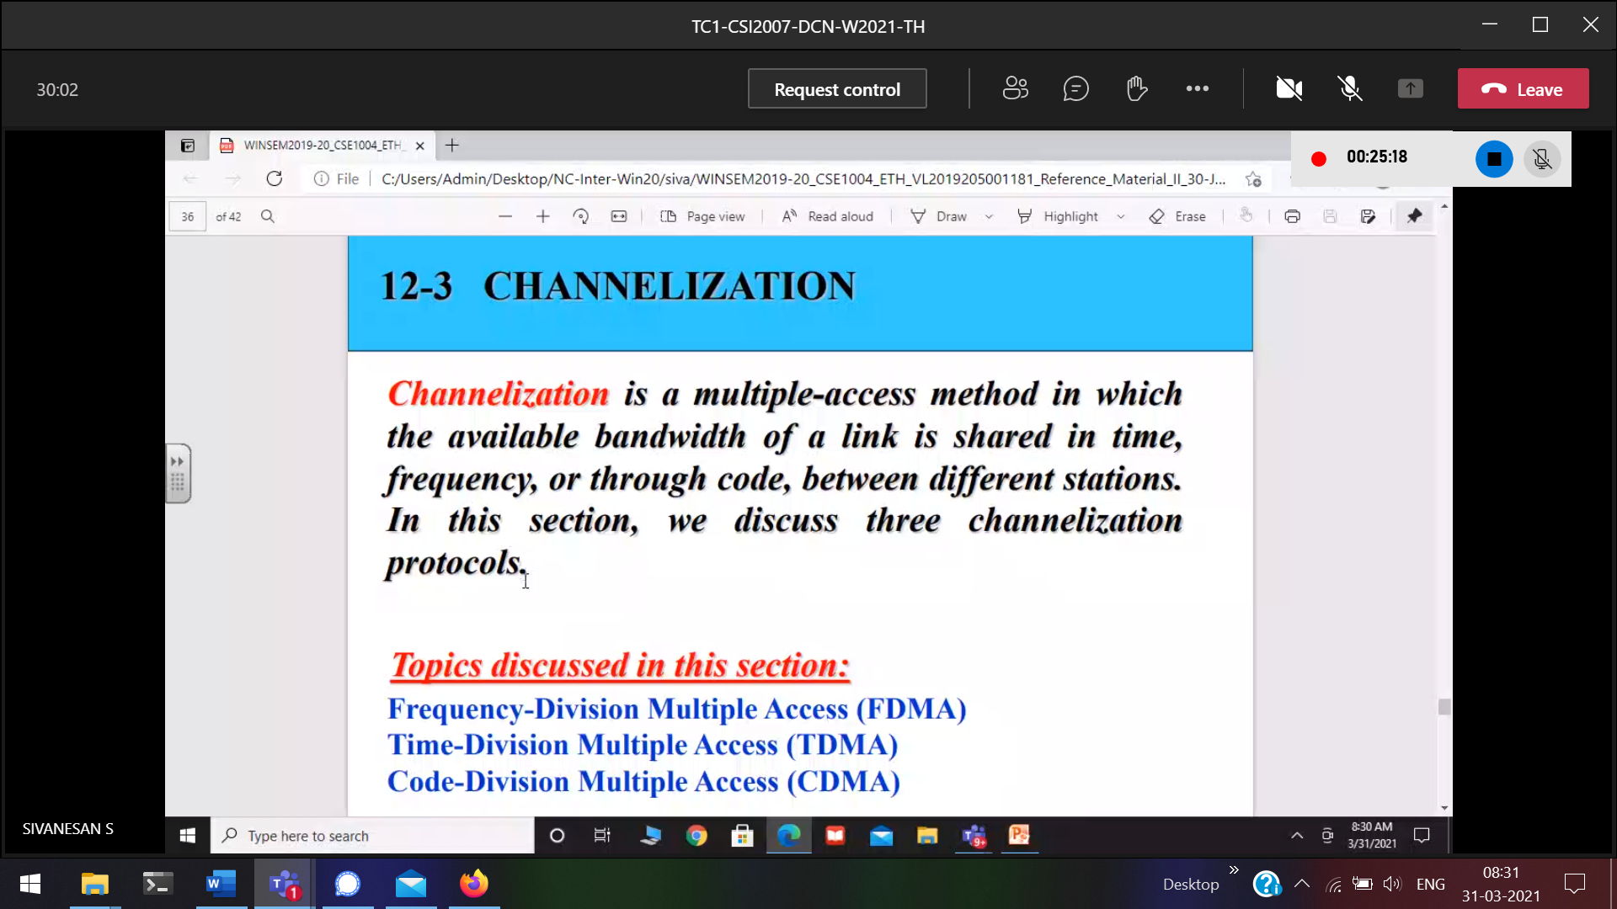

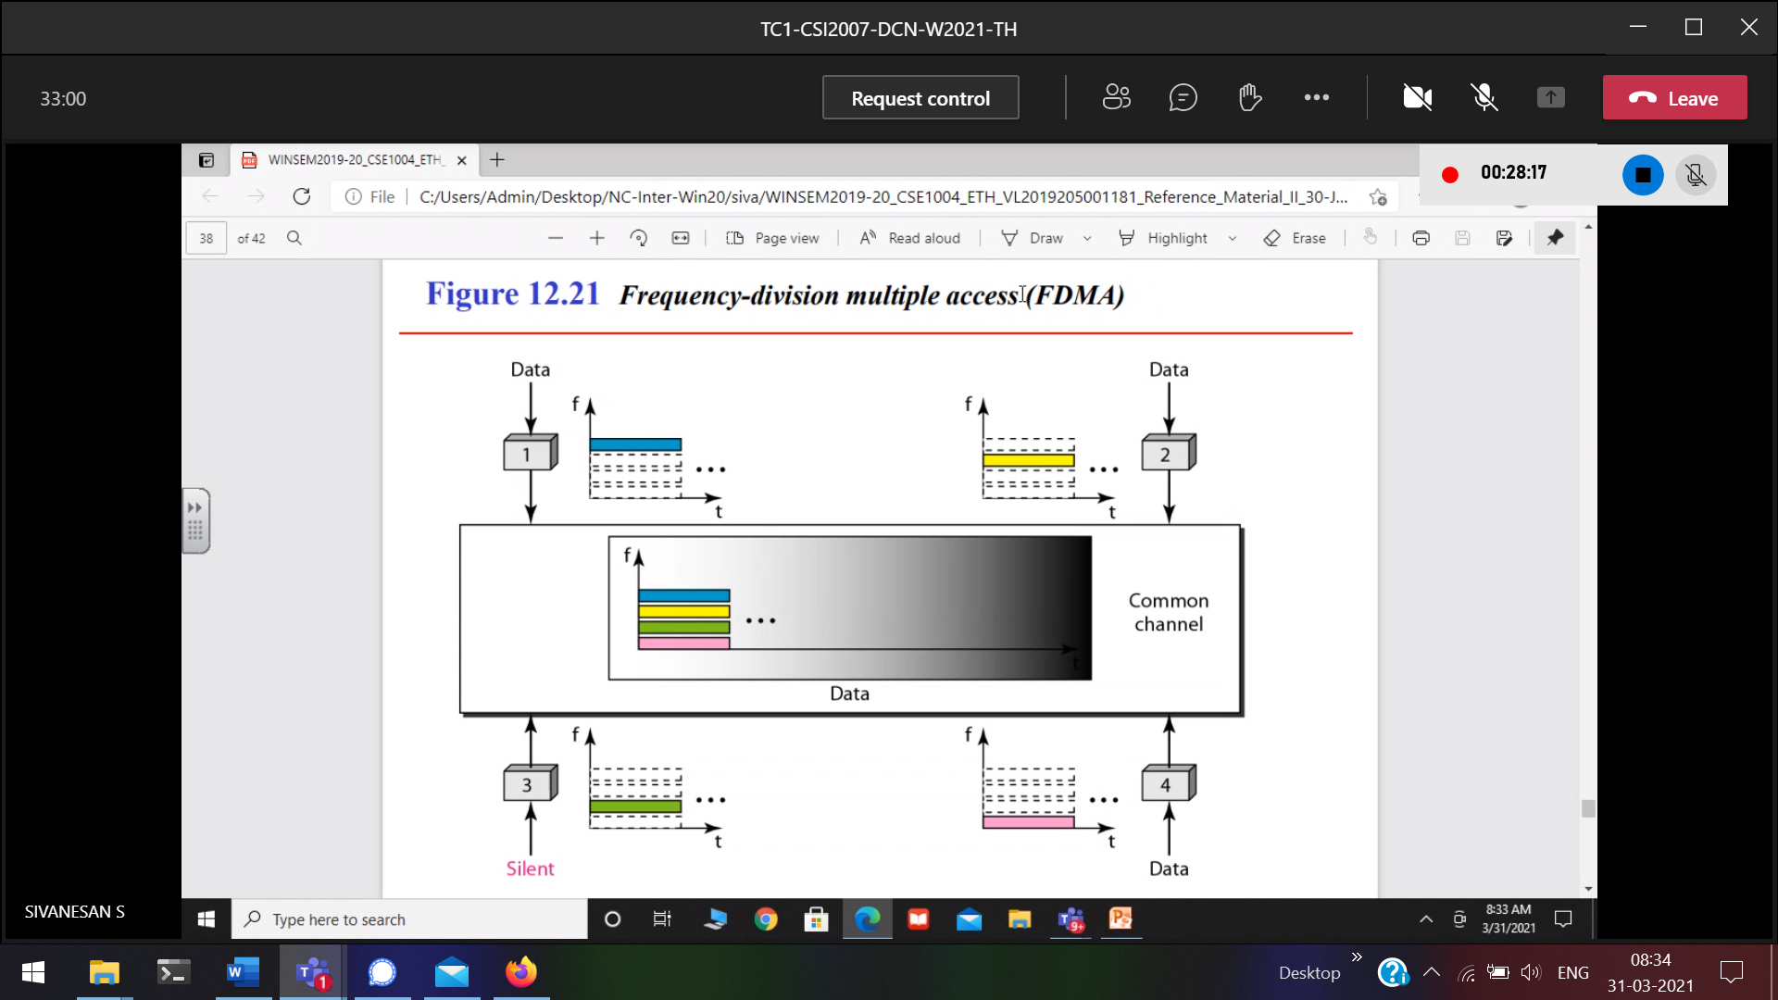

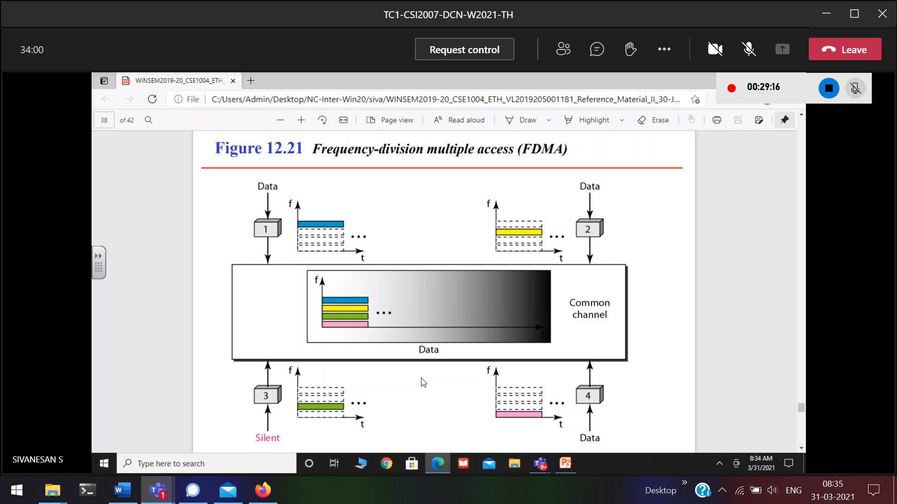

From the entire channel(i.e larger frequency) , Divided the frequency of the channel.(y -axis)

Similer to pure aloha

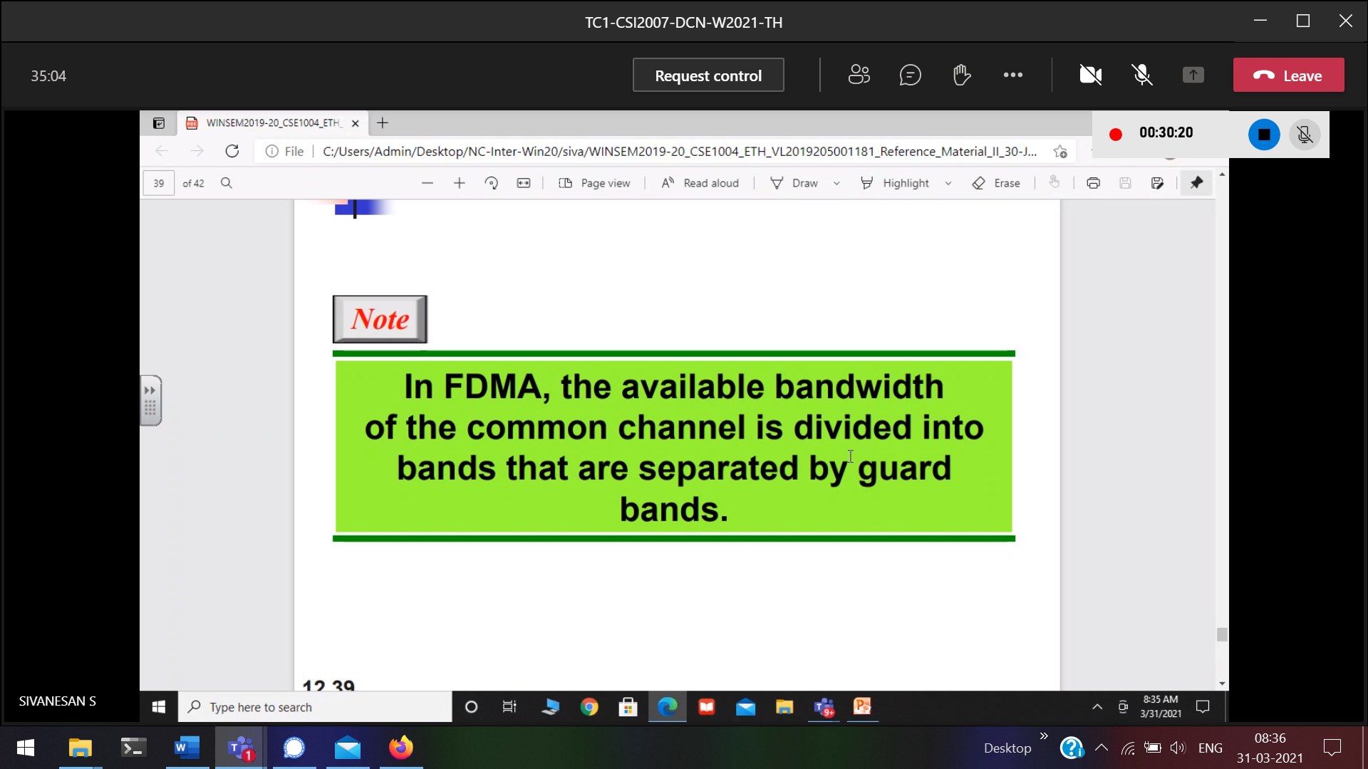

Guard is Similar to IFS

